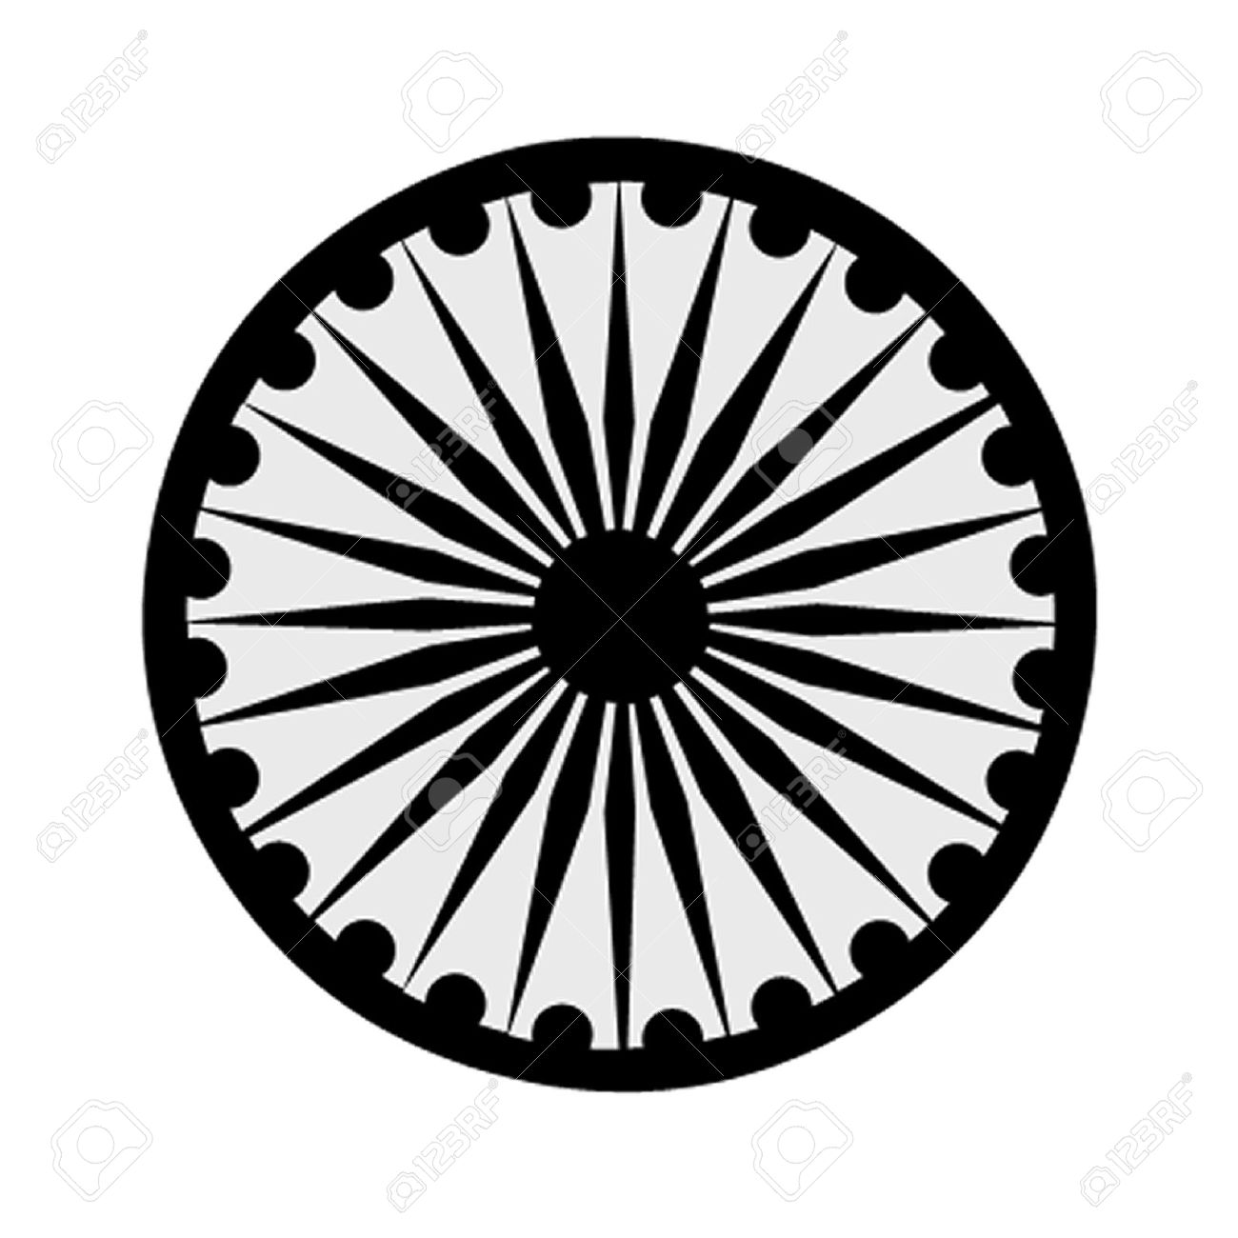 | HIGH COMMISSION OF INDIA, BRUNEI DARUSSALAM  P.O. BOX 439, LAPANGAN TERBANG LAMA  BANDAR SERI BEGAWAN BB 2339685  Telephone: 2339947 / 2339685  Fax: 2339783  E-mail: hoc.brunei@mea.gov.in  Website: www.hcindiabrunei.gov.in

Press Release No. 4/2023

9th International Day of Yoga (IDY)-2023
Brunei Darussalam

The 9th International Day of Yoga (#IDY-2023) in Brunei Darussalam was organized on Sunday, 18th June, at “India House”, the official Residence of the High Commissioner; “Yoga for Vasudheva Kutumbkam (One Earth-One Family-One Future)” being theme for the IDY 2023.

2. Youth, yoga-enthusiasts, friends-of-India, local & Indian community members, and members of Diplomatic Corps were among the participants.

3. International Day of Yoga is being celebrated every year since 21 June, 2015 as part of Prime Minister Shri Narendra Modiji’s global commitment to universal physical & mental health of the humanity, with the practice of yoga. As in the previous years, IDY 2023 was celebrated in Brunei Darussalam’s lush green nature, which is ideal for Yoga. A series of photographs, standees and posters were also showcased during the event as part of “Azadi ka Amrit Mahotsav (AKAM)” campaign as well as “Incredible India” features initiated by Government of India.

4. A Yoga-demonstration session was conducted on the occasion by Yoga Guru Mr. Brahmanand Tichkule, a renowned Yoga expert in Brunei, with participation of over 200 participants in the event. A walk-through exhibition on India’s Tourism, Travel, and Technology was also mounted on this occasion. Light Indian-snacks were served as refreshments at the conclusion of the function.

*******
Sunday, 18th June 2023
Brunei Darussalam

