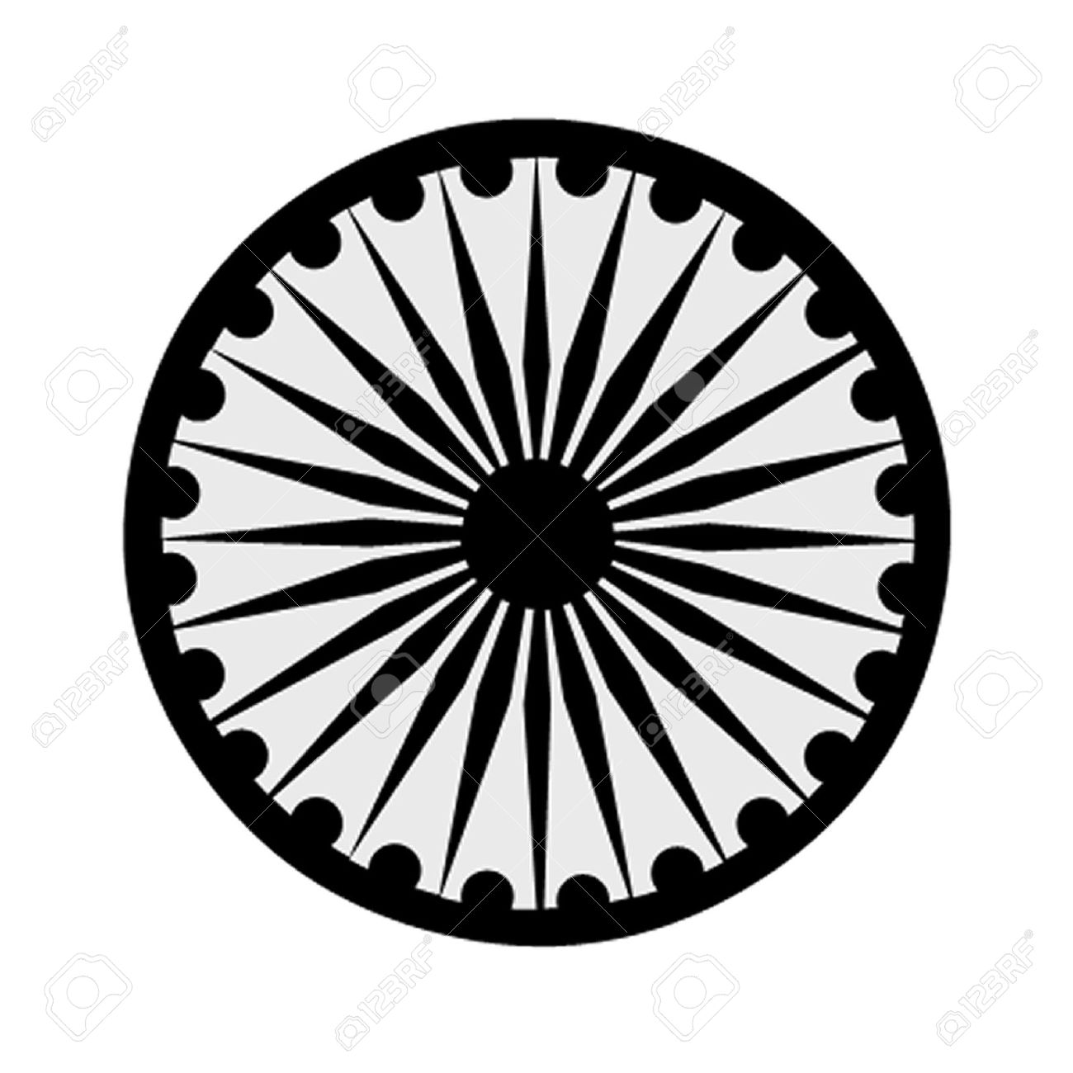 | HIGH COMMISSION OF INDIA, BRUNEI DARUSSALAM  P.O. BOX 439, LAPANGAN TERBANG LAMA  BANDAR SERI BEGAWAN BB 2339685  Telephone: 2339947 / 2339685  Fax: 2339783  E-mail: hoc.brunei@mea.gov.in  Website: www.hcindiabrunei.gov.in
Press Release No.13 of 2022
Press Release

8th International Day of Yoga (IDY)-2022
Brunei Darussalam

The 8th International Day of Yoga (#IDY-2022) in Brunei Darussalam was organized on Sunday, 19th June 2022, at “India House”, the official Residence of the High Commissioner: “Yoga for Humanity” being theme for the year.

2. Youth, yoga-enthusiasts, friends-of-India, local & Indian community, and members of Diplomatic corps joined in the event. Event was live-streamed on Mission’s social-media platforms to facilitate participation virtually and for wider dissemination.

3. International Day of Yoga observation is PM Modiji’s global commitment to universal health to humanity with the practice of Yoga. IDY 2022 was celebrated in Brunei Darussalam’s unique yogic serenity & peace as ideal for Yoga.

4. A Yoga demonstration-session was conducted on the occasion by Yoga Guru Shri Bramhanand Tichkule. Over one hundred and fifty participants attended the event. A walk-through exhibition on India’s Tourism, Travel, and Technology was also mounted on this occasion. Light Indian-snacks were served at the conclusion of the function.
*******
Sunday, 19th June 2022
Brunei Darussalam

