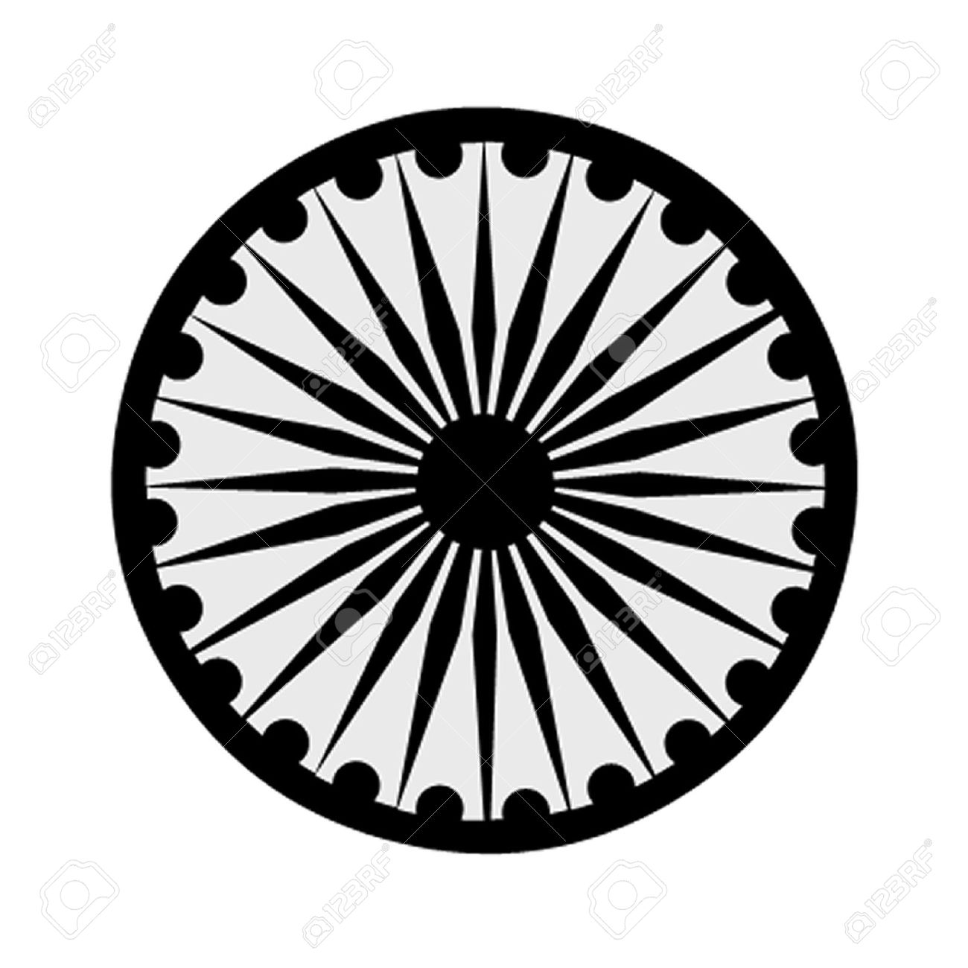 | HIGH COMMISSION OF INDIA, BRUNEI DARUSSALAM  P.O. BOX 439, LAPANGAN TERBANG LAMA  BANDAR SERI BEGAWAN BB 2339685  Telephone: 2339947 / 2339685  Fax: 2339783  E-mail: hoc.brunei@mea.gov.in  Website: www.hcindiabrunei.gov.in

Press Release

Celebrating India@75 – Azadi ka Amrit Mahotsav
- Donation presented to Pusat Ehsan Al-Ameerah Al-Hajjah Maryam

As part of “Azadi Ka Amrit Mahotsav” celebrations, the High Commissioner of India to Brunei Darussalam, His Excellency Ajaneesh Kumar visited Pusat Ehsan Al-Ameerah Al-Hajjah Maryam on Friday 26th November 2021 and presented a charitable donation of B$1000 to the organization.

The donation was made to Pengiran Datin Hajah Noraini binti Pengiran Dipa Negara Laila Diraja Pengiran Haji Abdul Momin, Executive Trustee of Pusat Ehsan on behalf of the organization. Pg Sarimah binti Pg Haji Abd Latiff and Ms Audrey Choo Wah, members of the Board of Trustees and Dyg Nurul Huda binti Awang Haji Muhin, Head of Administration and Dyg Kamsiah bte Hj Zaman, Senior Account Clerk of Pusat Ehsan were also present on the occasion.

The High Commission of India has been regularly supporting Pusat Ehsan an organization that champions special needs care, a cause that is dear to the Diplomatic Mission. The High Commissioner lauds the important role the organization plays in caring and nurturing as well as ensuring the inclusivity and holistic development of the special needs children in Brunei.

In the past, various cultural activities and performances had been organized by the the High Commission of India for students of Pusat Ehsan. Visiting cultural troupes from India have staged colorful performances. Special Yoga classes were also organized by the High Commission of India for the benefit of the special needs students.

*******

Brunei Darussalam, 26 November 2021

