High Commission of India
Nairobi
***
Press release

Organisation of Consular Camp at Nakuru

High Commission of India, Nairobi organised a consular camp in Nakuru on 30th October 2020 with the assistance of Hindu Council of Kenya, Nakuru.

Consular services, including Passports, OCI cards etc were provided at the camp to around 135 Indians and Overseas Citizens of India, saving them from travelling to Nairobi for availing these services. All Covid-19 protocols such as use of sanitizers, face masks and social distancing were observed during the camp. The High Commission is planning similar consular camps in other cities of Kenya in the coming months.

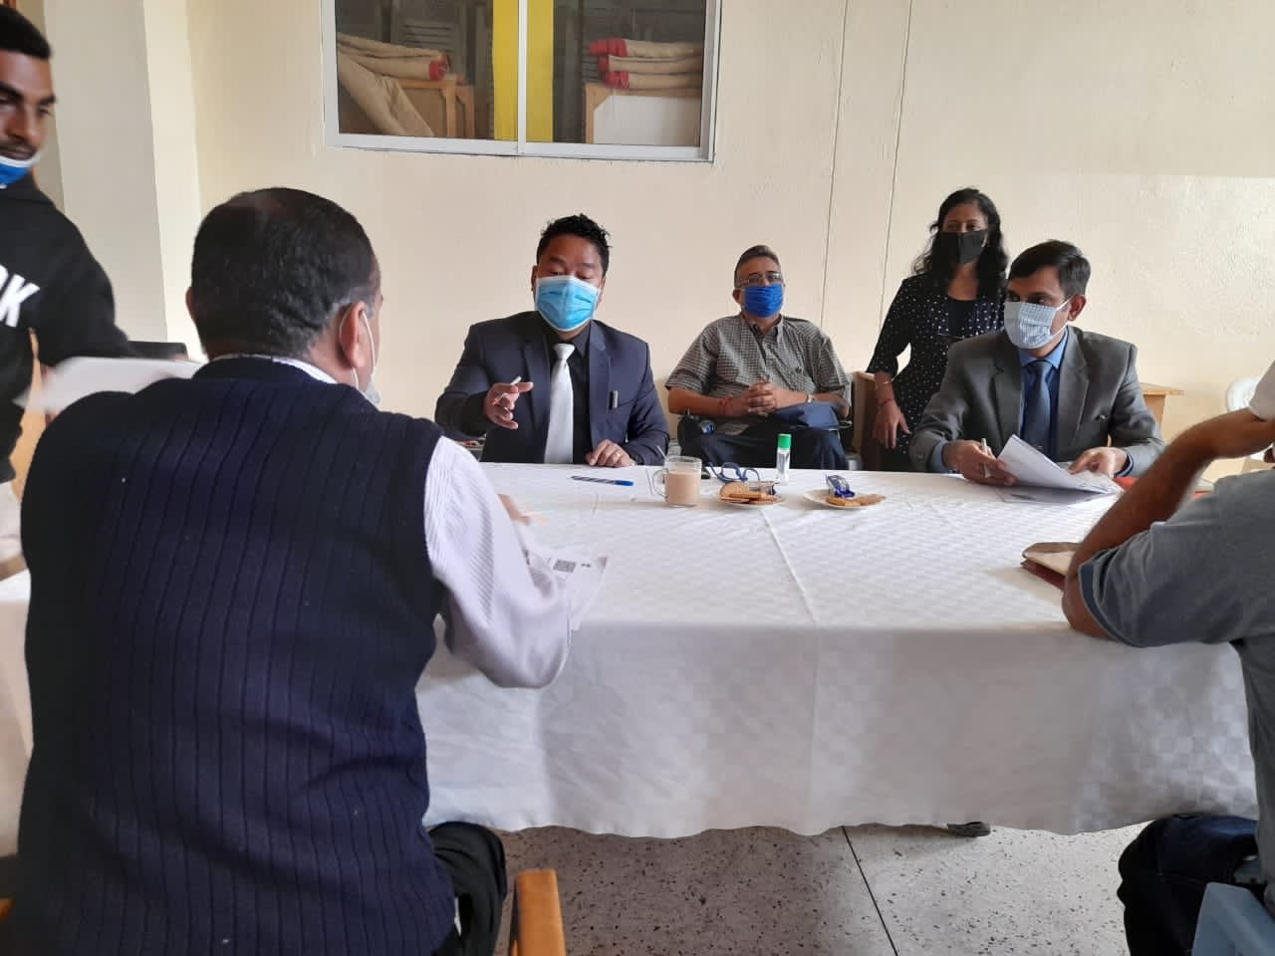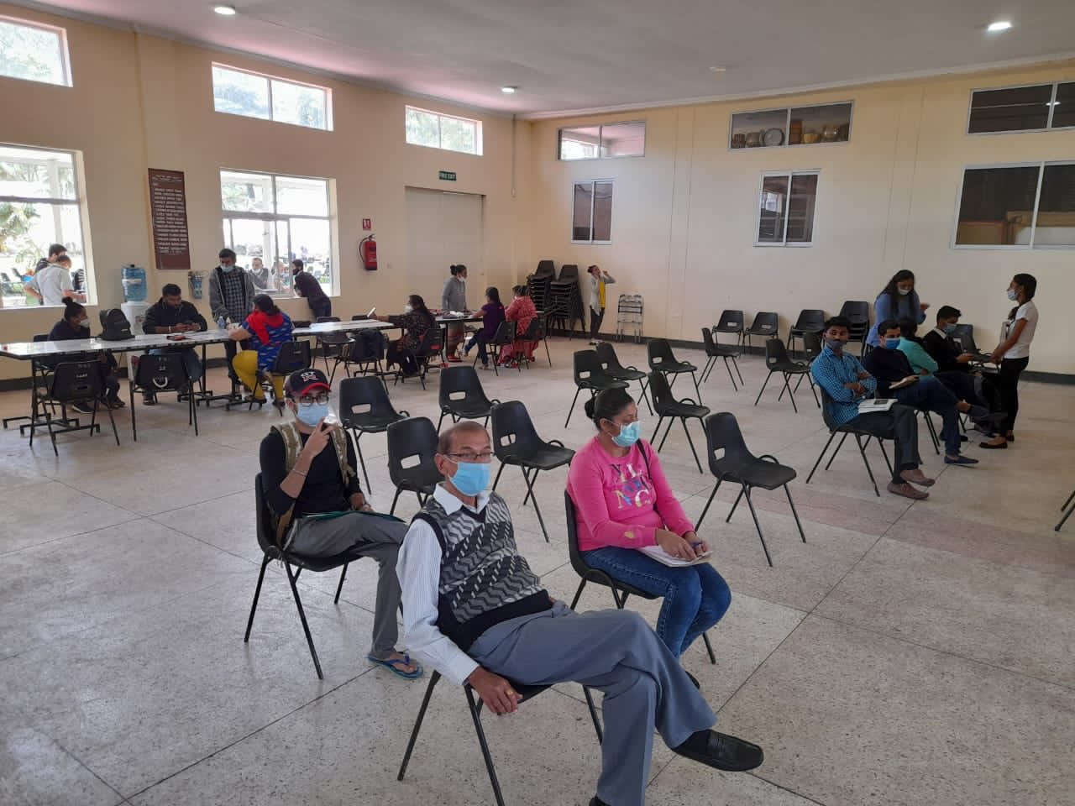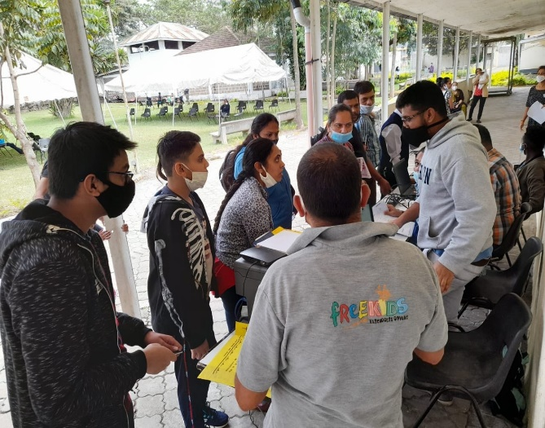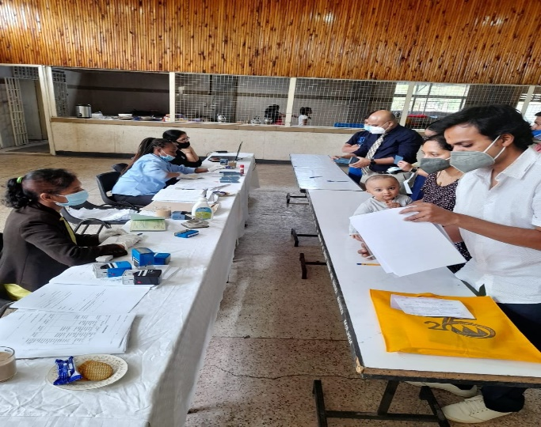

***

[Nairobi, 30 October, 2020]

