High Commission of India
Nairobi
***
Press release

Celebration of 151st Birth Anniversary of Mahatma Gandhi & 14th International Day of Non-Violence

High Commission of India, Nairobi celebrated the 151st Birth Anniversary of Mahatma Gandhi & 14th International Day of Non-Violence on Friday, 2nd October, 2020. To mark the occasion, the High Commission, in association with Posta Kenya, University of Nairobi (UoN) and Kenya-India Friendship Association (KIFA) organized an event which was also streamed live on High Commission’s social media platforms.

2. The event was attended by members of the Diplomatic Corps & the UN, senior functionaries from Government of Kenya, media and representatives of Indian Community in Kenya including Director General, United Nations Office at Nairobi Ms. Zainab Hawa Bangura, CAS, Foreign Affairs Hon. Ababu Namwamba, and VC UoN Prof. Stephen Kiama Gitahi.

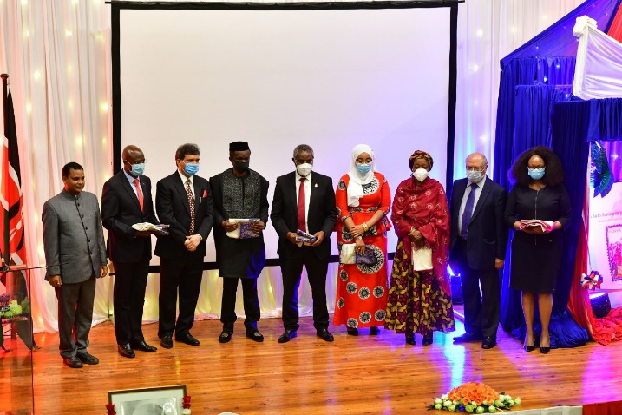

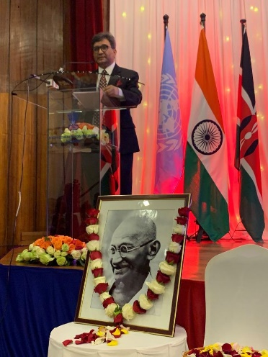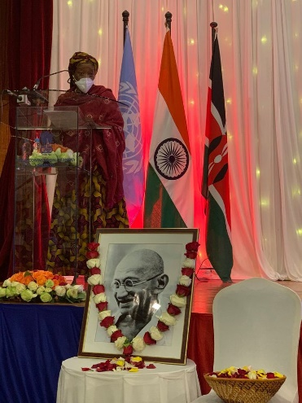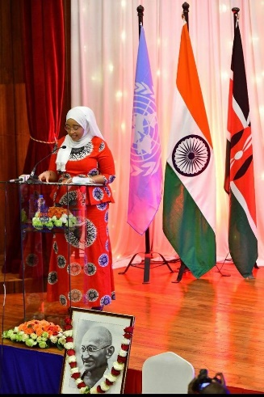

3. High Commissioner Dr. Virander Paul also offered floral tributes at the Mahatma Gandhi Statue in the University campus and underlined the importance of Mahatma Gandhi’s ideals of non-violence and truth in today’s world.

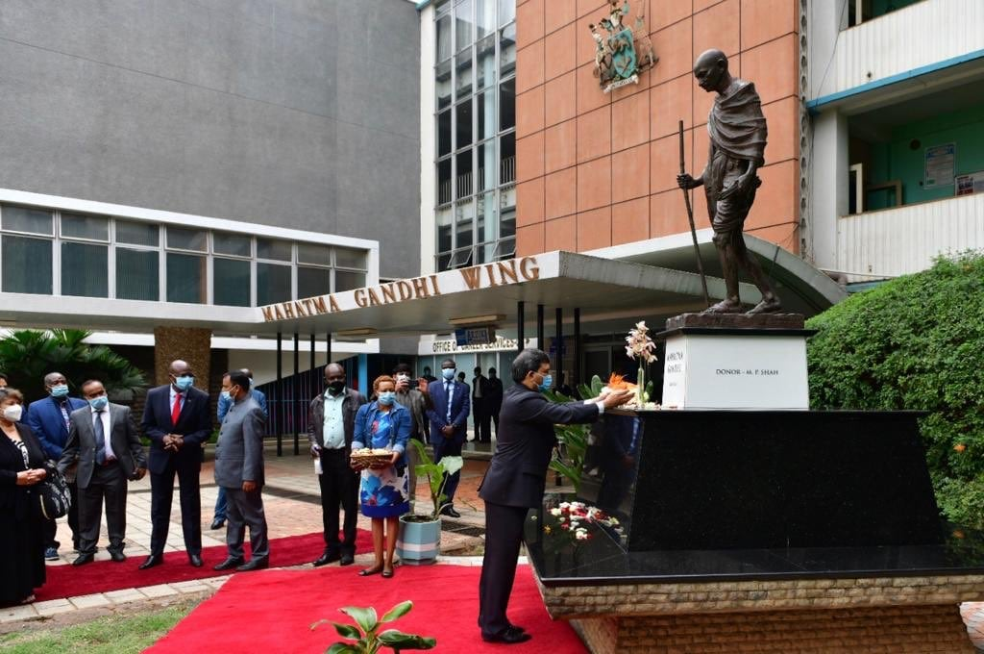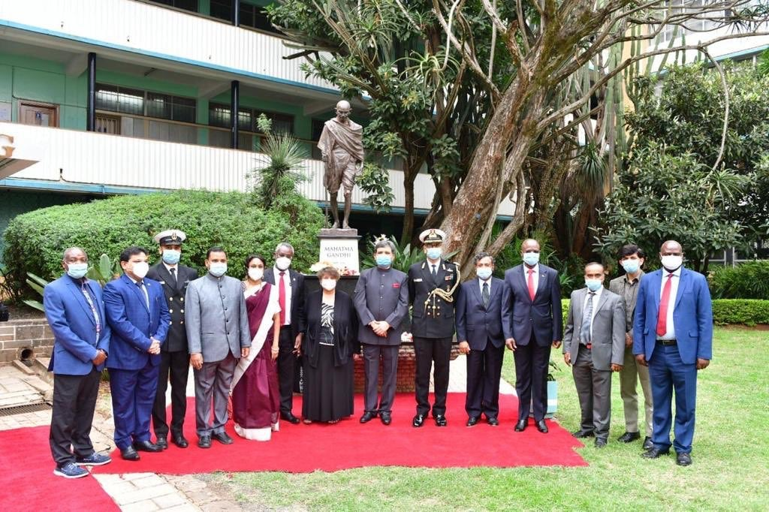

4. Postal Corporation of Kenya released a commemorative Postal Stamp on Mahatma Gandhi.

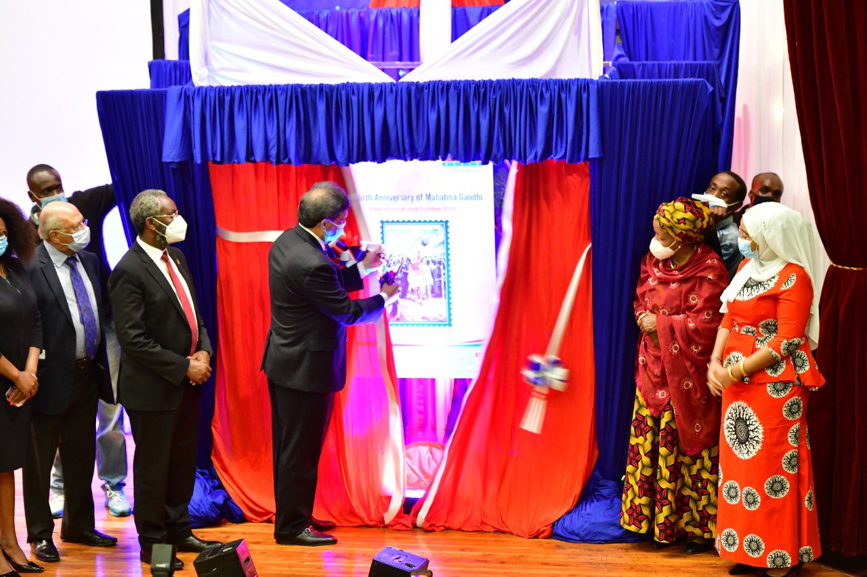

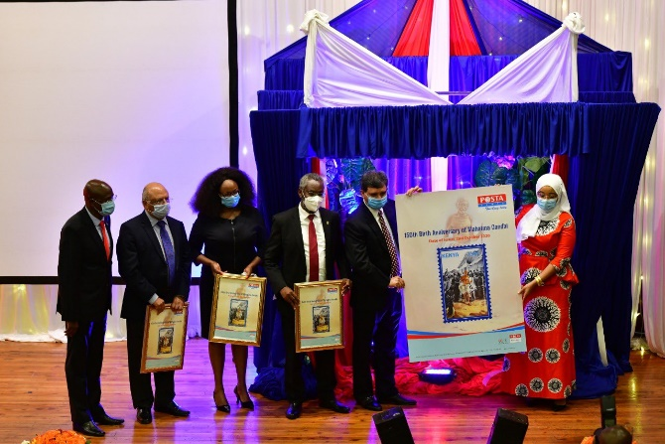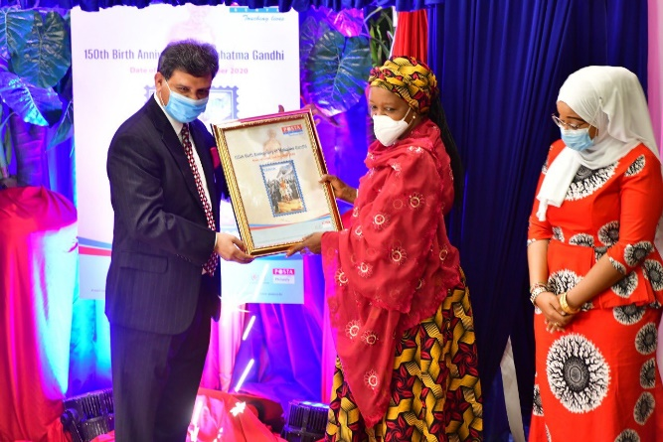

5. The event was also addressed through virtual means by Gandhian Scholars in Kenya, dignitaries from Kenyan Government. Gandhi Katha (A tale of Gandhi) was also delivered by Ms. Shobhana Radhakrishnan, a globally renowned Gandhian from India.

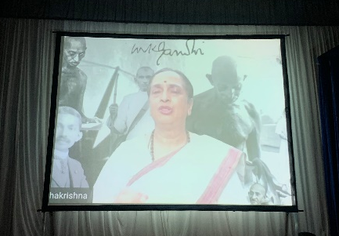

***

[Nairobi, 05 October, 2020]

