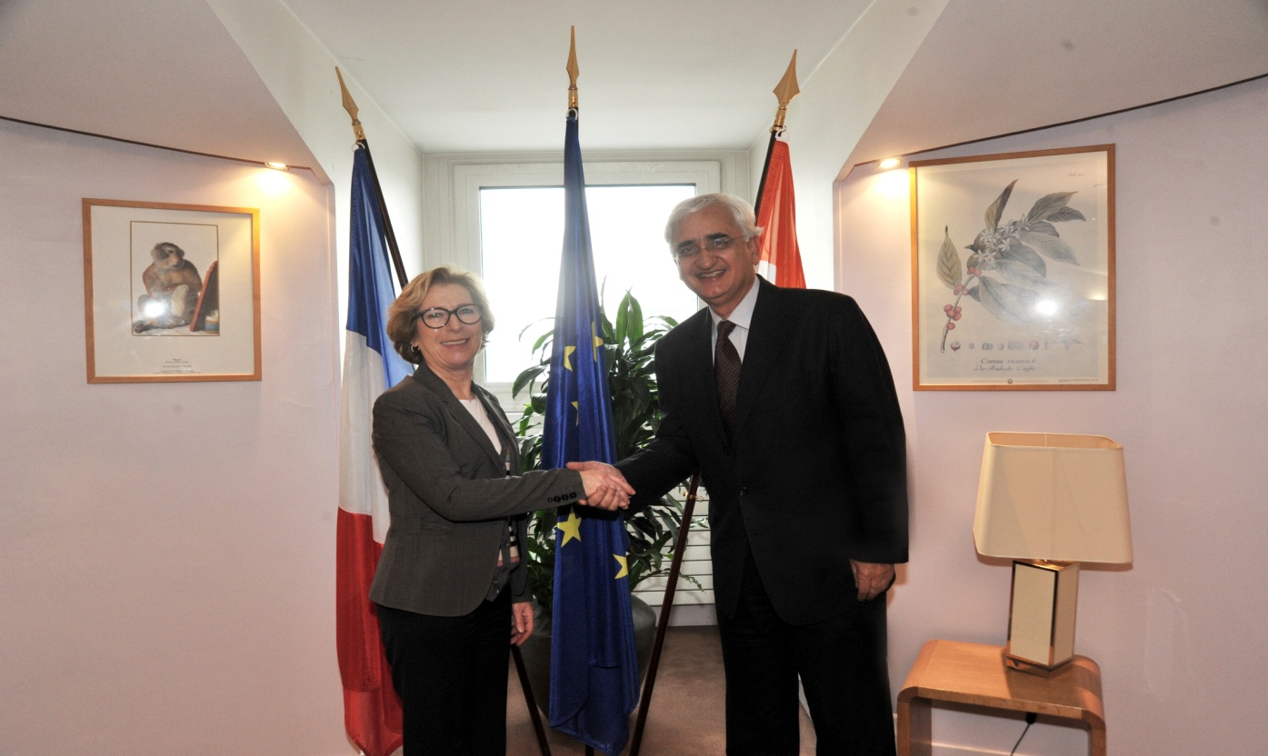
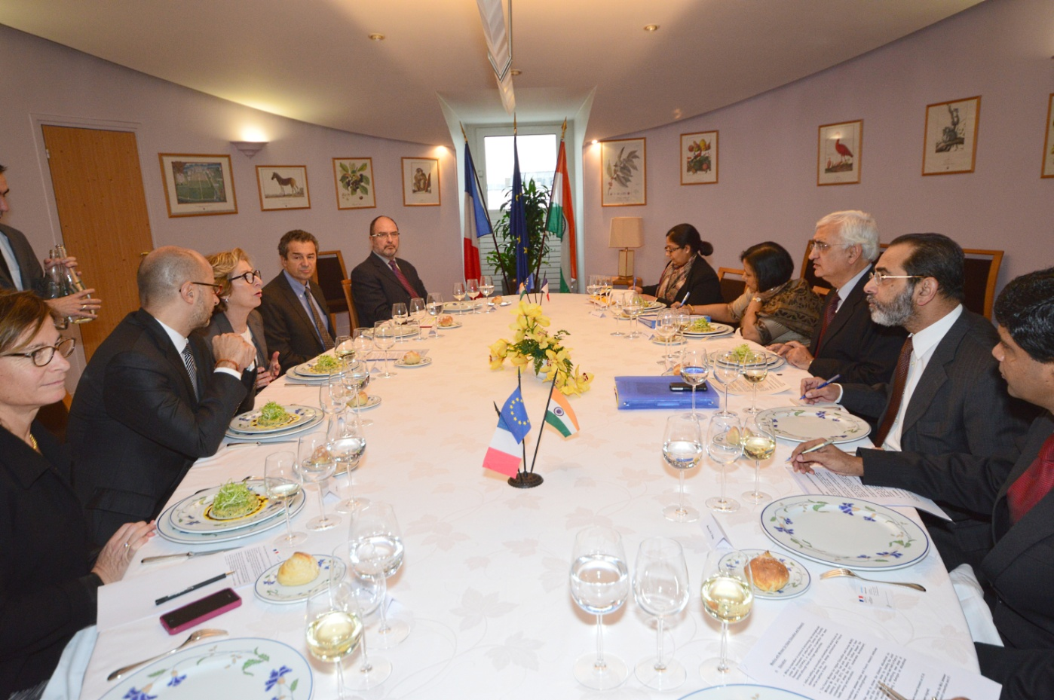

Shri. Salman Khurshid, Minister of External Affairs,India meeting with Mme. Genevieve Fioraso, French Minister for Higher Education and Research. Paris.11th January,2013

