Embassy of India
Dushanbe
……

On 18 January 2019, the 17th lecture of the on going series on ‘Commemoration Lecture on India-Tajikistan: 25 years of Friendship’ jointly organized by Embassy of India in Dushanbe, Indira Gandhi Central Scientific Library and India-Tajikistan Friendship Society was held at the Indira Gandhi Central Scientific Library, Academy of Sciences of the Republic of Tajiksitan. Dr. Shamsuddin Muhammadiev, Senior Member at Rudaki Institute of Language and Literature presented a paper on “Tradition of Persian Anthology Writing in India”.

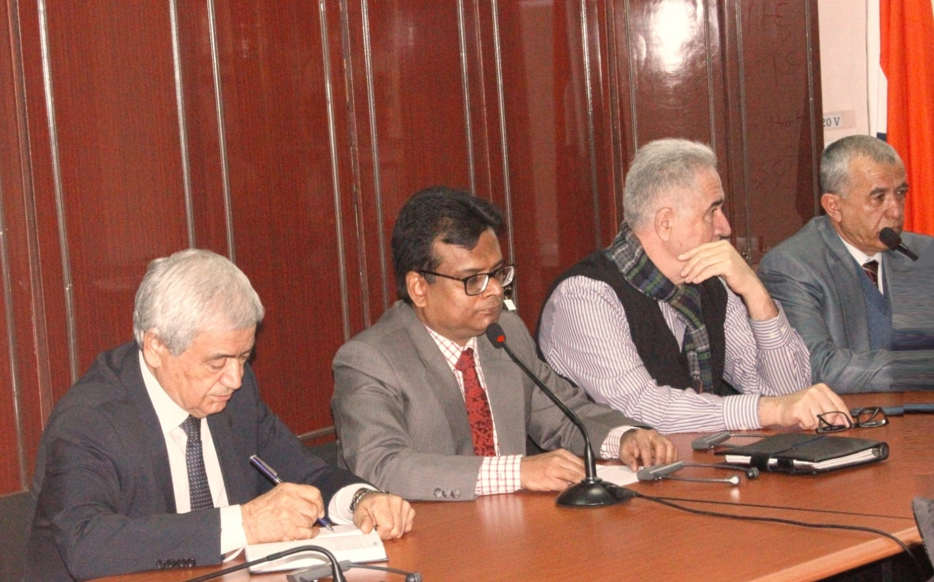

(Shri Somnath Ghosh, Ambassador of India to Tajikistan delivers opening address.)

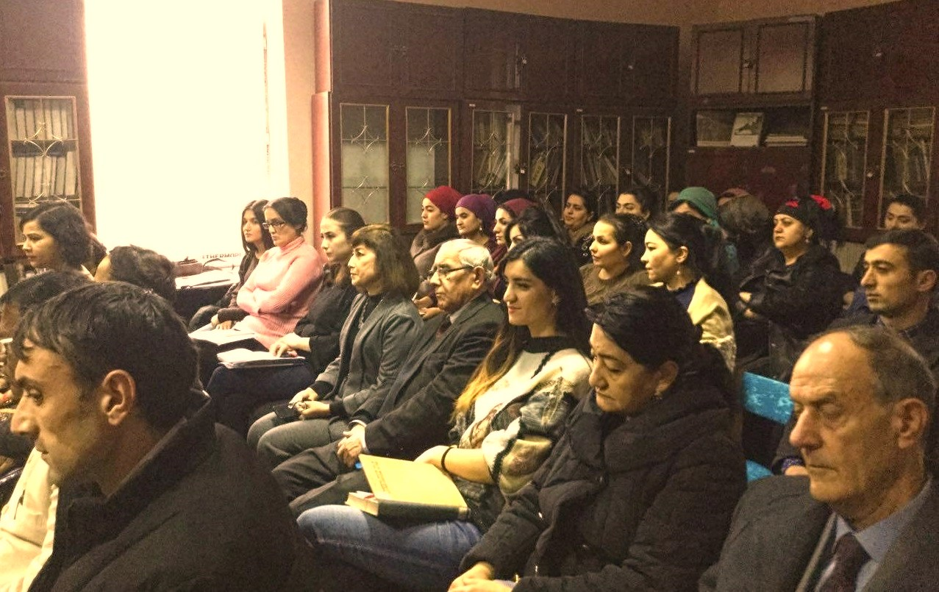
(A cross section of audience)

