High Commissioner presents copies of Credentials to Acting Chief of Protocol

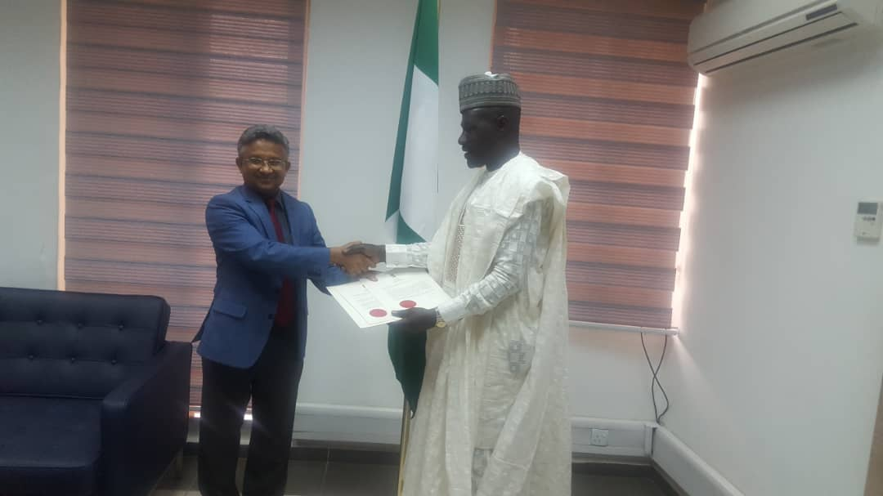

On his arrival in Abuja today, the High Commissioner of India H.E. Mr. Abhay Thakur presented the copies of his Credentials to the Acting Chief of Protocol Mr. Mohammed Maina Maidugu, at the Ministry of Foreign Affairs of the Federal Republic of Nigeria. At the meeting, both sides recalled the warm and friendly relations between India and Nigeria, the leading economies in their respective regions, and underscored the importance of further strengthening India-Nigeria cooperation in the years ahead.

Abuja
04 January 2019.

