Embassy of India
Dushanbe
……

Embassy of India in Dushanbe organized ‘Indian Film Festival’ in collaboration with Russian-Tajik Slavonic University and Cinematographers Union of Tajikistan from 10-14 December 2018 at Russian-Tajik Slavonic University. During the festival, 5 Indian films dubbed in Tajiki with English subtitles will be shown.

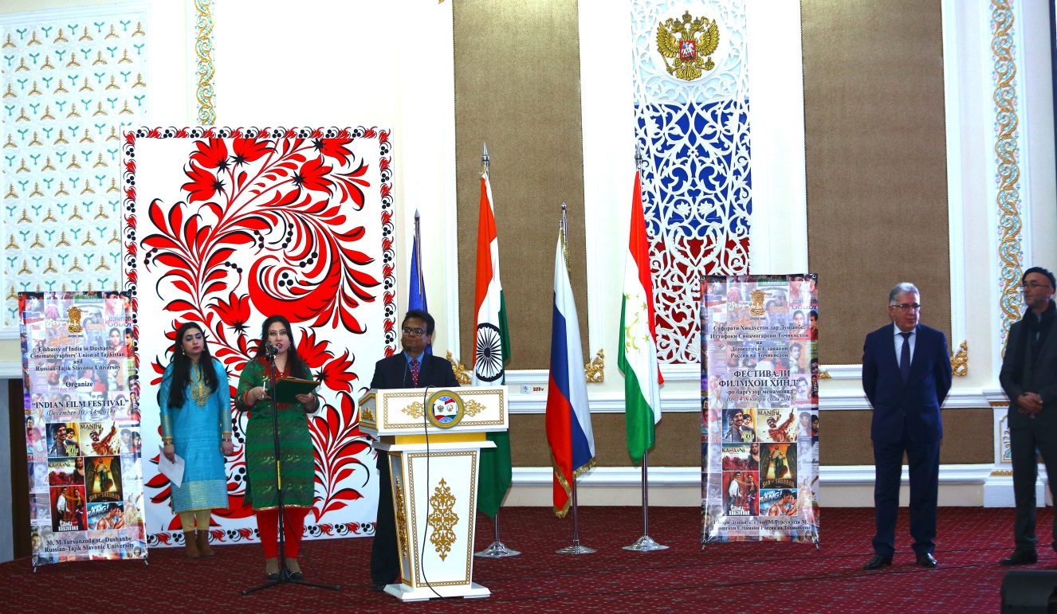

Shri Somnath Ghosh, Ambassador of India to Tajikistan inaugurates the ‘Indian Film Festival’

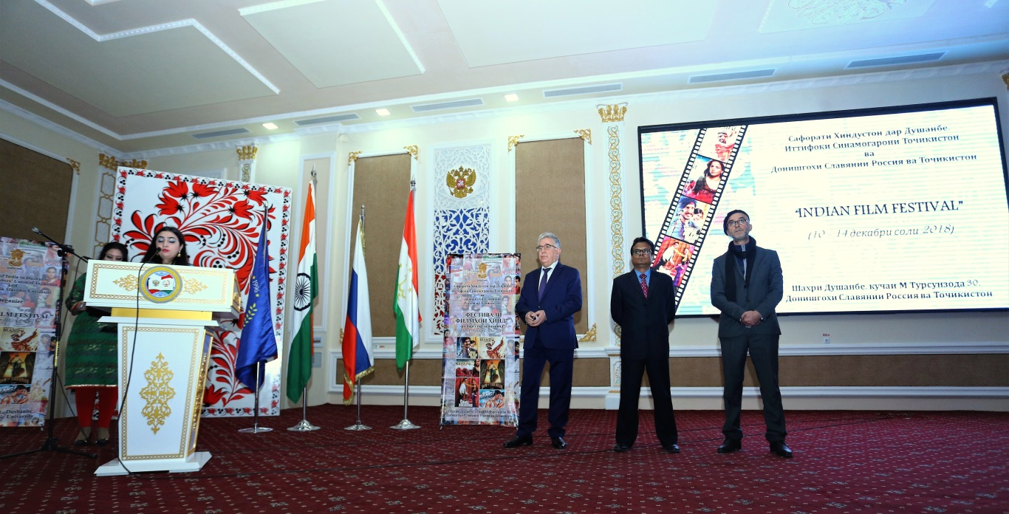

Inaugural Ceremony of ‘Indian Film Festival’ at Russian-Tajik Slavonic University on 10 December 2018

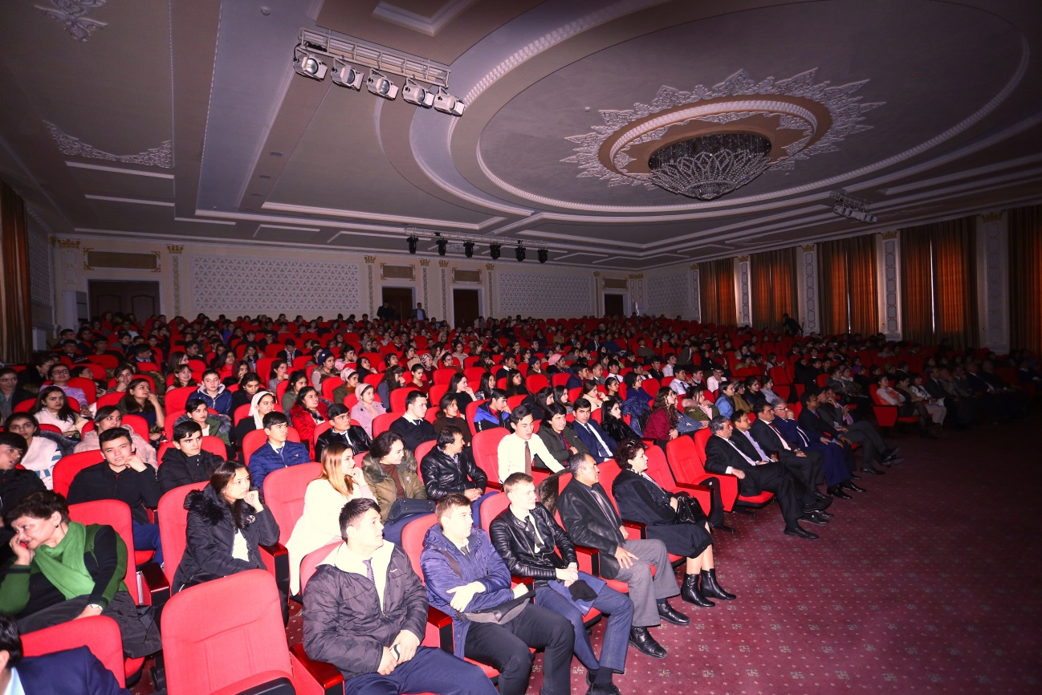
A cross section of Indian film lovers

