Embassy gearing up for the 2nd IDY celebrations planned for 25th June, 2016
Adults :

Began with the chanting of ‘OM’……
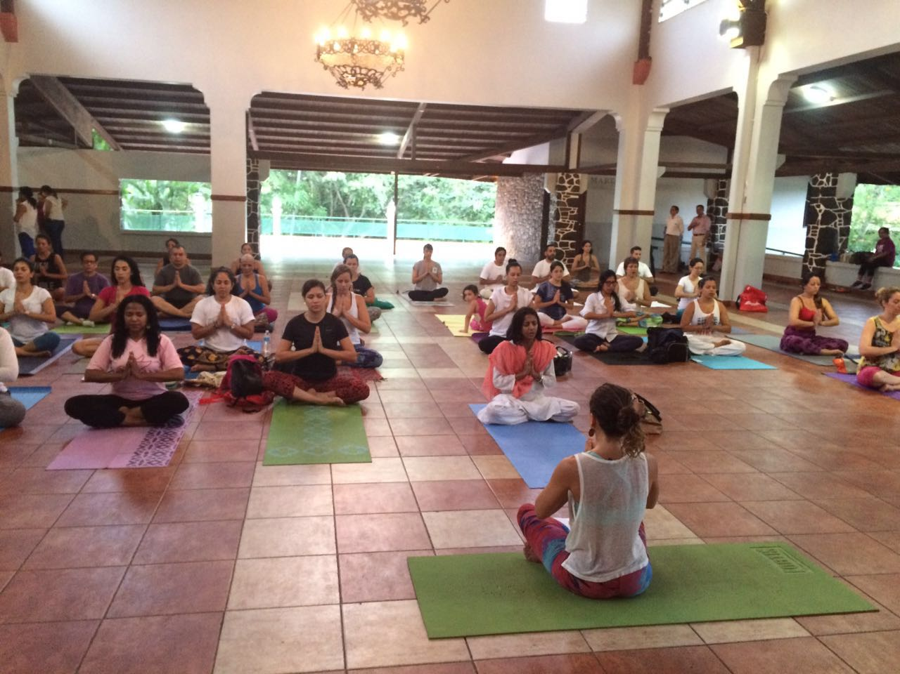

Stretching the body…

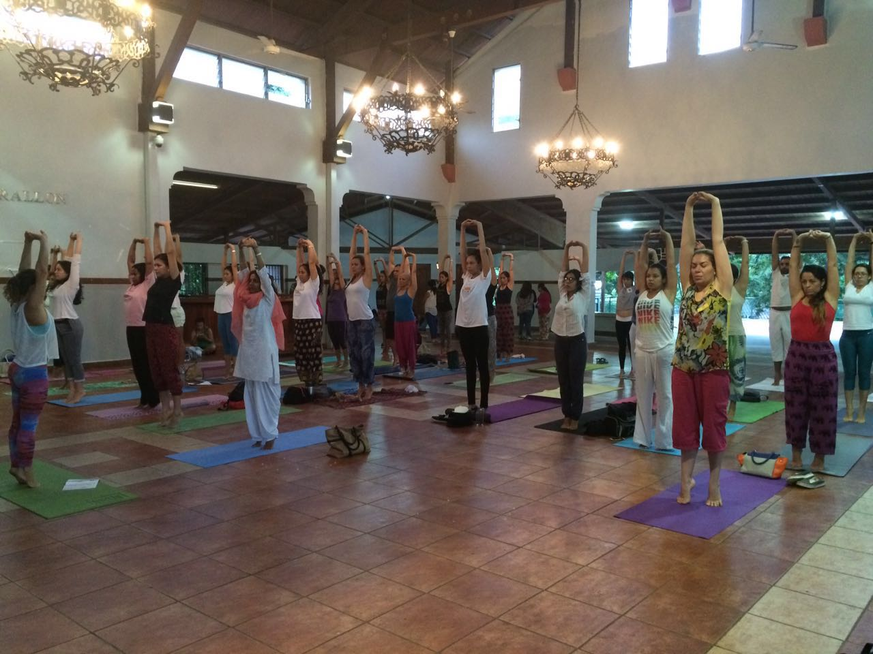

Building balance of mind and body
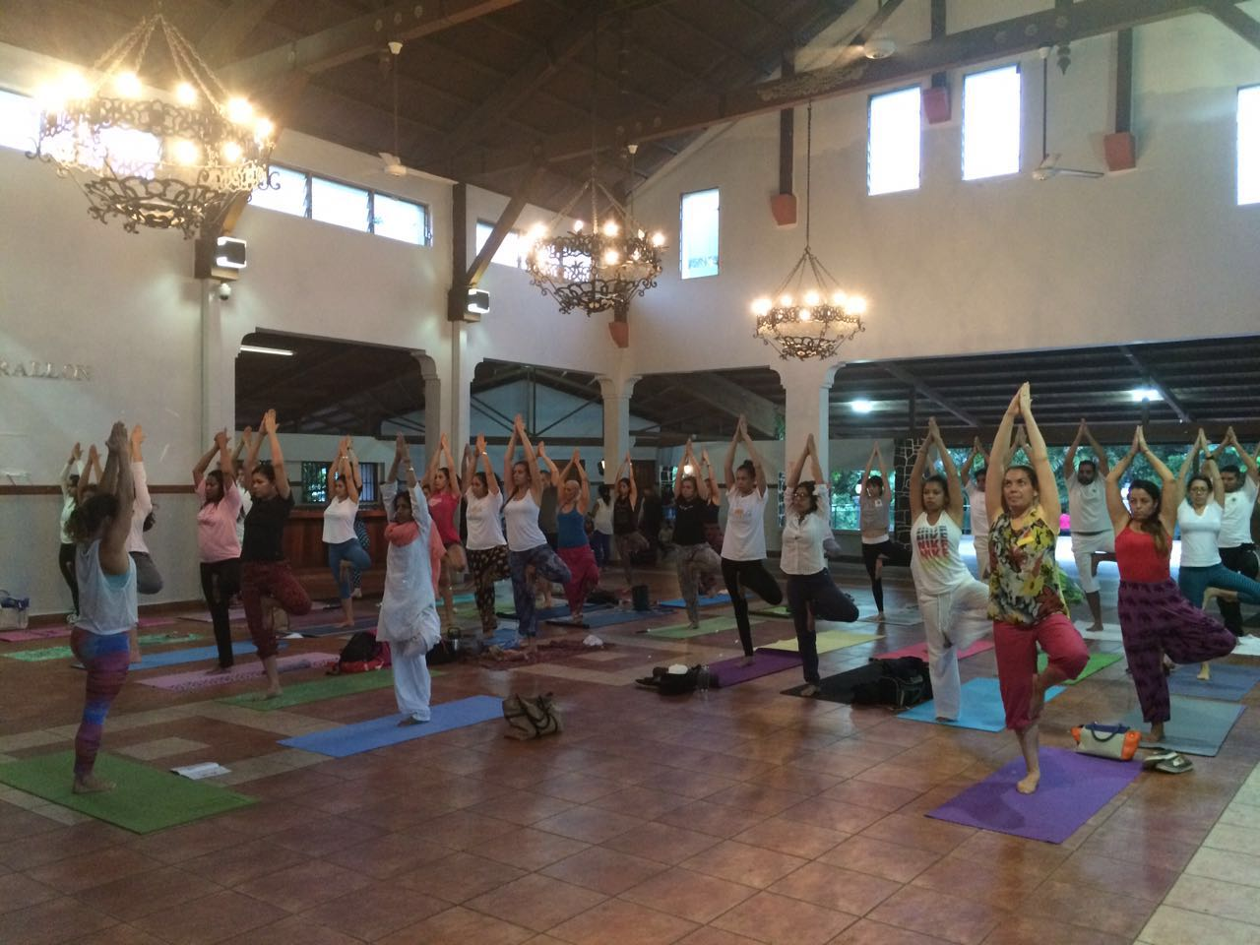

CHILDREN
The budding Yoga enthusiasts!

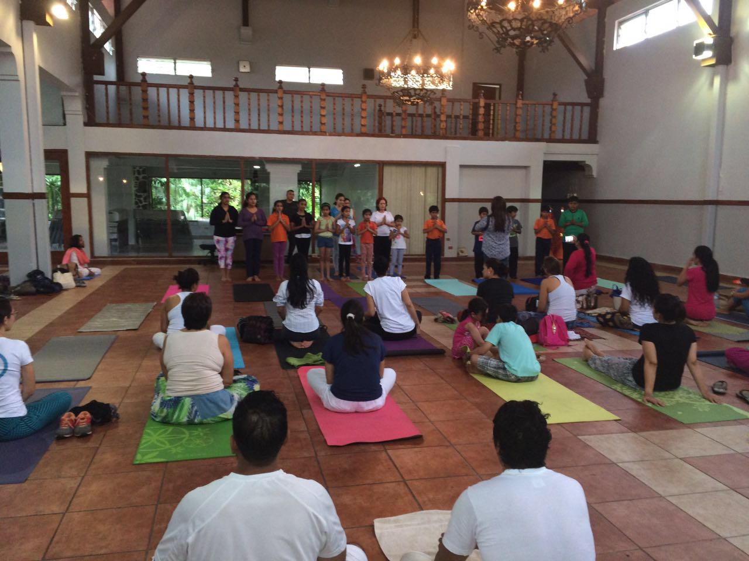

Young Children practicing complex Yoga postures
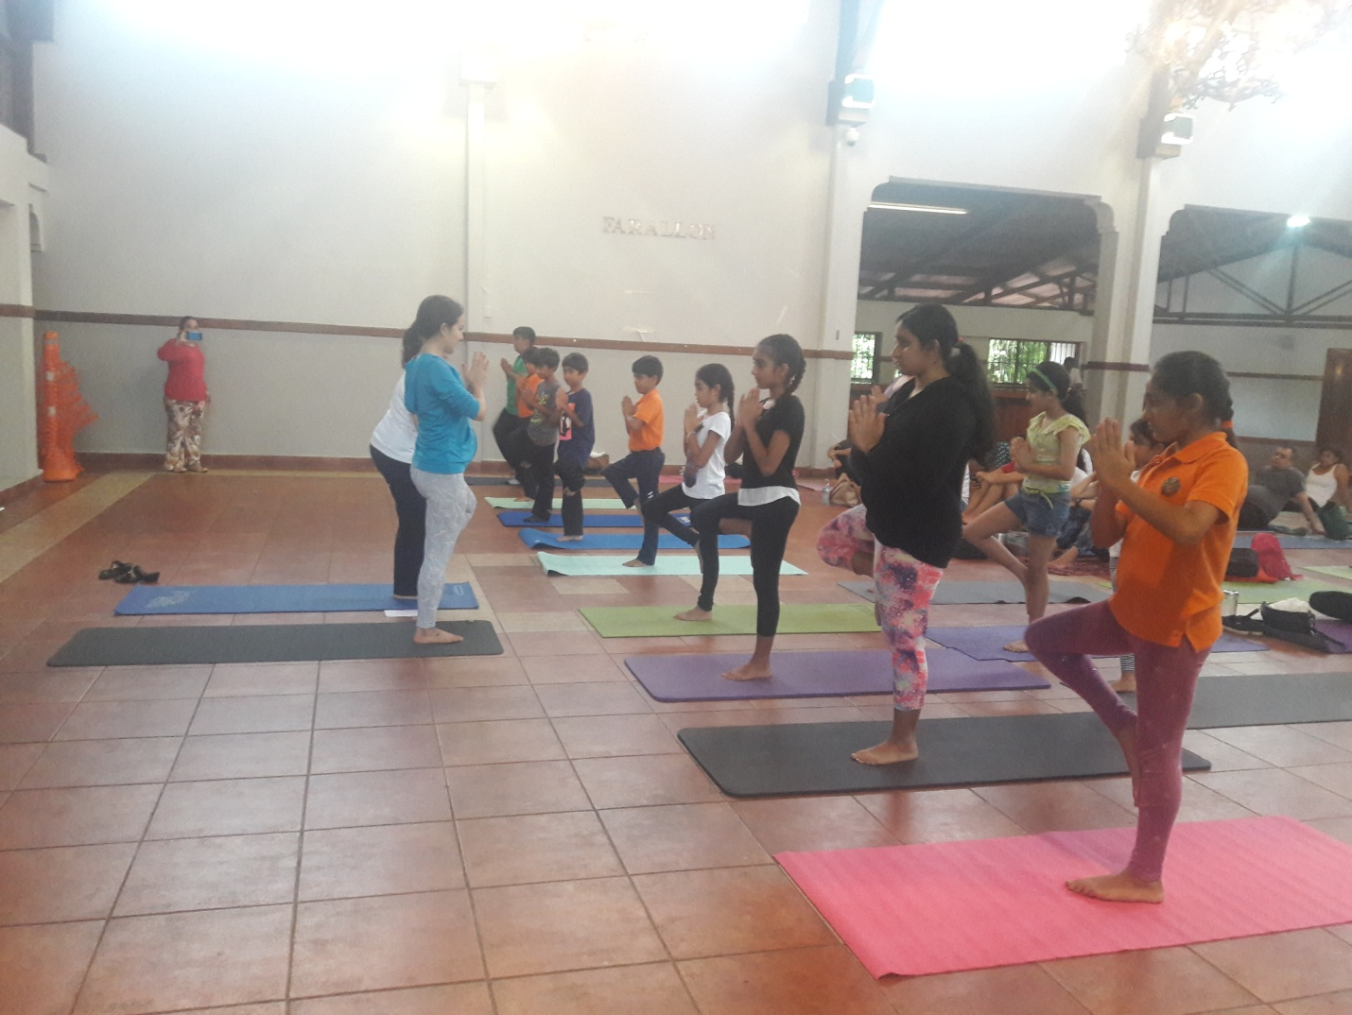

Stepping forward with Yoga …
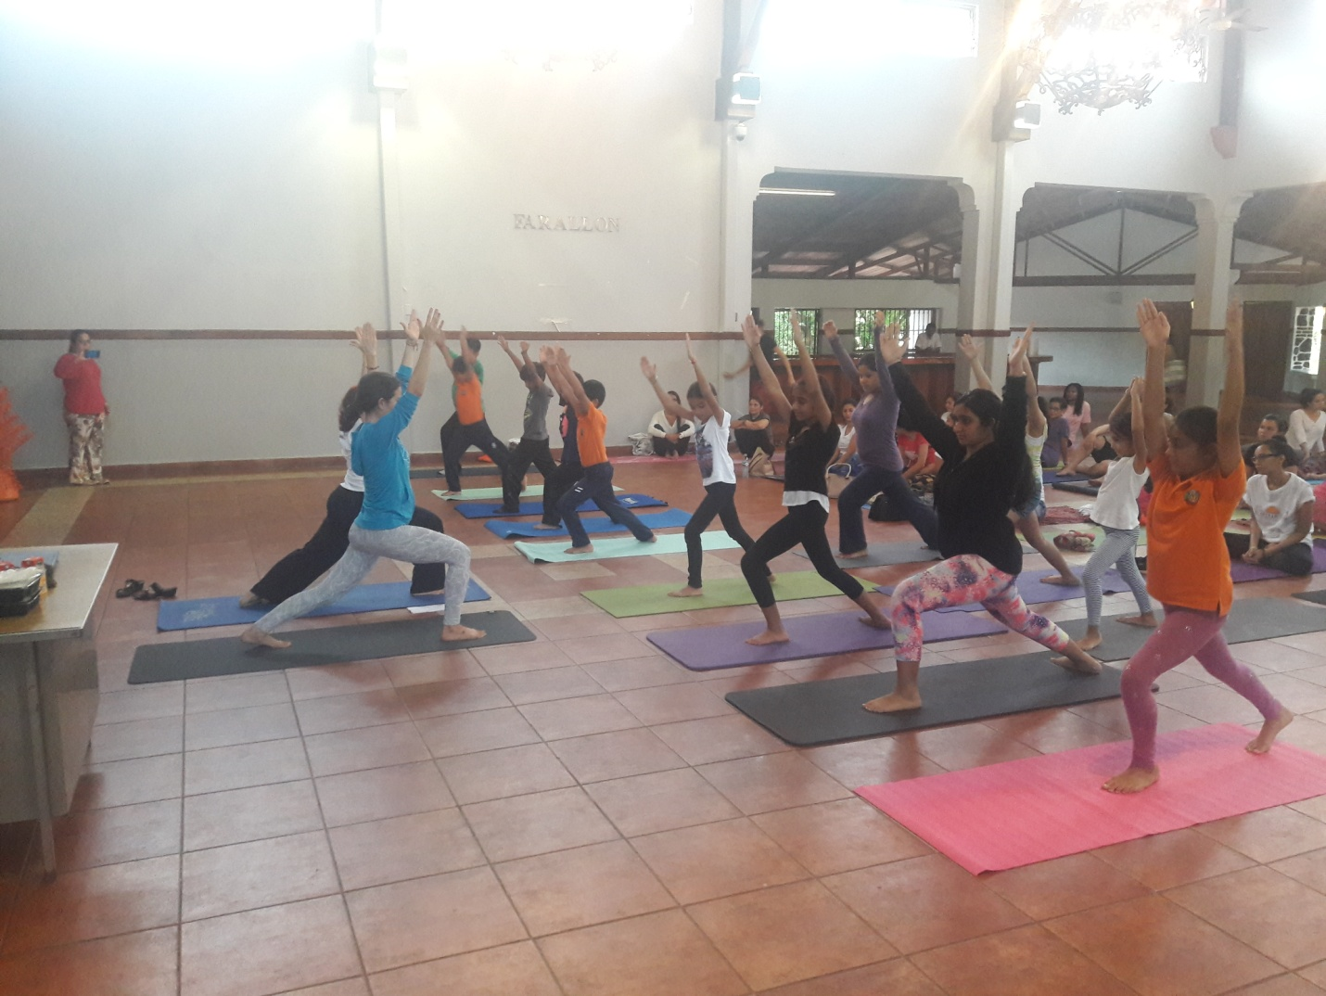

Yoga helps build concentration skills…ideal for school children.
