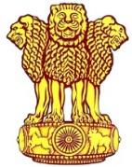 | Embassy of India  Ashgabat | 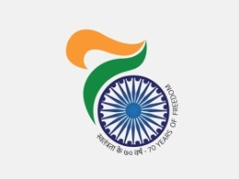

Ambassador gifts Books to Hindi Students
Ambassador H.E. Mr. Azar A H Khan paid a visit to “Turkmen National Institute of World Languages named after D Azadi” and met the Rector of the Institute and interacted with faculty and students of the Institute. Ambassador also gifted Hindi Books to students learning Hindi at the Institute.
***
12th April,, 2018, Ashgabat
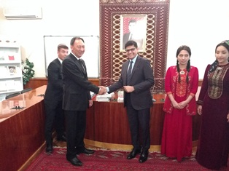
Ambassador of India to Turkmenistan with Rector of the Institute
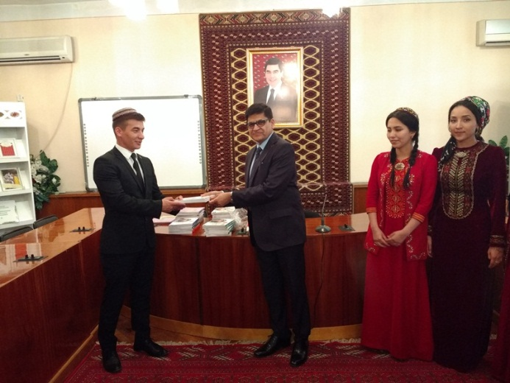 | 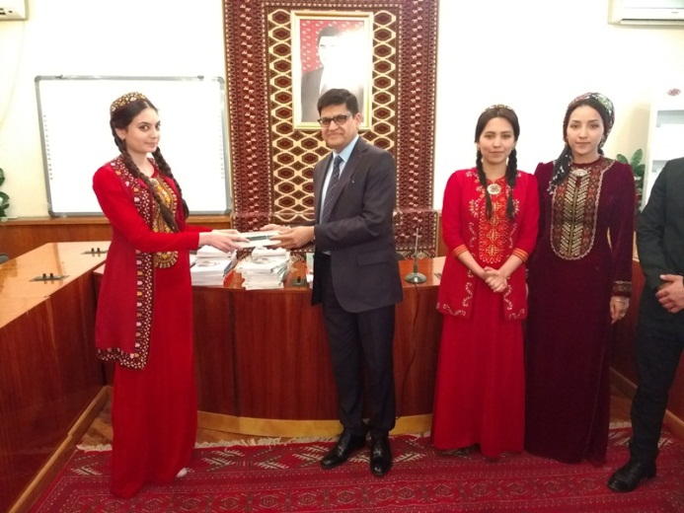

Ambassador of India to Turkmenistan gifting books to students.

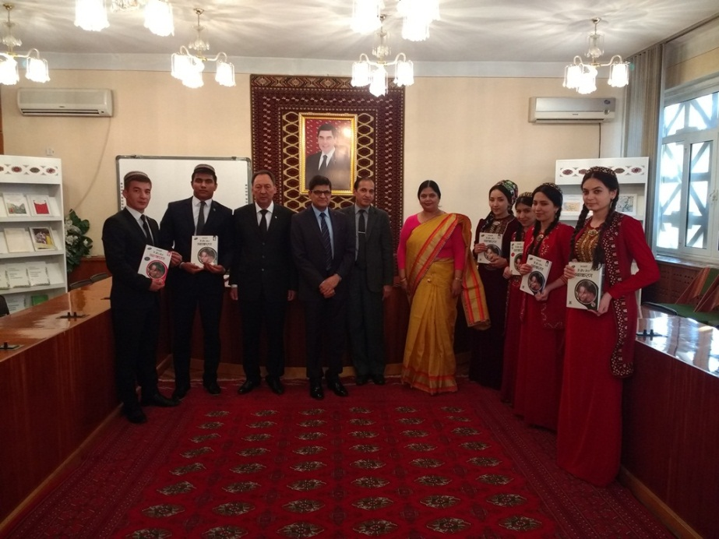
Ambassador of India to Turkmenistan with Rector, Hindi chair and Hindi Students of the Institute

