EMBASSY OF INDIA
***
Diplomat’s Day 2018
The Ministry of Foreign Affairs of Turkmenistan organized Diplomat’s Day on February 17th, 2018 at the foyer of the Institute of International Relations Ashgabat. Various Diplomatic Missions and International Organizations participated in the event. Embassy of India put up pavilion in the exhibition displaying object‘d arts, traditional clothes, posters, food items highlighting Indian culture and traditions. Indian Pavilion was well appreciated by the visitors which included Cabinet Minister of Turkmenistan, Heads of Foreign Missions, Members of Diplomatic Community, Students of Institute of Internal Relations and local Turkmens.
***
17th February, 2018, Ashgabat
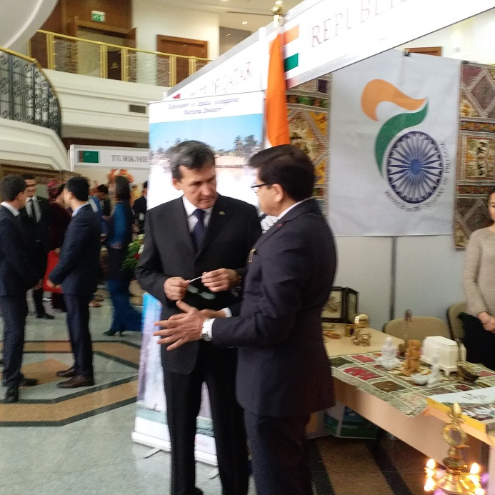
Diplomat's Day 2018- Rashid Meredov – Deputy Prime Minister for Foreign Affairs visiting Indian pavilion

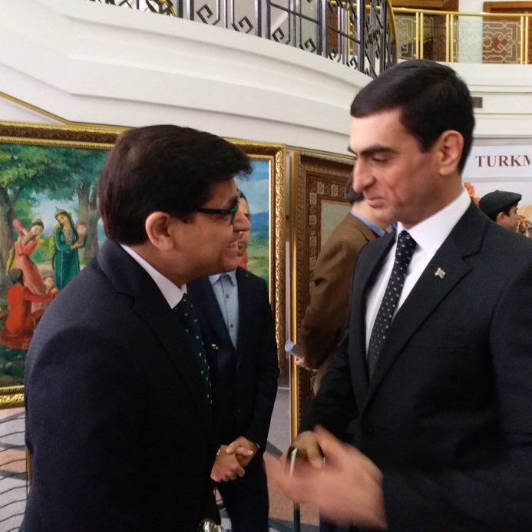
Diplomat's Day 2018- Mr. Vepa Hajiyev, Deputy Minister of Foreign Affairs of Turkmenistan – Deputy Prime Minister for Foreign Affairs visiting Indian pavilion

