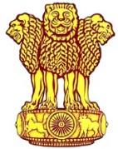 | Embassy of India  Ashgabat | 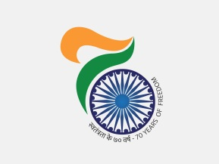
Arrival of MOS (MJA) in Ashgabat
H.E Shri M J Akbar, Hon’ble Minister of State for External Affairs arrived in Ashgabat on 13 November, 2017 to participate in RECCA VI scheduled from 14-15 November, 2017. Hon’ble Minister was received by H.E Mr. Vepa Hajiyev, First Deputy Foreign Minister of Turkmenistan at the airport.
On the sideline of the Summit, MOS had a meeting with Mr. Rashid Meredov, Chairman of the Cabinet of Ministers and Foreign Minister of Turkmenistan.
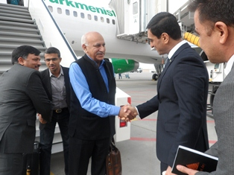
Shri M J Akbar, Hon’ble Minister of State for External Affairs being received at airport on arrival by Mr. Vepa Hajiyev, First Deputy Foreign Minister of Turkmenistan
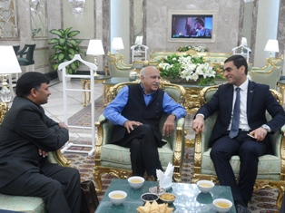
Shri M J Akbar, Hon’ble Minister of State for External Affairs and Mr. Vepa Hajiyev, First Deputy Foreign Minister of Turkmenistan at Ashgabat Airport
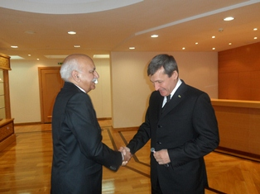

Shri M J Akbar, Hon’ble Minister of State for External Affairs with Mr. Rashid Meredov, Chairman of the Cabinet of Ministers and Foreign Minister of Turkmenistan.

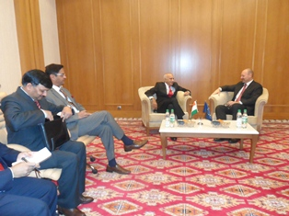
Shri M J Akbar, Hon’ble Minister of State for External Affairs in a bilateral discussion with Mr. Roland Kobia, EU Special Envoy on Afghanistan.

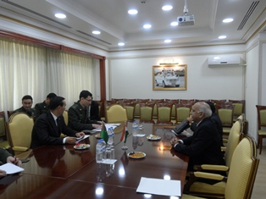

Shri M J Akbar, Hon’ble Minister of State for External Affairs in a bilateral discussion with Colonel General Yailym Berdiyev, Minister of Defence and Secretary, National Security Council of Turkmenistan

