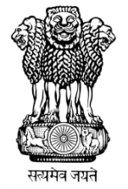 | भारत का राजदूतावास, मिंस्क  EMBASSY OF INDIA, MINSK
Visit of the President of the Republic of Belarus to India (11-12 September 2017)

At the invitation of the President of India, the President of the Republic of Belarus, H.E. Mr. Alexander Lukashenko paid a State visit to India from 11-12 September 2017.
The visit took place in a year when Belarus and India are celebrating 25th anniversary of the establishment of diplomatic relations. During the visit, President Lukashenko held meetings with President Shri Ram Nath Kovind, Vice President Shri Venkaiah Naidu, Prime Minister Shri Narendra Modi and the External Affairs Minister Smt. Sushma Swaraj.

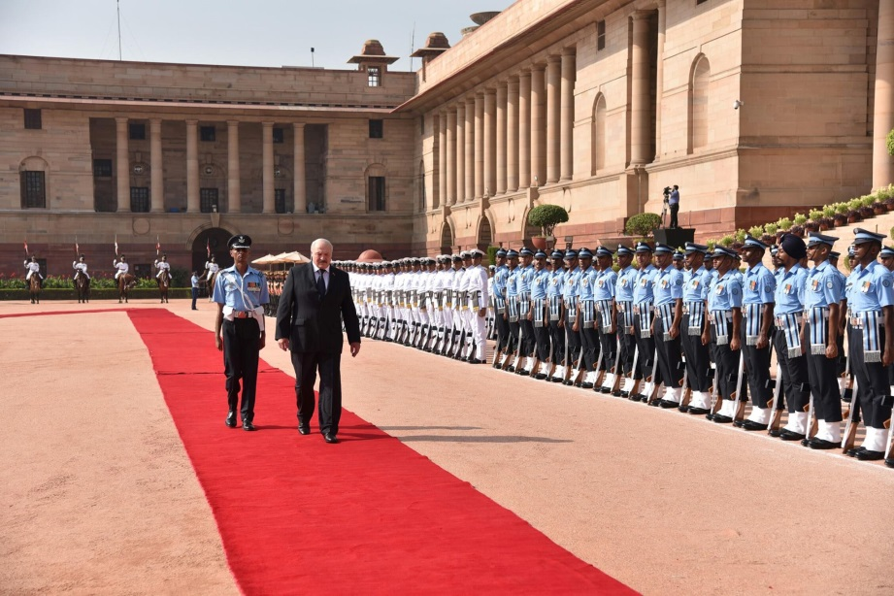
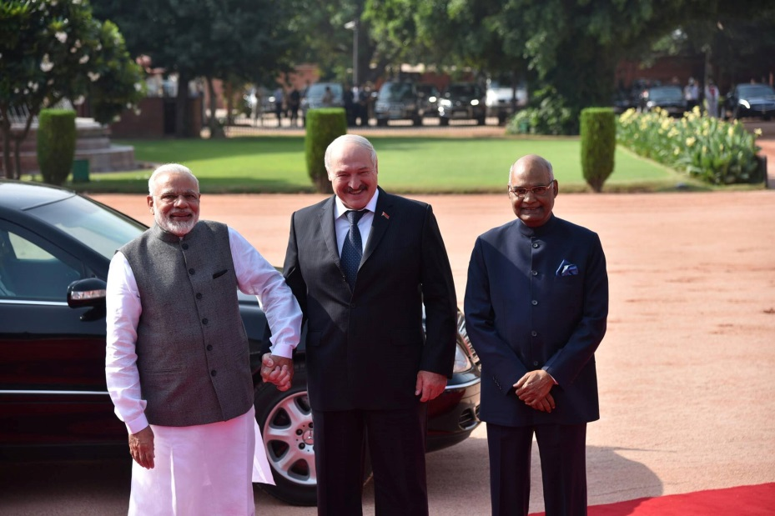
President Alexander Lukashenko of the Republic of Belarus receives ceremonial welcome at the forecourt of Rashtrapati Bhavan on his two day visit to India (11-12 September 2017)

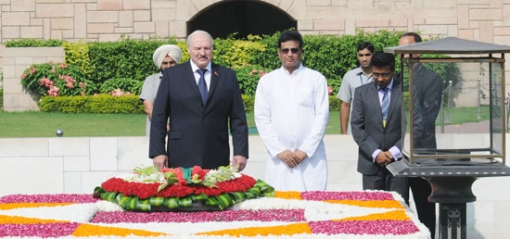
H.E. Mr. Alexander Lukashenko, President of Republic of Belarus pays tribute to Mahatma Gandhi at Rajghat
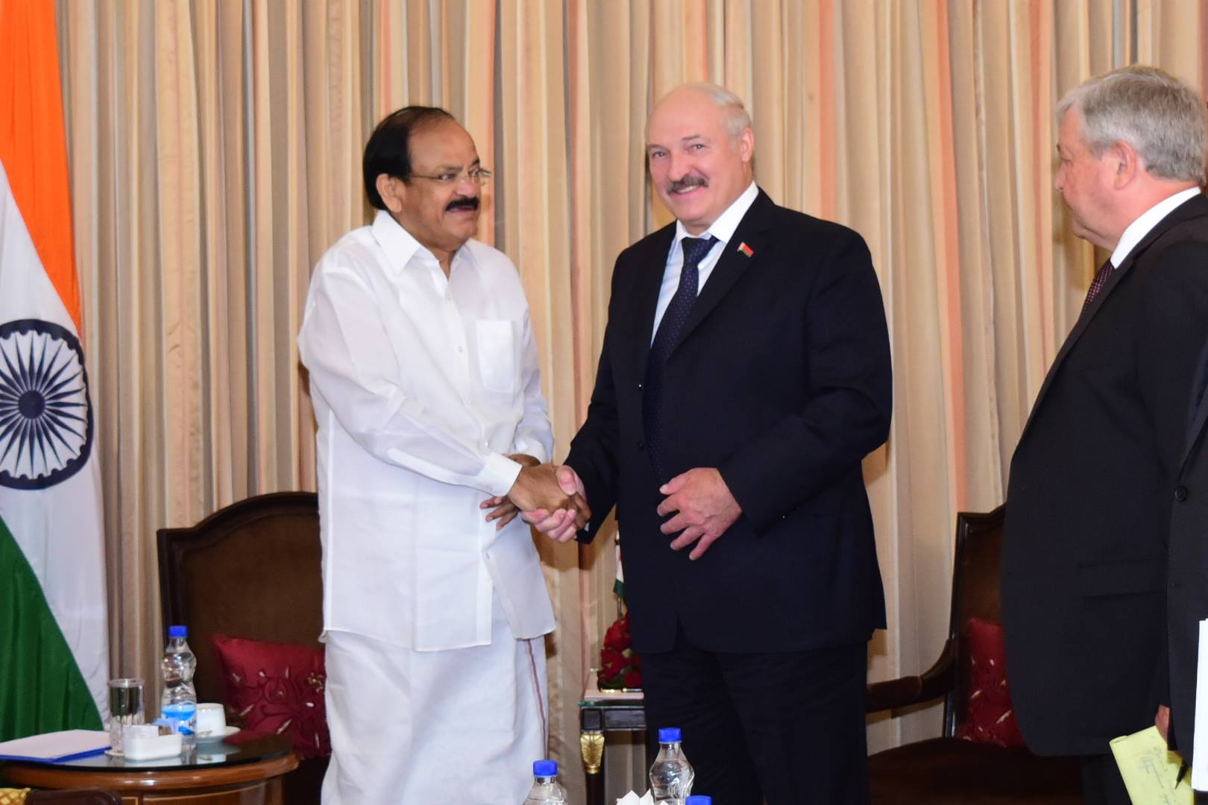
Vice President M Venkaiah Naidu calls on President Alexander Lukashenko on 11 September 2017
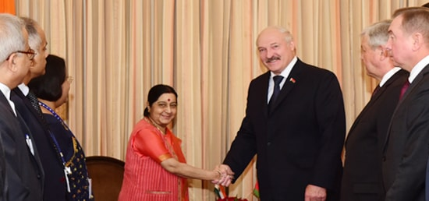
Smt. Sushma Swaraj, Minister of External Affairs of India, calls on H.E. Mr. Alexander Lukashenko, President of Belarus in New Delhi on 12th September 2017
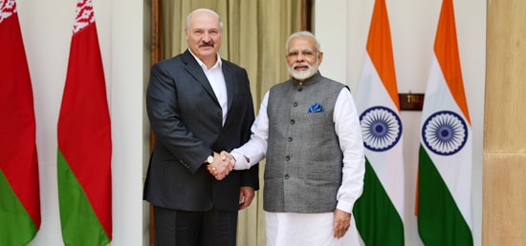
Prime Minister meets Mr. Alexander Lukashenko, President of Belarus at Hyderabad House in New Delhi
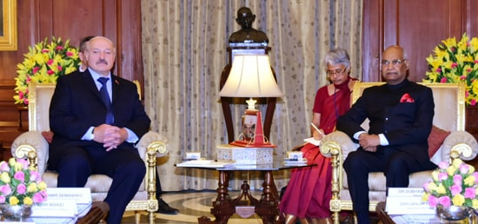
President meets Mr. Alexander Lukashenko, President of Belarus at Rashtrapati Bhavan in New Delhi
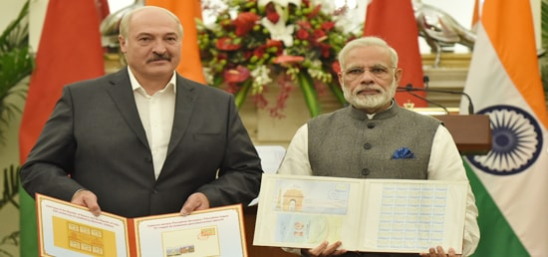
Mr. Narendra Modi, Prime Minister of India and H.E. Mr. Alexander Lukashenko, President of Belarus release Joint Commemorative Postal Stamps in New Delhi

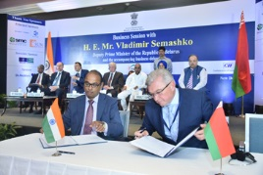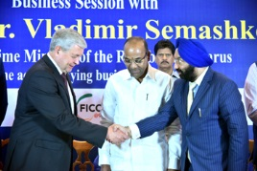
On the sidelines of State visit of Belarusian President, H.E. Alexander Lukashenko, India-Belarus Business Forum was held in New Delhi on 11 September 2017. It was jointly organised by FICCI, CII and ASSOCHAM. The Belarusian Business delegation was headed by the Deputy PM of Belarus, Mr. Vladimir I. Semashko.

**************************************

