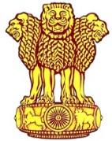 | Embassy of India  Ashgabat | 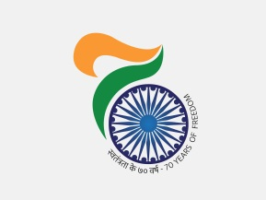

Indian Tennis team emerges victorious at the 5th AIMAG
India clinched 1 Gold, 1 Silver and 2 Bronze on 27th September, the concluding day of the 5th AIMAG at Ashgabat. In Indoor Tennis Men’s Singles Sumit Nagal won gold defeating compatriot Vijay Natarajan. India won two more Bronze medals in Chess. India’s tally of medals at the end of the game reached to 40 including 9 Gold 12 Silver and 19 Bronze.

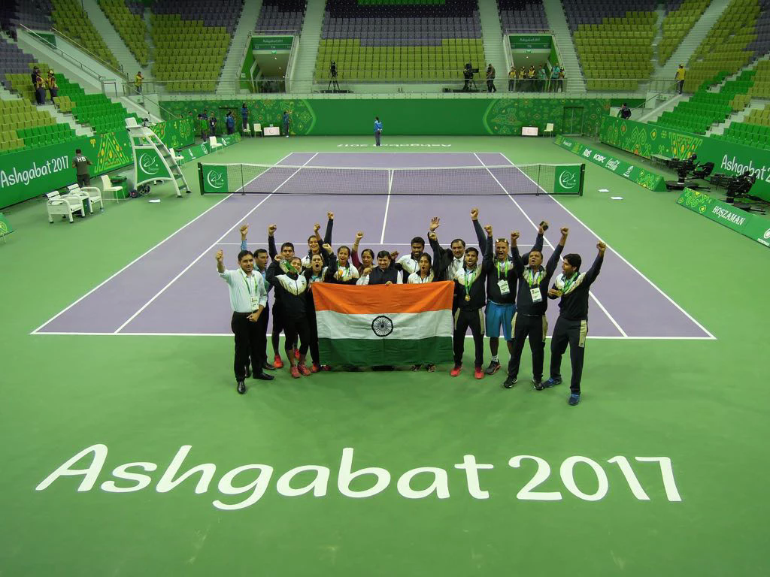

Ambassador of India to Turkmenistan Dr. T V Nagendra Prasad with victorious Indian Tennis Team at AIMAG, 2017 in Ashgabat in which everyone won a medal.

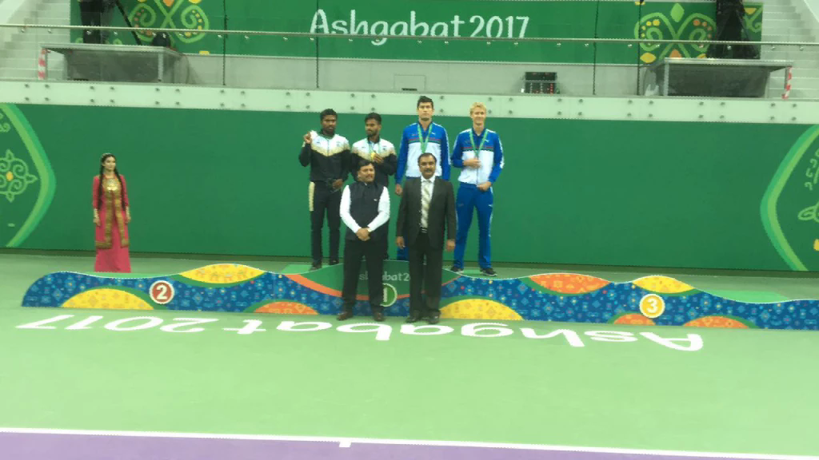
AIMAG 17: Ambassador of India to Turkmenistan Dr T V Nagendra Prasad presented medals to Indoor Tennis Men’s Singles at 5th AIMAG in which Sumit Nagal won gold defeating compatriot Vijay Natarajan

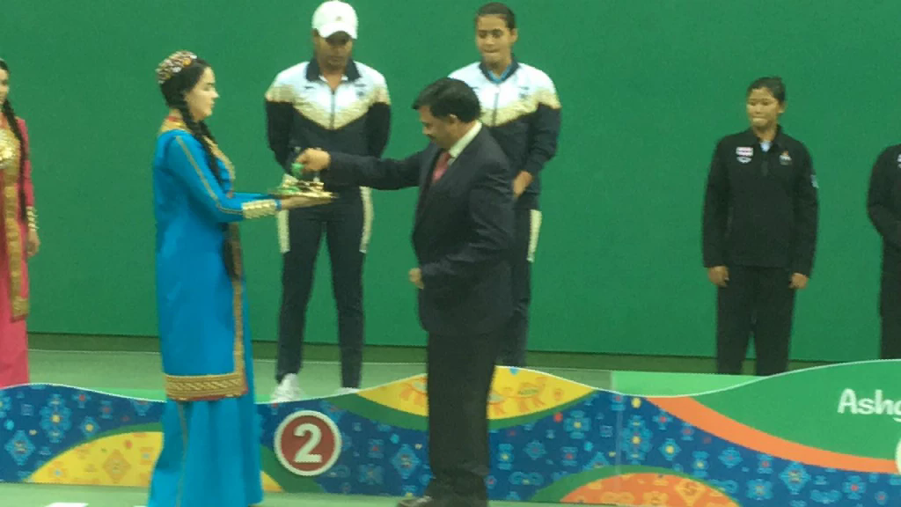
AIMAG 17: Ambassador of India to Turkmenistan Dr T V Nagendra Prasad presenting medals at Indoor Women’s Tennis Doubles in which Indian team won silver medal

