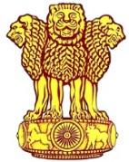 | Embassy of India  Ashgabat | 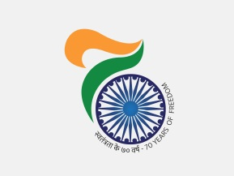

India clinched 1 Gold, 3 Silver and 3 Bronze on penultimate day at 5th AIMAG
Indian clinched 1 Gold, 3 Silver and 3 Bronze on 26th September, 2017. Indian pair of J Vishnuvardhan and Vijay Natarajan won gold in Men’s Doubles Indoor Tennis. Indian pair of Ankita Raina and P Thombare had to settle for silver in Women’s Doubles in tough fight against Thailand team. On the day, India clinched two sliver and 1 bronze in wrestling (Silver for Naveen in Men's Greco-Roman 130 kg and Ravinder Khatri in Men's Greco-Roman -85 kg and Bronze for Gurpreet Singh in Men's Greco-Roman -75 kg) and two Bronze in Chess (Men’s Rapid Team Under-23 and Women’s Rapid Team)
India’s tally of medals, as on 26th September reached to 36 including 8 Gold 11 Silver and 17 Bronze.
***
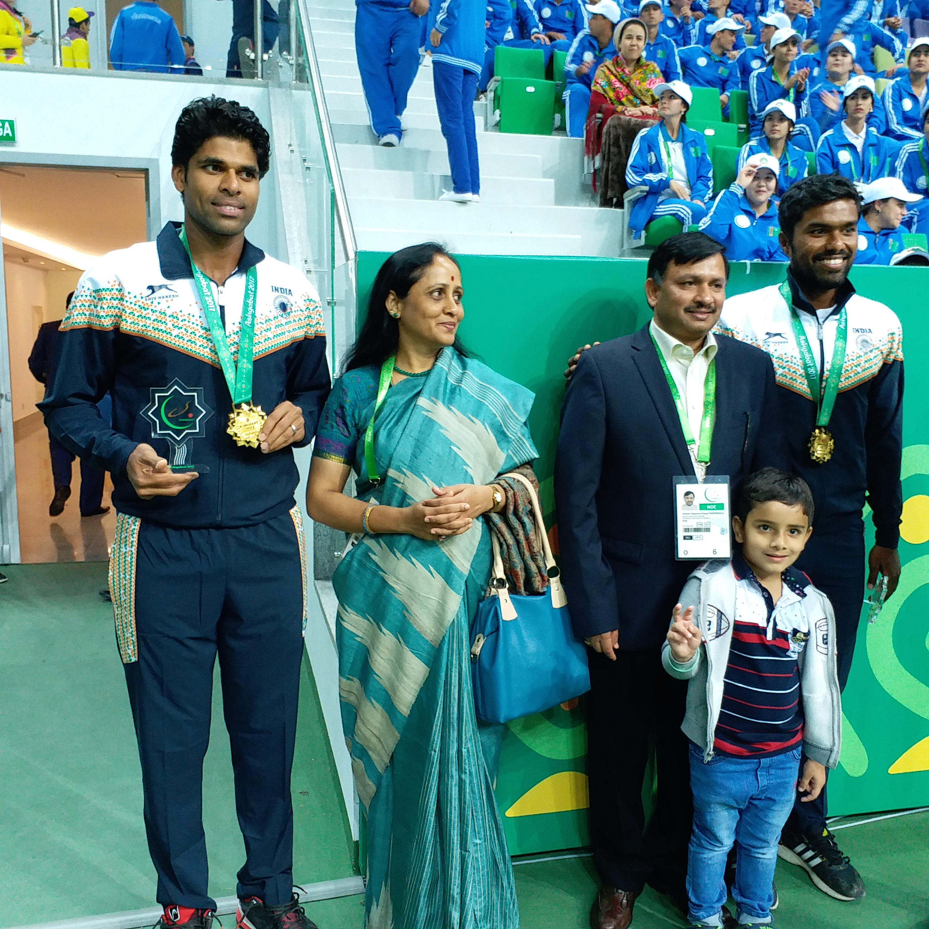
AIMAG 17: J Vishnuvardhan and V Natarajan winners of Men’s Doubles Indoor Tennis with Ambassador of India in Turkmenistan Dr. T V Nagendra Prasad.

