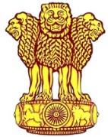 | Embassy of India  Ashgabat | 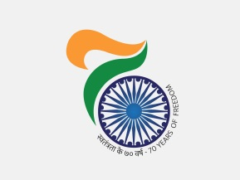

AIMAG 17: India picked up two more gold on 20 September. 17
India clinched two more gold medals on 20th September, 2017. Ajay Kumar Saroj picked gold medal in Men’s 1500 meter and Arpinder Singh picked up gold in Men’s triple jump. Other winners on 20th September were Debrorah Herold (Silver Medal in Women’s sprint track cycling), Neha Solanki (bronze medal in Kurash women’s 87+kgs ) and Jyoti (bronze medal in Kurash women’s -87 kgs.) India’s tally of medals, as on 20th September, 2017 reached to 12 including 5 gold 3 silver and 4 bronze.
***
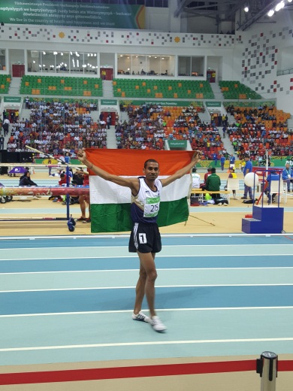
AIMAG 17: Ajay Kumar Saroj winner of Men’s 1500 meters gold medal
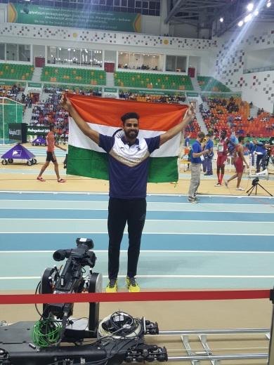
AIMAG 17 Arpinder Singh winner of Men’s triple jump meters gold medal

