 | Embassy of India  Ashgabat | 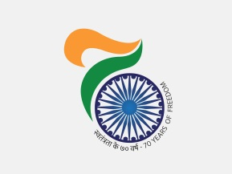

INDIA PHARMA - 2018 & INDIA MEDICAL DEVICE- 2018

Department of Pharmaceuticals, Ministry of Chemicals and Fertilizers Government of India, in association with the Federation on Indian Chambers of Commerce & Industry (FICI) will be organizing the 3rd edition of International Exhibition & Conference on Pharmaceutical & Medical Devices Industry-INDIA PHARMA 2018 & INDIA MEDICAL DEVICE 2018 at Bangalore International Exhibition Centre, Bengaluru, and Karnataka from February 15-17 2018

For more information please refer to website http:/www.indiapharmaexpo.in

***

