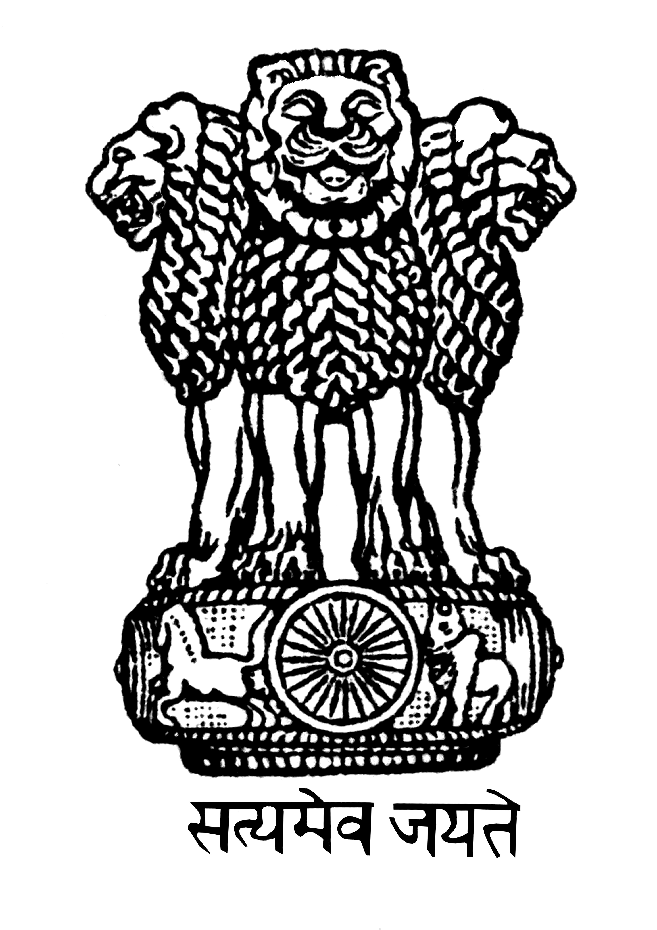

Embassy of India
Minsk

Celebration of 3rd International Day of Yoga in Minsk 2017

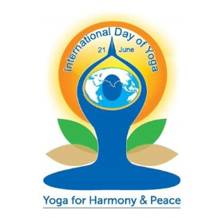

The Third International Day of Yoga was celebrated in Gorki Park in Minsk on Saturday, June 17, 2017 which was attended by senior officials of MFA and other organs of Belarusian Government. There was a sizeable presence of Diplomatic community, Yoga practitioners and lovers, and Indians living in Belarus. This year IDY was also simultaneously held on June 17 in Brest and Vitebsk regions in Belarus with the help of local Yoga groups and local authorities. On June 13, the Mission organized a curtain raiser to give wide publicity to the event.

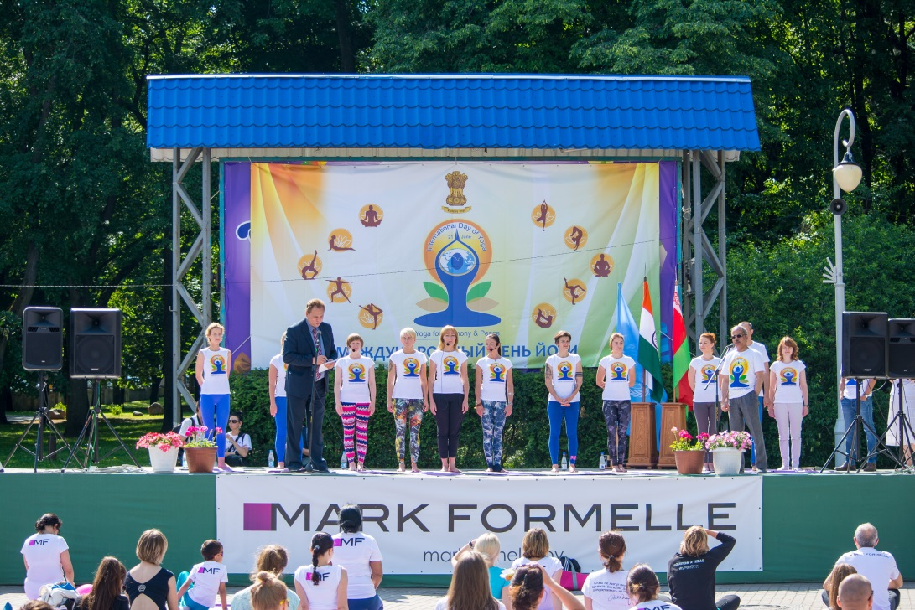

The programme began by short speeches by UNDP Resident Representative Mr. Sanaka Samarasinha and Ambassador Mr. Pankaj Saxena to the gathered audience. Suryanamashkar and various Asanas were performed by the assembled people under the supervision of leaders of ten Yoga groups

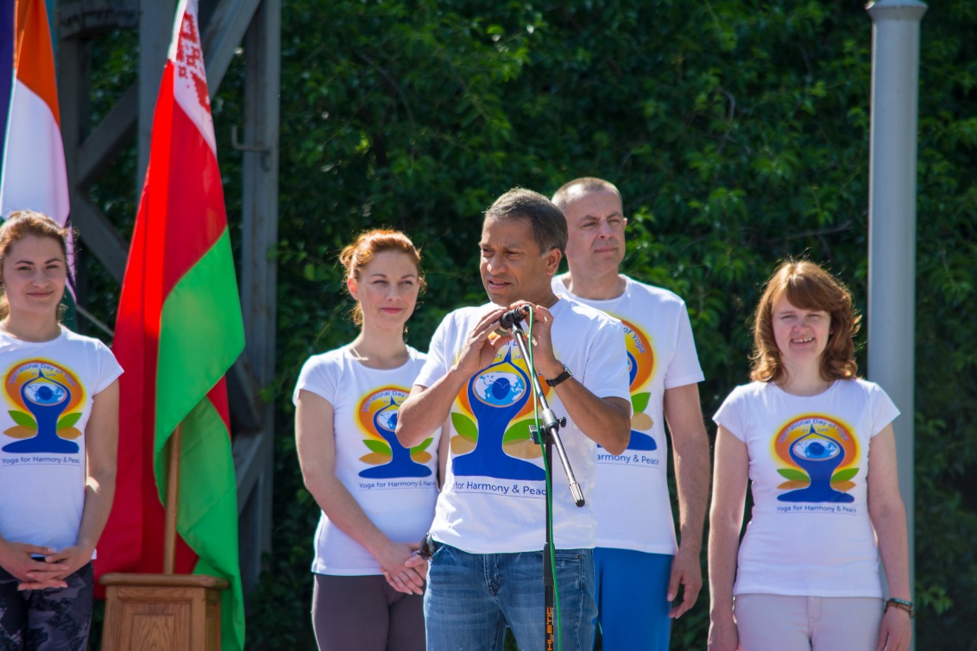

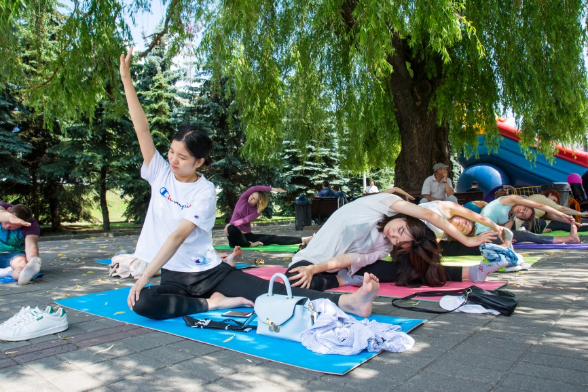

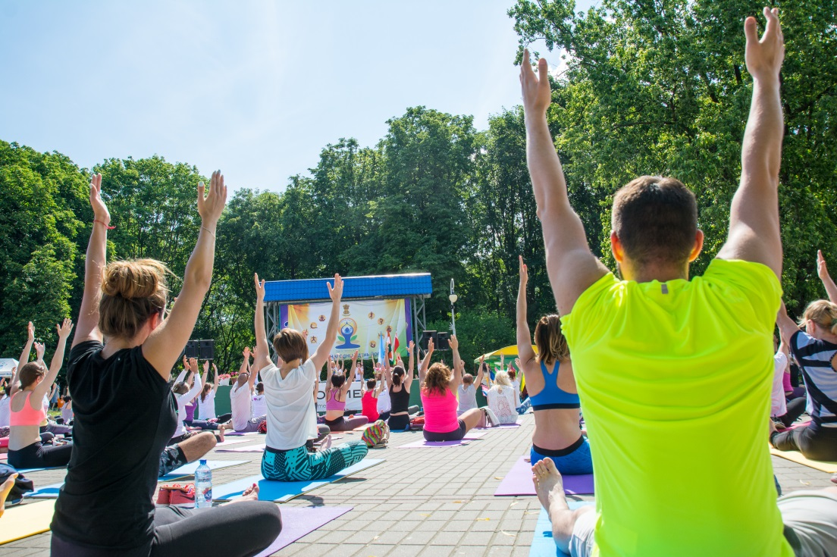

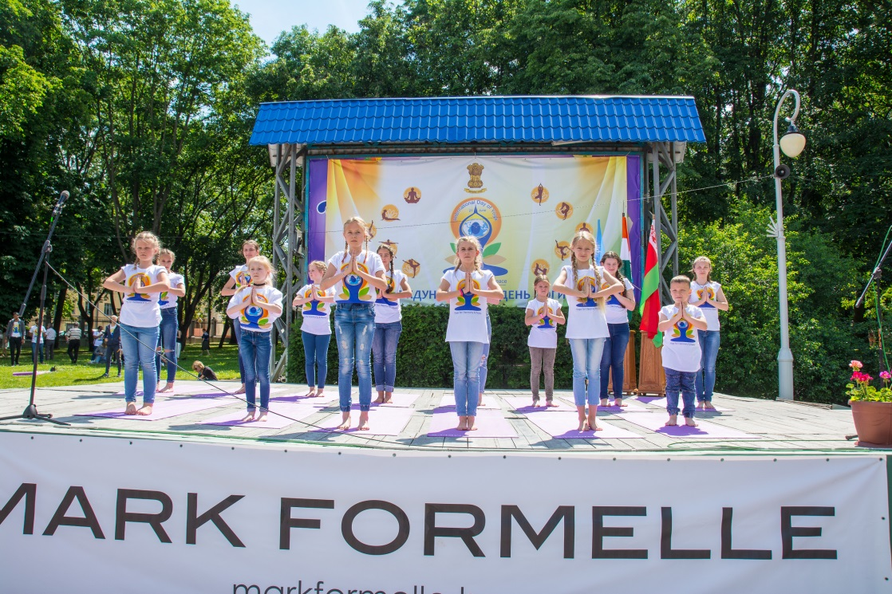

A painting competition, quiz and essay writing were organized by the Mission. The winners were awarded certificates and cash prizes.

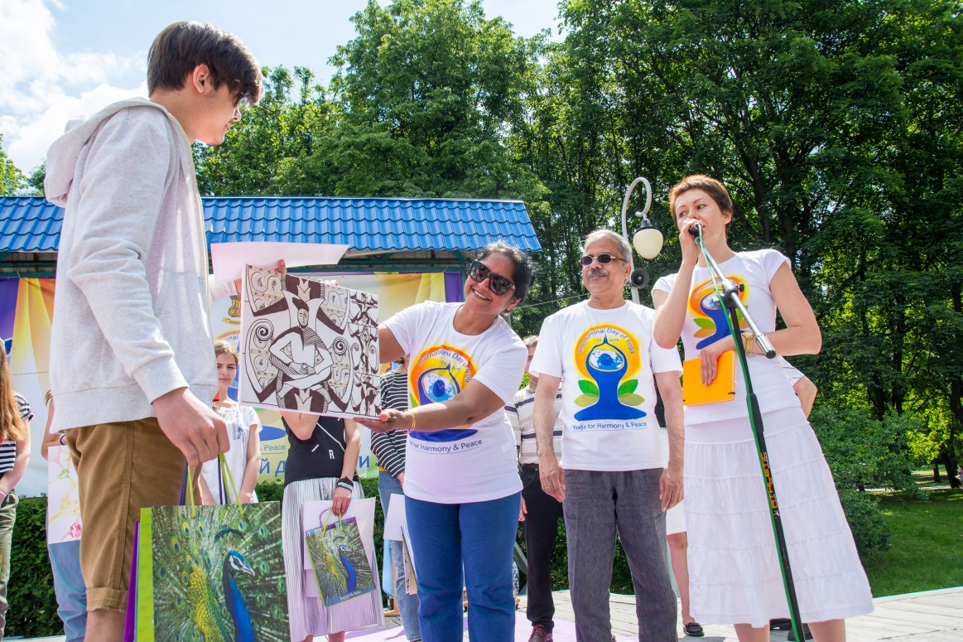

19 June 2017

