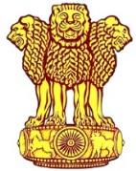 | Embassy of India  Ashgabat | 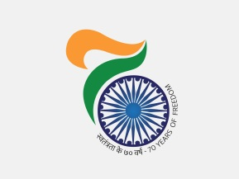

To the run up of the 3rd International Day of Yoga (3rd IDY) Embassy of India organized a quiz titled “Know India” at Ashgabat Yoga Centre on 15th June, 2017. 6 Groups consisting of 4 participants each took part in the lively and learning quiz. Participants were cheered by large number of audiences. Winners are announced who shall be awarded on celebration of 3rd IDY scheduled on 18th June, 2017 at Ashgabat Yoga Centre, Ashgabat.

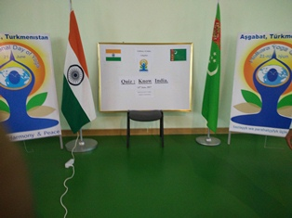

Quiz to the run up of IDY 2017

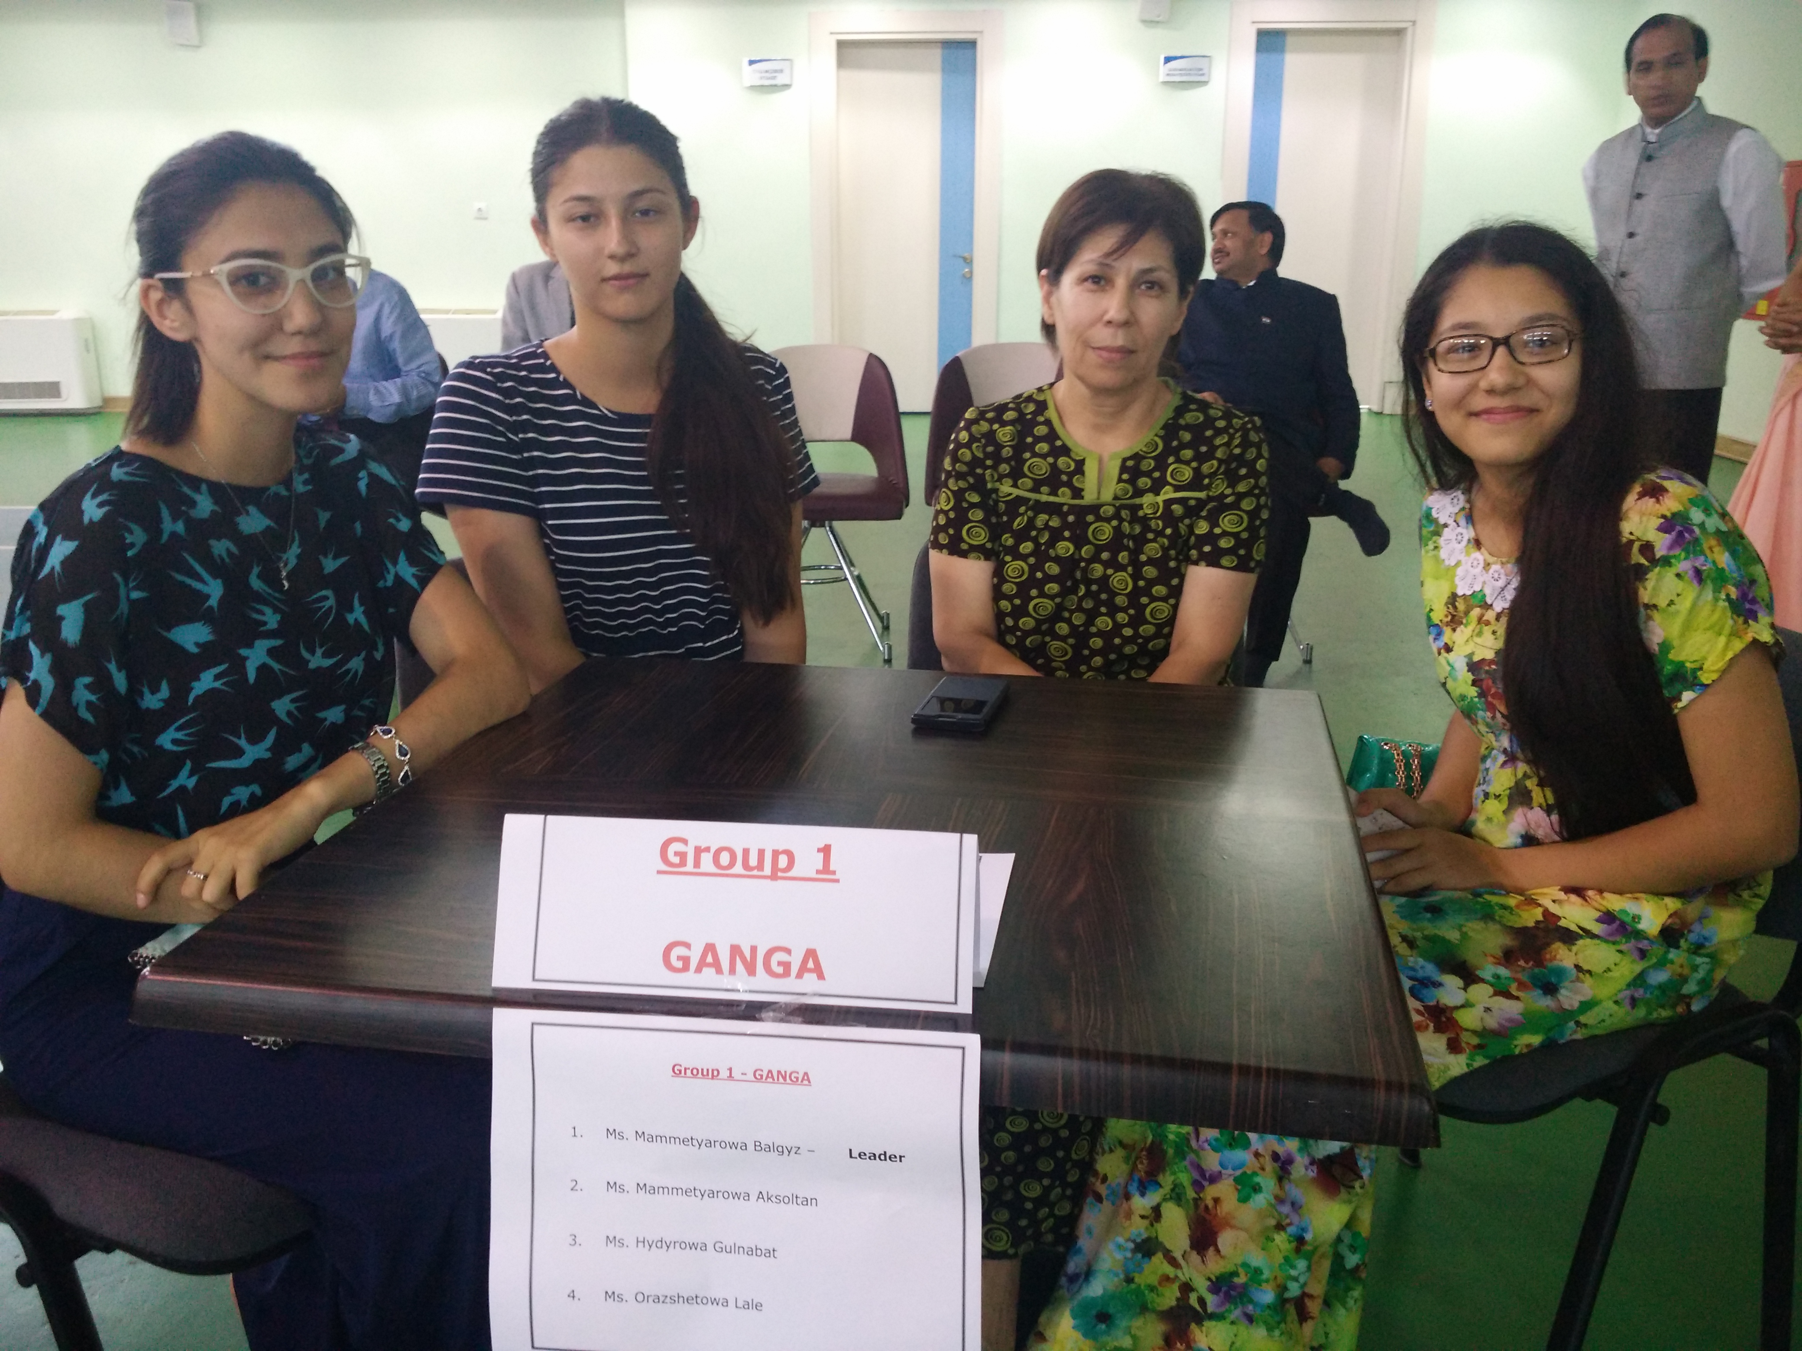

Quiz to the run up of IDY 2017: Participants

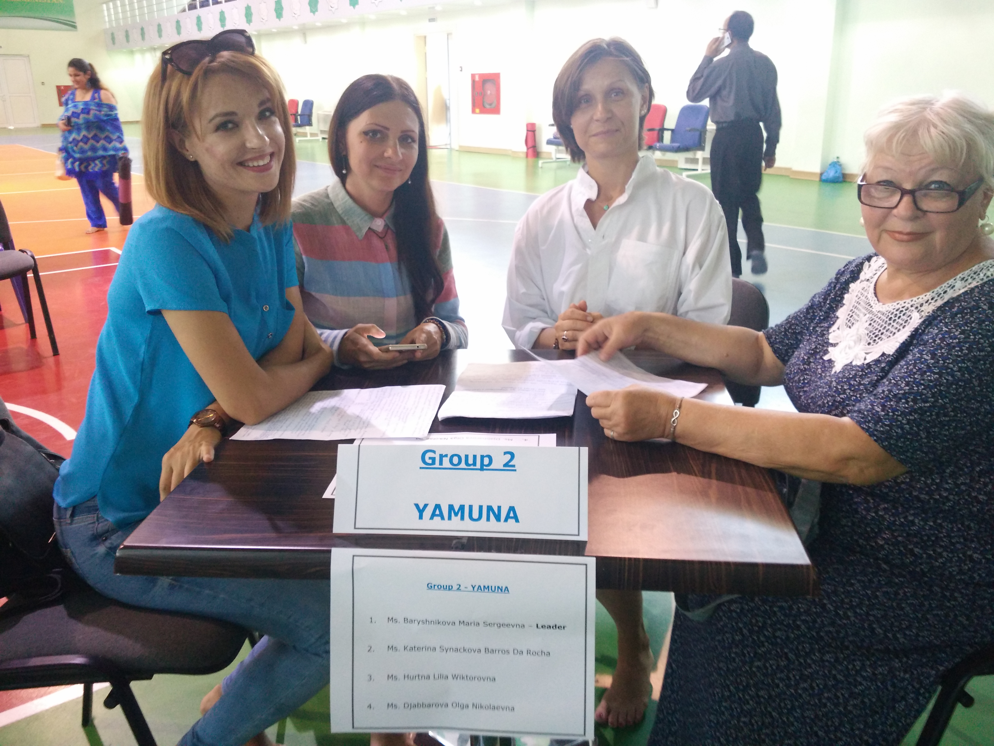

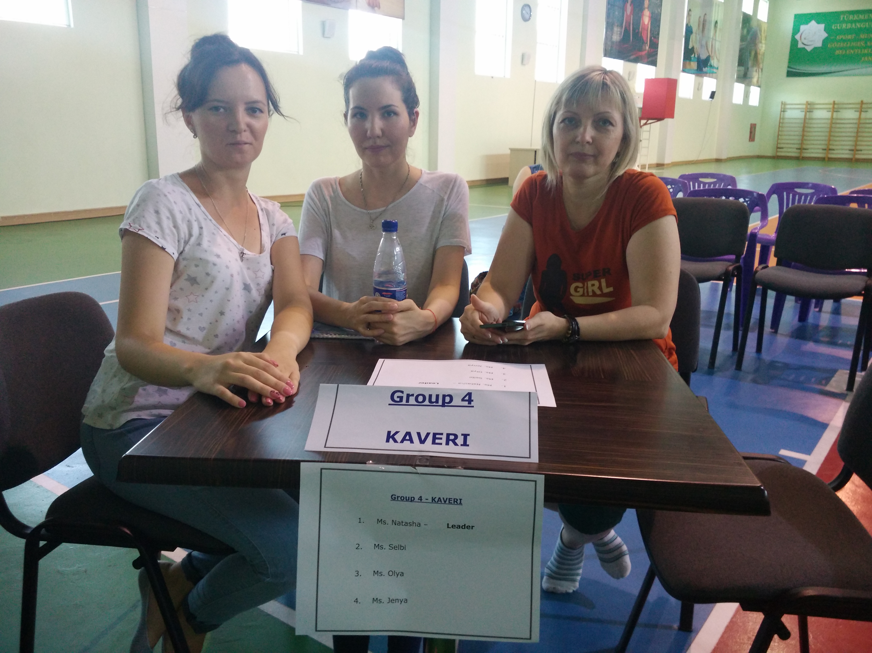

Quiz to the run up of IDY 2017: Participants

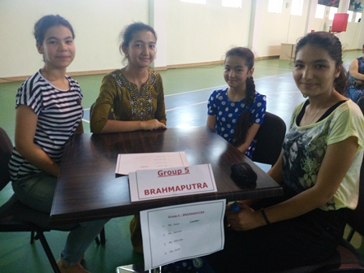

Quiz to the run up of IDY 2017: Participants

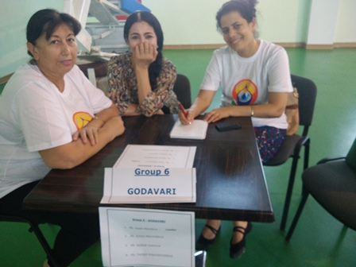

Quiz to the run up of IDY 2017: Participants

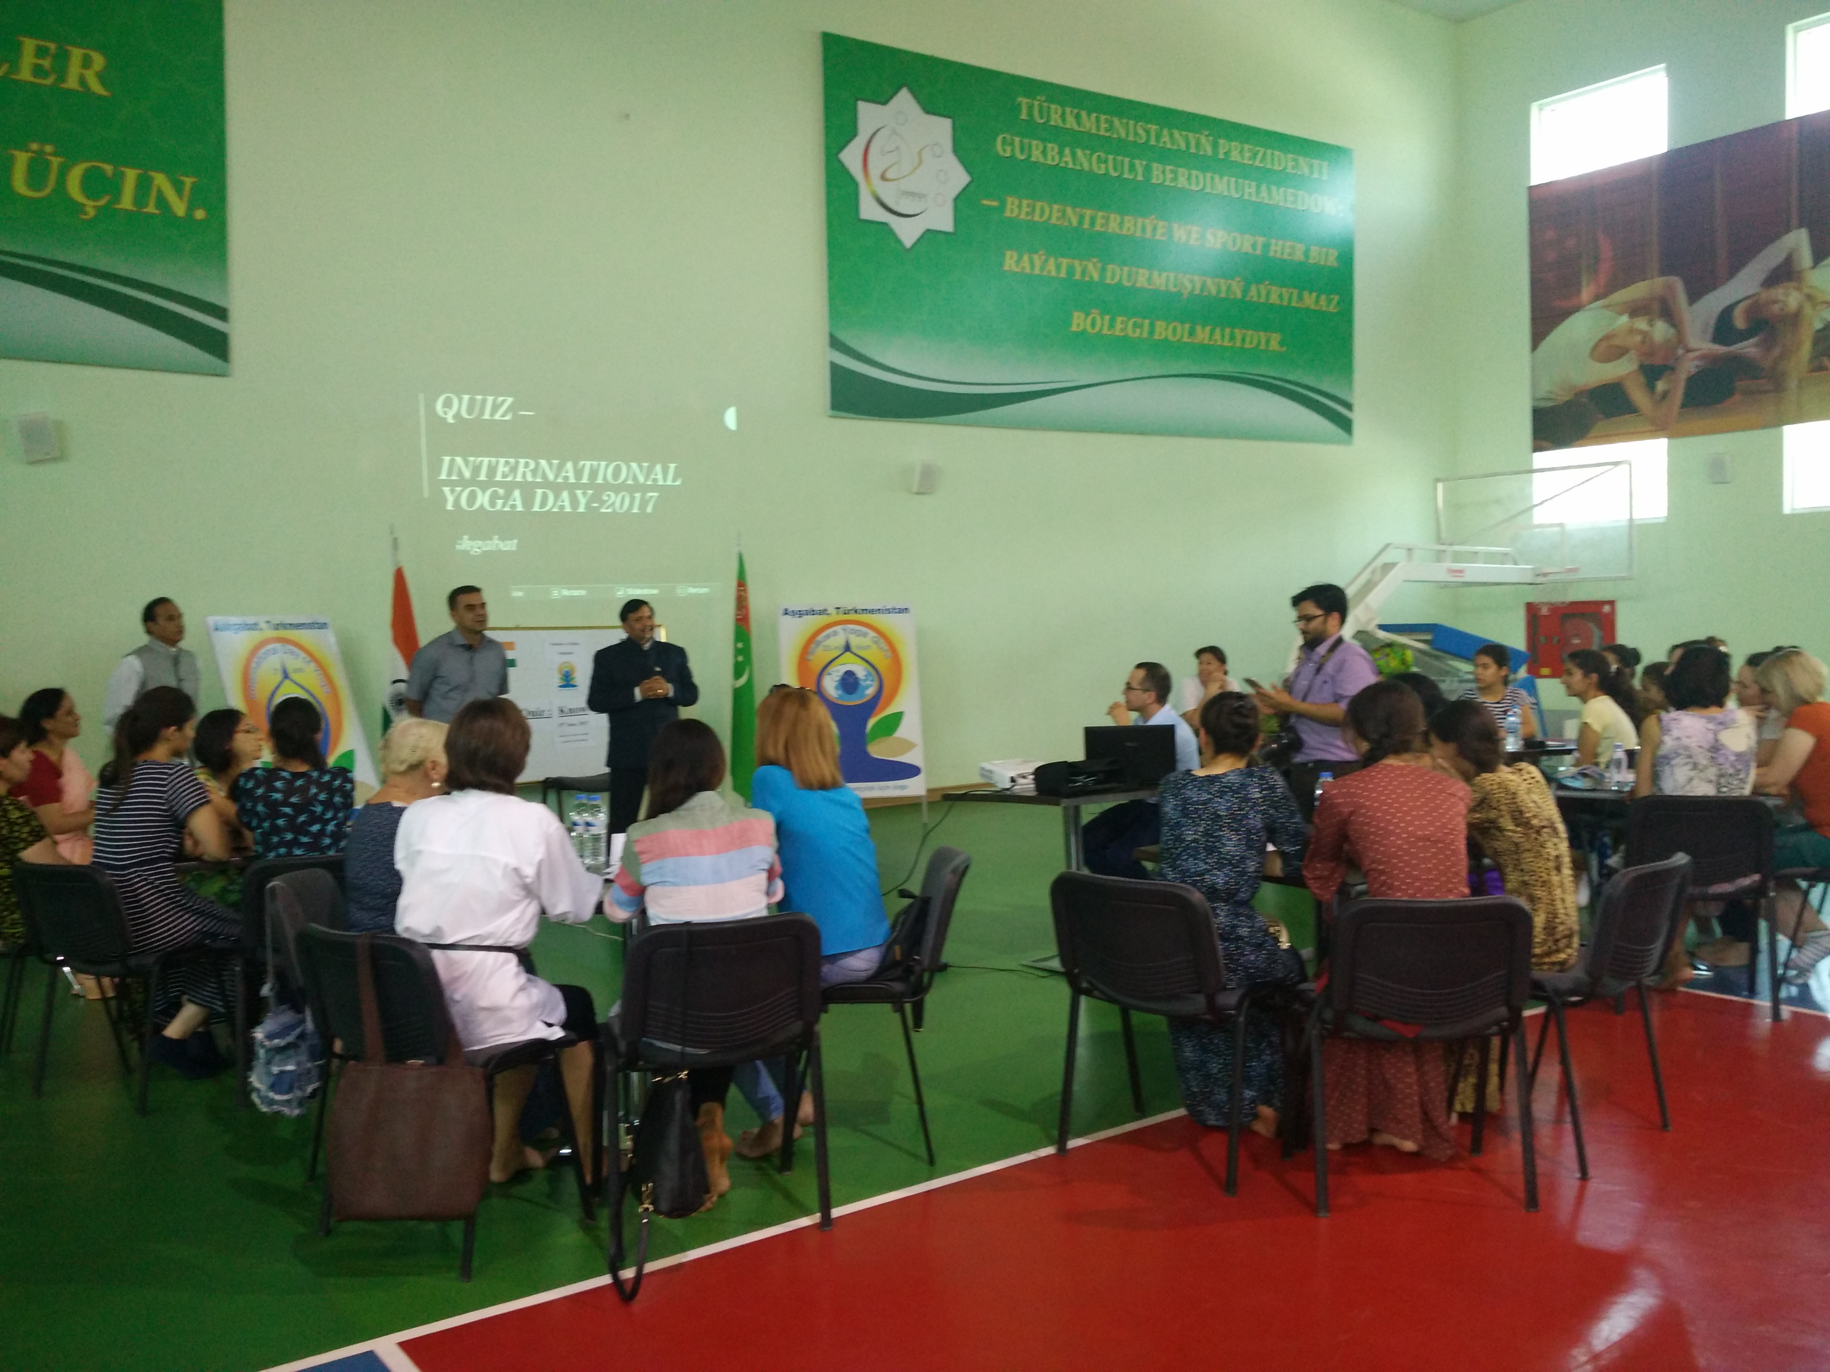

Quiz to the run up of IDY 2017: Ambassador of India to Turkmenistan interacting with participants and audiences
