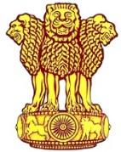 | Embassy of India  Ashgabat | 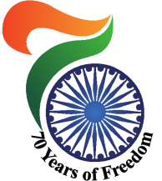

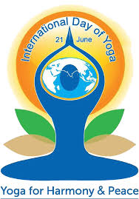
Embassy of India, Ashgabat, in association with the esteemed Government of Turkmenistan, is celebrating 3rd International Day of Yoga, 2017 (IDY 2017) on 18th June, 2017 at Bagtyarlyk Sports Complex.
On this occasion, a Quiz Programme is also being organized on 15th June, 2017 (at1600 hrs) at the Ashgabat Yoga Centre, Bagtyyarlyk Sports Complex, Ashgabat.
Preparation for the IDY 2017 is in full swing.
IDY 2017 Special Practice Sessions

IDY 2017 Special Practice Sessions

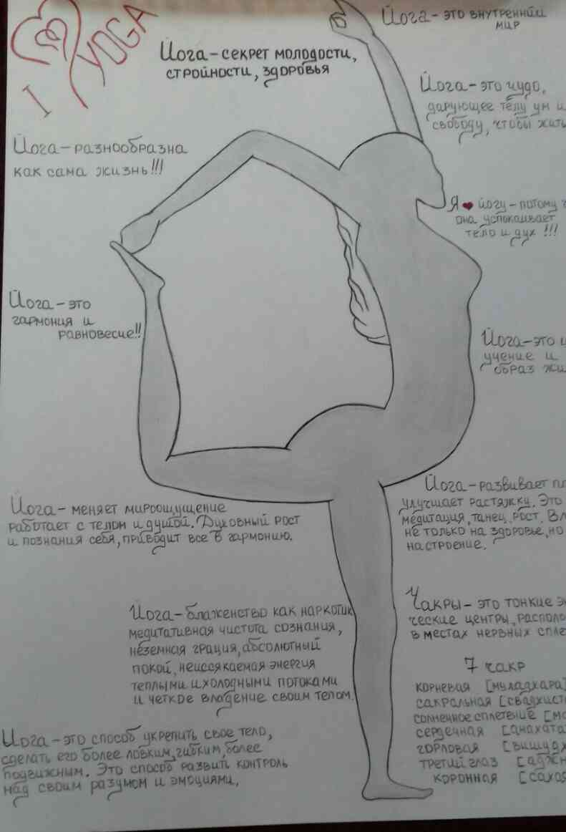
IDY 2017 : A Creative Art by Ms Maya Kurbanova Turkmen Yoga practitioner.

