 | Embassy of India  Ashgabat | 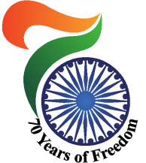

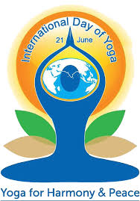
IDY 2017:
Extraordinary response to the essay writing competition
Received entry even from a woman over 70 years of age, expressing her positive experience after joining the Yoga Centre.
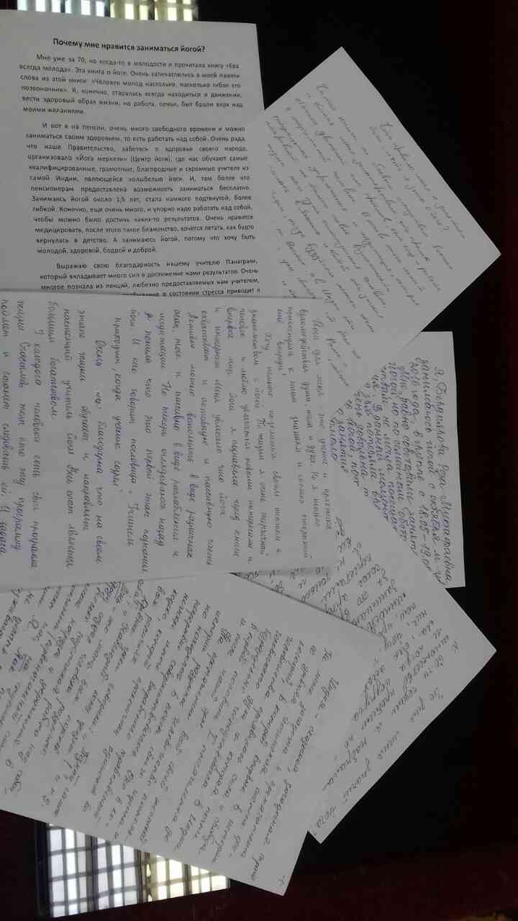
IDY 2017: Responses to the essay writing competition.

