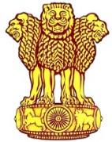 | Embassy of India  Ashgabat | 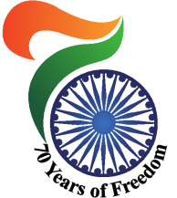

Visit of delegation led by Dr. Arvind Gupta, DNSA & Secretary, NSCS

A four member delegation led by Dr. Arvind Gupta, Deputy National Security Adviser (DNSA) and Secretary, National Security Council Secretariat (NSCS) visited Ashgabat in connection with India-Turkmenistan forum from 29-30 May, 2017. Delegation has fruitful bi-lateral meetings with Turkmen side including meeting Mr. Rashid Meredov – Deputy Prime Minister for Foreign Affairs of Turkmenistan.

During the meeting, the participants exchanged views on a number of key issues of regional and international character. Both sides analyzed the current situation with security in the region. Security challenges such as extremism, regional stability and security, cooperation in the field of cyber security, combating illicit drug trafficking and smuggling have also been discussed.
***
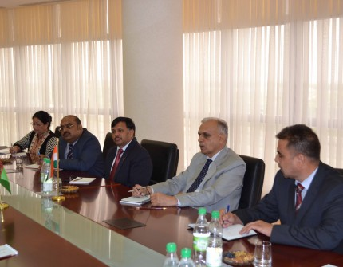
Indo Turkmen Consultations : Indian Delegation led by Dr. Arvind Gupta, DNSA & Secretary NSCS.

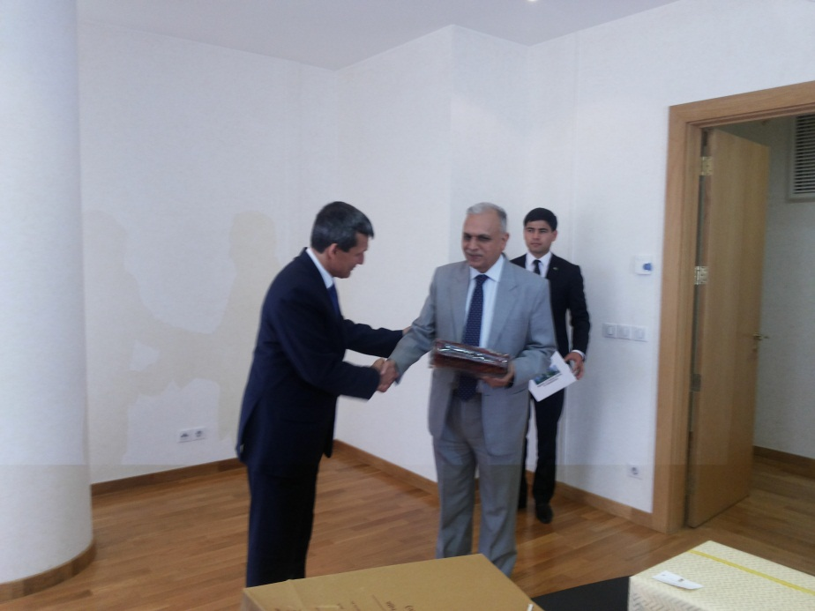
Dr. Arvind Gupta, DNSA & Secretary NSCS being welcomed by Mr. Rashid Meredov – Deputy Prime Minister for Foreign Affairs of Turkmenistan
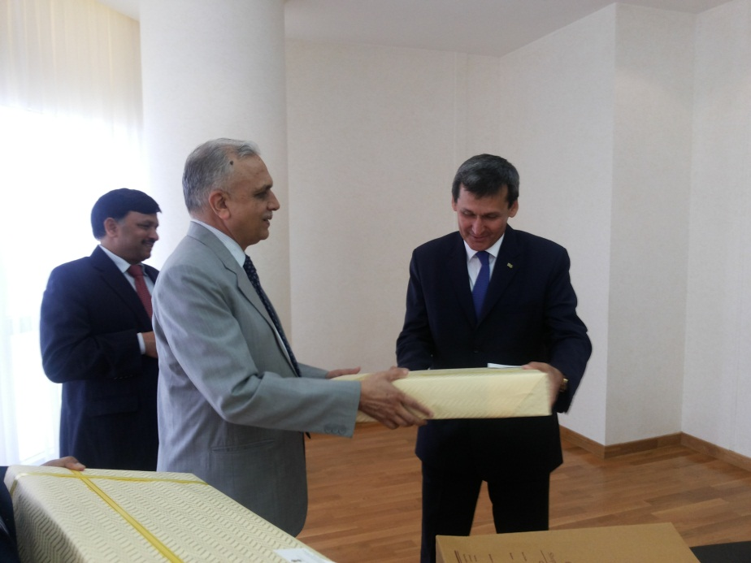

Dr. Arvind Gupta, DNSA & Secretary NSCS with Mr. Rashid Meredov – Deputy Prime Minister for Foreign Affairs of Turkmenistan

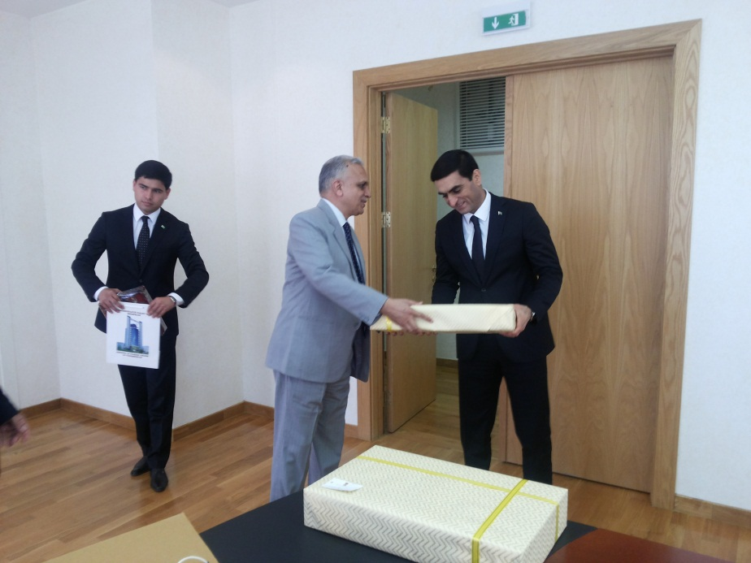

Dr. Arvind Gupta, DNSA & Secretary NSCS– with Mr Wepa Hajiyev Deputy Minister for Foreign Affairs of Turkmenistan
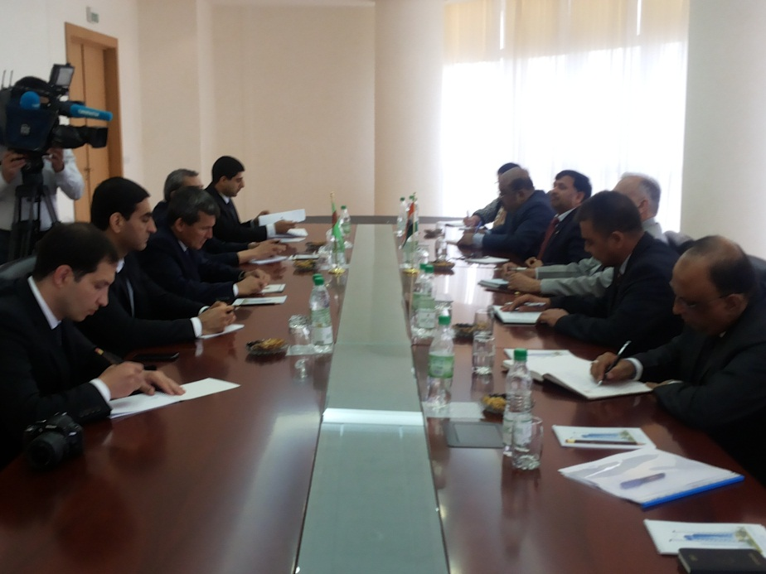

Bi-lateral Meeting at Ministry of Foreign Affairs of Turkmenistan

