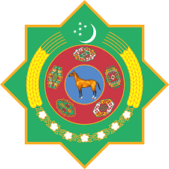 | 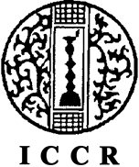 | 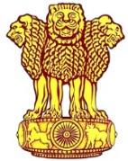
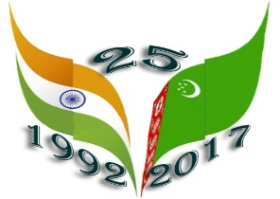
Embassy of India
Ashgabat

Food Festival in Ashgabat
Thursday, April 20, 2017 marked the 25th Anniversary of the Diplomatic Relations between India and Turkmenistan. To mark the occasion Embassy of India in Ashgabat, in association with Ministry of Culture, Government of Turkmenistan, and Indian Council for Cultural Relations (ICCR), Ministry of Tourism, Government of India, India Tourism Office, Frankfurt announced the organization of “Indian Cultural Week” from 16th May, 2017 to 23rd May, 2017.
Series of events began with inauguration of exhibition titled “Vastram: Splendid World of Indian Textiles” followed by performance by Bollywood Group “Dance Era” on 17th and 18 May, 2017 and film festival at Ashgabat kono theater on 19-21 May, 2017.
The culminating event of the week was Food Festival hosted by the Embassy, in collaboration with India Tourism Office, Frankfurt and Ministry of Tourism, Government of India. The food festival was organized at Yyldyz hotel in Ashgabat on 22nd May, 2017. Mr. Vepa Hajiyev, the Deputy Minister for Foreign Affairs was the chief guest of the occasion from Turkmen government. H.E Dr. T V Nagendra Prasad, while welcoming the guests, briefed on rich tradition and diversity in Indian cuisines. A team of culinary experts led by a Master Chef, who has served at Rashtrapati Bhawan, prepared a vast array of authentic Indian dishes for the guests which were highly appreciated by the guests The popularity of Indian food was felt with the comments of guests.
A “Food (Cooking) Demonstration” was also organized on 23rd May, 2017 at Yyldyz hotel demonstrating, to an enthusiastic crowd over 40 including local Turkmen , members of diplomatic community. The initiative first of its kind in Turkmenistan was highly appreciated.
***
