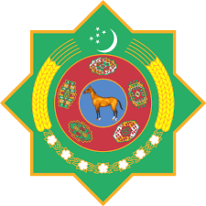 |  | 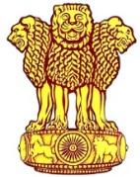
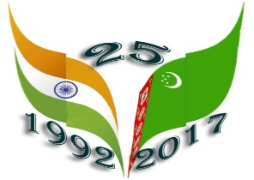
Embassy of India
Ashgabat

Performance by Bollywood Group Dance Era
Thursday, April 20, 2017 marked the 25th Anniversary of the Diplomatic Relations between India and Turkmenistan. To mark the occasion Embassy of India in Ashgabat, in association with Ministry of Culture, Government of Turkmenistan, and Indian Council for Cultural Relations (ICCR), Ministry of Tourism, Government of India, India Tourism Office, Frankfurt and announced the organization of “Indian Cultural Week” from 16th May, 2017 to 23rd May, 2017.
Series of events began with inauguration of exhibition titled “Vastram: Splendid World of Indian Textiles” followed by performance by Bollywood Group “ Dance Era” at Turkmenistan Kino theater , Ashgabat on 17th May, 2017 (1830 hrs. ). The group is sponsored by Indian Council for Cultural Relations.
The event was started with lighting of traditional lamp by Mrs. Bahargul Abdiyeva, Deputy Minister in Ministry of Culture, Government of Turkmenistan and H. E Dr. T V Nagendra Prasad, Ambassador of India to Turkmenistan.
The kino theater was packed to the capacity attended by Heads of Foreign Missions, Members of Diplomatic Community, officials of the Embassy and their family members, Officials of the Government of Turkmenistan and local Citizens. Dance Era performed dance drama on the theme of “Grand Indian wedding”. All were mesmerized by the splendid performance by the group on the popular Bollywood tunes. The programme was concluded with a short dance session involving spectators.
In continuation to the series of events during India cultural week, second performance by the ICCR sponsored Bollywood Dance Group “Dance Era” was at Watan Kino theater , Ashgabat on 18th May, 2017 (1830 hrs. ).
Like the previous show the performance at the Watan Kino Theater attracted the audience from all walks of like which included Heads of Foreign Missions, Members of Diplomatic Community, officials of the Embassy and their family members, Officials of the Government of Turkmenistan and local Citizens. Kino theatre was packed to the capacity. The performance based on Bollywood tunes sets on the theme “Grand Indian Wedding was splendid and received standing ovation on many occasions.
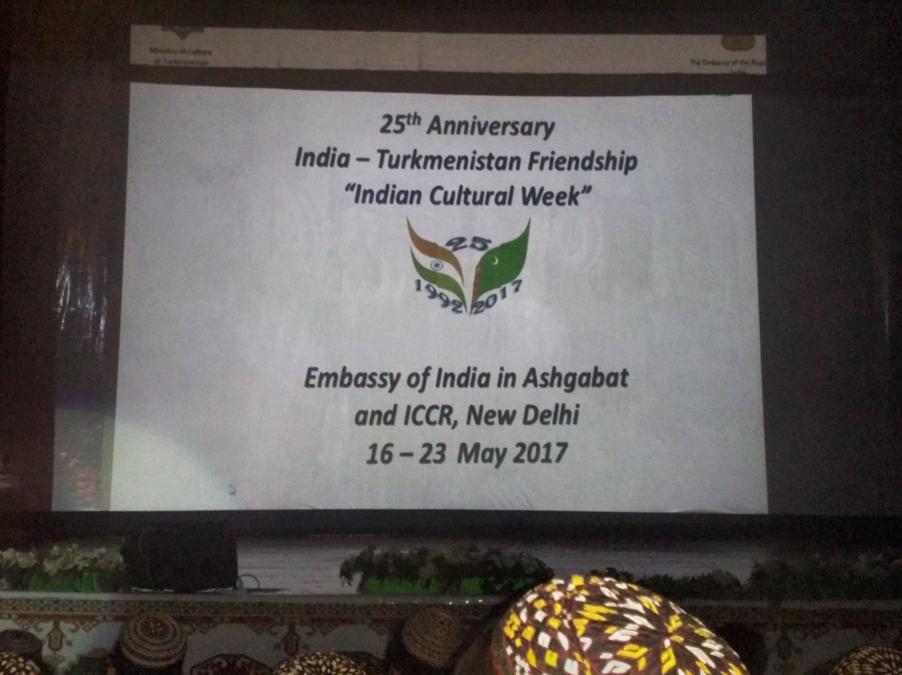
Indian Culture Week in Ashgabat 16-23 May, 2017
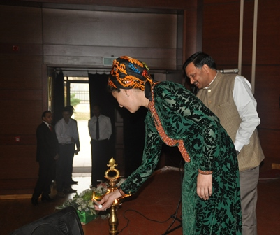
Performance by Bollywood Group Dance Era at Turkmenistan Theatre on 17th May, 2017: Inauguration
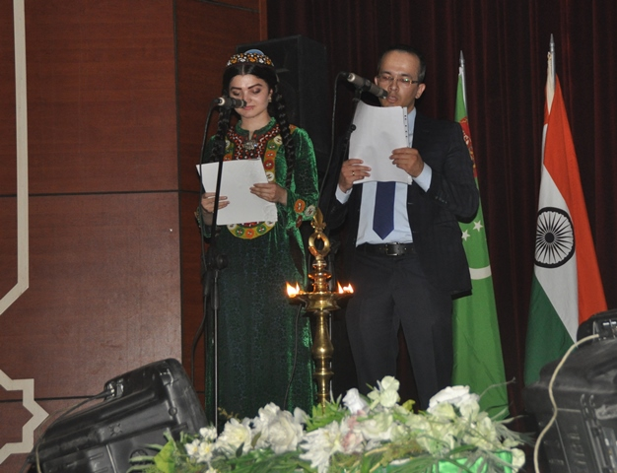

Performance by Bollywood Group Dance Era at Turkmenistan Theatre on 17th May, 2017: Introduction to the Programme
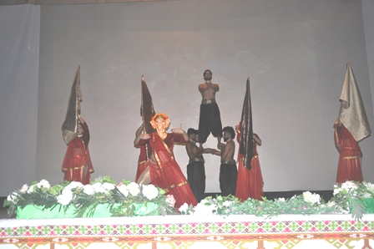
Performance by Bollywood Group Dance Era at Turkmenistan Theatre on 17th May, 2017

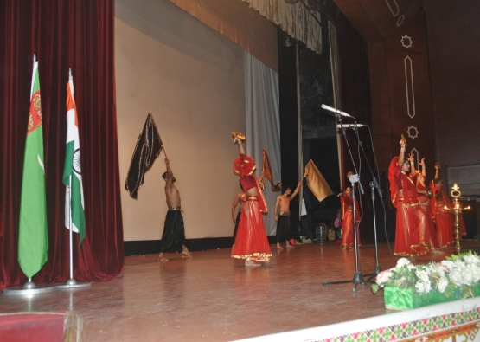

Performance by Bollywood Group Dance Era at Turkmenistan Theatre on 17th May, 2017
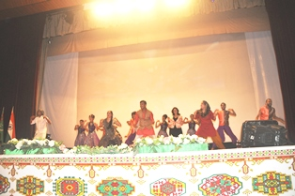
Performance by Bollywood Group Dance Era at Turkmenistan Theatre on 17th May, 2017
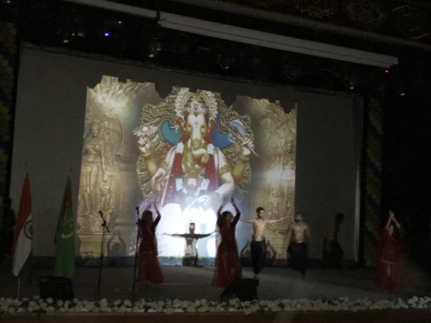
Performance by the ICCR Sponsored Bollywood them Group Dance Era on 18th May, 2017 at Watan Kino Theater , Ashgabat

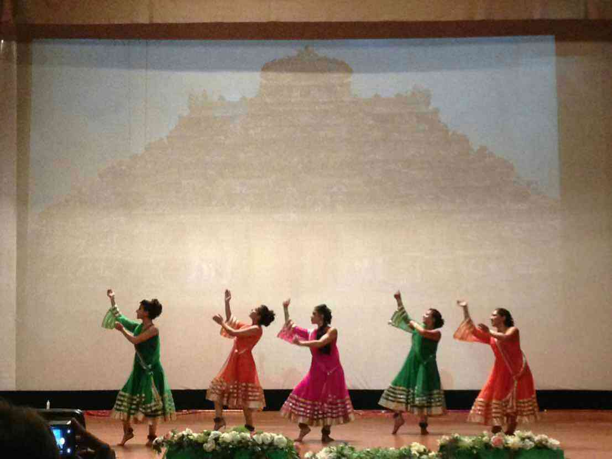
Performance by the ICCR Sponsored Bollywood them Group Dance Era on 18th May, 2017 at Watan Kino Theater, Ashgabat

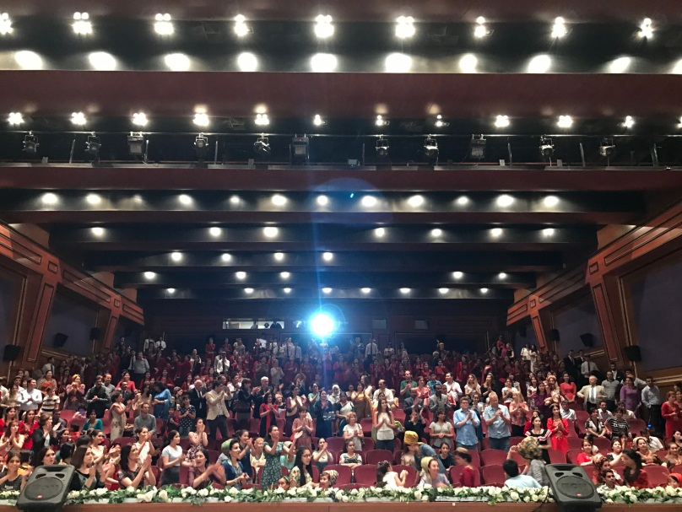
Performance by the ICCR Sponsored Bollywood them Group Dance Era on 18th May, 2017 at Watan Kino Theater , Ashgabat; Standing ovation by the Audience.

