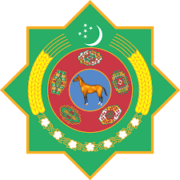 | 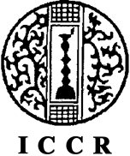 | 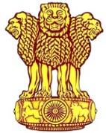
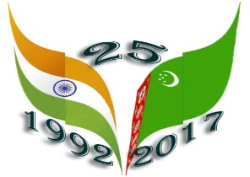
Embassy of India
Ashgabat
“Vastram” Splendid World of Indian Textiles
Thursday, April 20, 2017 marked the 25th Anniversary of the Diplomatic Relations between India and Turkmenistan. To mark the occasion Embassy of India in Ashgabat, in association with Ministry of Culture, Government of Turkmenistan, and Indian Council for Cultural Relations (ICCR), Ministry of Tourism, Government of India, IndiaTourism Office, Frankfurt and announced the organization of “Indian Cultural Week” from 16th May, 2017 to 23rd May, 2017.
The series of events began with inauguration of exhibition titled “Vastram: Splendid World of Indian Textiles” at 1000 hrs. on Tuesday, 16th May, 2017 at Museum of Fine Arts, Ashgabat. The exhibition till 19th May, 2017. The exhibition is sponsored by Indian Council of cultural relations.
The event was started with lighting of traditional lamp. Hosting the event Mr. Saparmemmet Merdov thanked Embassy of India for such a lively display of Indian Textiles and described the event as close relation between India and Turkmenistan. Addressing the guests, H E Dr. T V Nagendra Prasad elaborated the events scheduled for celebration of 25th Anniversary of diplomatic relations between two friendly countries. He also informed that cotton and carpets are two ancient links to Indo –Turkmen relations. Dr. Prasad further informed that the textile traditions of India are varied, vibrant and rich both in their history, texture, colour etc. It is remarkable that these traditions are shared to a very large extent between Indian and other neighborhood countries.
The event was well attended by Heads of Foreign Missions, Members of Diplomatic Community, Students of Museum of Fine Arts and officials of the Embassy and their family members. The inauguration event was highlighted by presentation on the displayed items, Video showcasing rich traditions of Indian costumes and Indian and Turkmen ladies brightly attired in Sarees, the traditional Indian costume. The event was further elaborated by visiting ladies learning to wear sarees. The event was well appreciated by all the visiting guests.
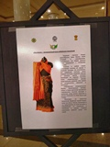
Vastram Exhibition at Museum of Fine Arts, Ashgabat from 16th May, 2017 to 19th May, 2017
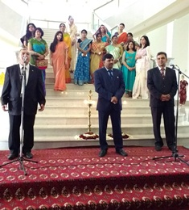
Vastram Exhibition: Inauguration
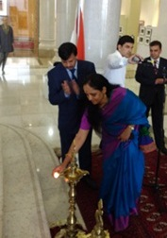
Vastram Exhibition: lighting of Lamp
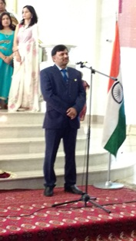
Vastram Exhibition: Inaugural Exhibition by Ambassador of India to Turkmenistan, Dr. T V Nagendra Prasad

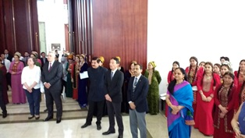
Vastram Exhibition: Guests at Inauguration ceremony
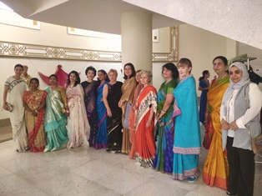
Vastram Exhibition: Indian and Turkmen Ladies in Sarees

