Embassy of India
Ashgabat

Film Festival: Indian Filmy Days at Ashgabat from 25th to 28th February, 2017
Under the Publicity initiative, Embassy of India Ashgabat, in association with Ministry of Culture, Turkmenistan, is organizing the film festival titled “Indian Filmy Days” from 25th to 28th February, 2017 at Ashgabat Theater. The Theater located in heart of the city and has sitting capacity of 500.
The event was inaugurated by H. E. Dr. T V Nagendra Prasad , Ambassador of India to Turkmenistan on 25th February, 2017 at 1900 hrs., in presence of Mr. Eresh Saparovich, Deputy Director in the Cinema Division of Ministry of Culture.
The entry to the films shows is free. Turkmen are fond of Bollywood movies and therefore, as expected the shows are full to the capacity. Apart from the Local Turkmen, members of diplomatic community, including several Ambassadors and foreign national residing in Ashgabat attended the inauguration ceremony and film shows.
Incredible India Posters and publicity materials were distributed.
***
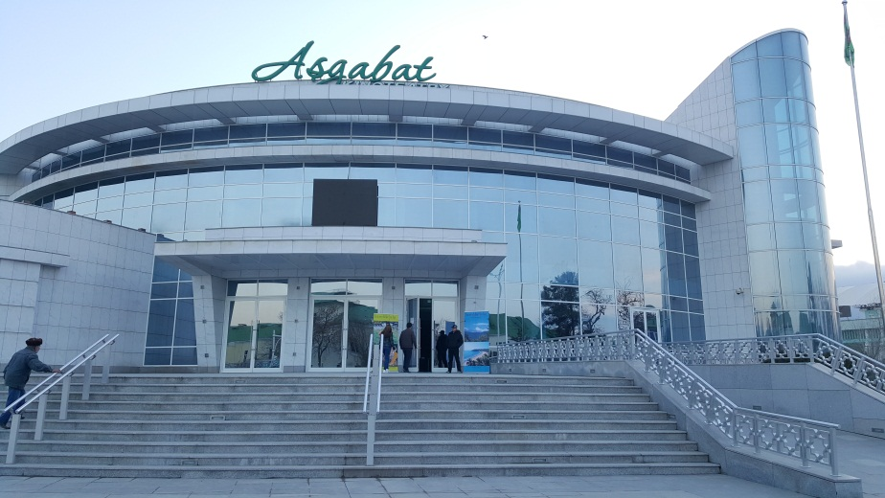
Ashgabat Kinotheatre : Venue of the Film Festival
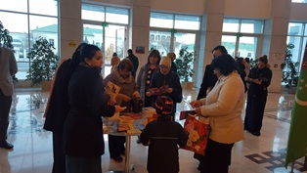
Film Festival “Indian Filmy Days”: Display of Publicity Booklets
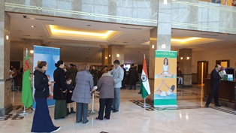
Film Festival “Indian Filmy Days”
Film Festival “Indian Filmy Days”: Enjoying the movie

