EMBASSY OF INDIA

***
Diplomat’s Day 2017
The Ministry of Foreign Affairs of Turkmenistan organized Diplomat’s Day on February 18th, 2017 at the foyer of the Institute of International Relations Ashgabat. Various Diplomatic Missions and International Organizations participated in the event. Embassy of India put up pavilion in the exhibition displaying object‘d arts, traditional clothes, posters, food items highlighting Indian culture and traditions. Indian Pavilion was well appreciated by the visitors which included Cabinet Minister of Turkmenistan, Heads of Foreign Missions, Members of Diplomatic Community, Students of Institute of Internal Relations and local Turkmens.
***
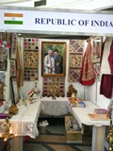
Diplomat's Day 2017- Indian pavilion
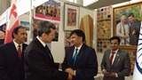
Diplomat's Day 2017- Rashid Meredov – Deputy Prime Minister for Foreign Affairs visiting Indian pavilion

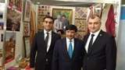
Diplomat's Day 2017- Cabinet Minister's Visiting Indian pavilion

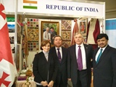
Diplomat's Day 2017- Head of Diplomatic Missions visiting Indian pavilion

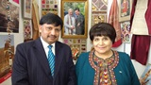
Diplomat's Day 2017-Ms. Akja Nurberdieva chairperson (speaker) of the Mejlis of Turkmenistan visiting Indian pavilion

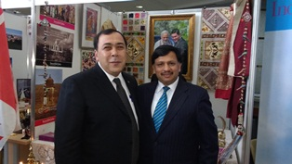
Diplomat's Day 2017- Mr. Berdyniyaz Matiyev, Deputy Minister of Foreign Affairs of Turkmenistan – Deputy Prime Minister for Foreign Affairs visiting Indian pavilion

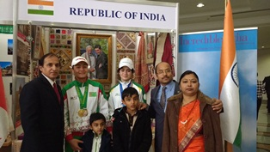
Diplomat's Day 2017-Indian officials and family with local Turkmen visiting Indian pavilion

