|  |  |
| --- | --- |
| http://www.indianconsulate-sf.org/images/ashokachkra.gif | EMBASSY OF INDIA KUWAIT |

**PRESS RELEASE**

HALA FESTIVAL was inaugurated on 10 February 2017 with much zeal and enthusiasm at Salem Al-Mubarak Street, Salmiya. Hala Festival is being annually organized in Kuwait since February 1999, mainly to promote tourism and culture. The Festival offers arts, sports, live carnival shows, entertainment events and display of vintage vehicles & motorbikes during the month. Kuwaiti Ministries, Government institutions and some Embassies had put up their stalls during the event.

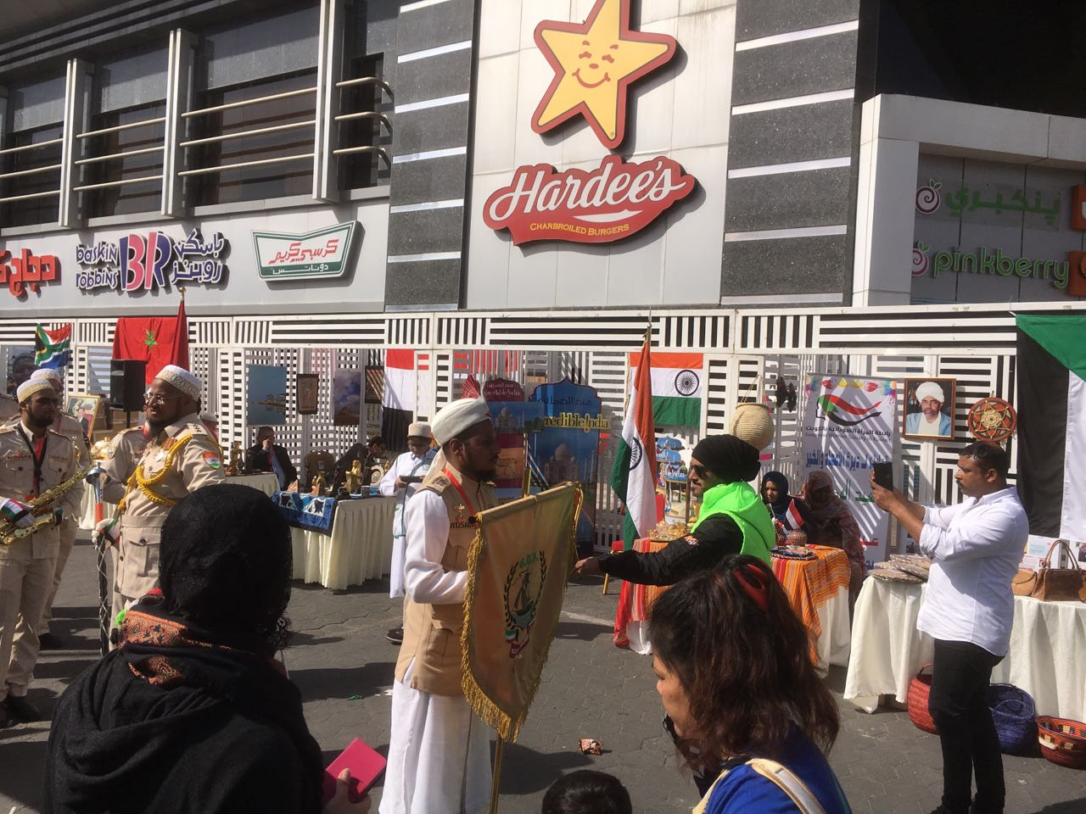

Indian Embassy also participated in the Opening Ceremony. The Indian stall was exquisitely decorated with “Incredible India” posters and tourism material. India’s Bohra Band (Burhani Guards) held the audience spellbound by their performances the whole day. Children from the Bohra community spread the message of importance of cleanliness in our daily lives by cleaning the surroundings during the event.

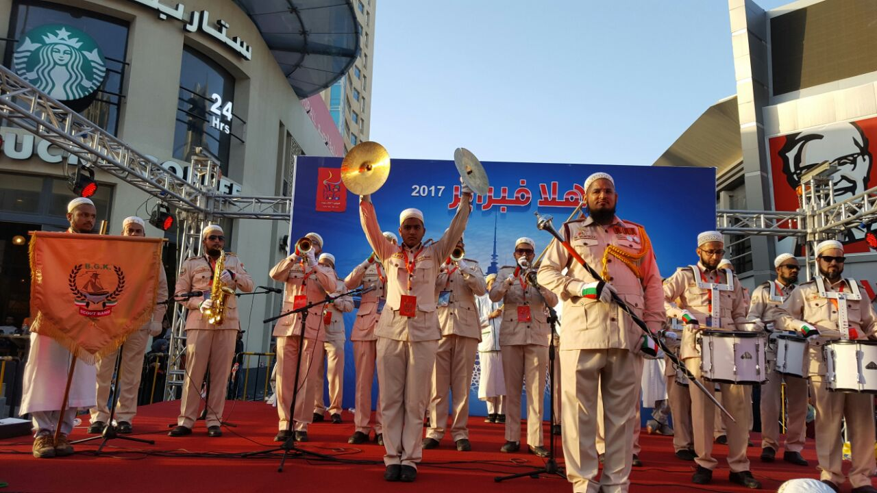

The Opening Ceremony witnessed, inter alia, a parade in which children from various Kuwaiti schools, some Kuwaiti Ministries and government agencies, Embassies etc. participated. India’s Bohra Band (Burhani Guards) also took part in the parade.

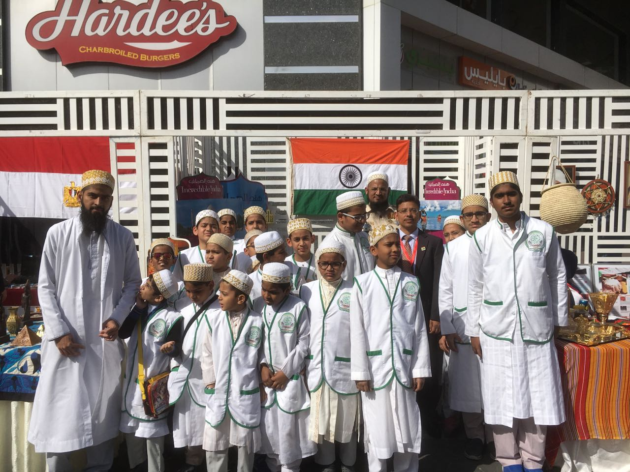

Many visitors, especially children took the opportunity to take photographs posing in front of the Embassy stall and highly enjoyed the event.

**12 February 2017**