Republic Day Reception 2017

A reception was held at Yyldyz hotel in Ashgabat to celebrate 68th Republic Day of India. Over 140 guests from Diplomatic Corps, local government, local guests and Indian community. The Deputy Prime Minister for Oil and Gas H E Y Kakayev graced the occasion as the Chief Guest. Ambassador and Mr Kakayev stressed on the growing bilateral relations between India and Turkmenistan. Mr Kakayev also stressed on the TAPI pipeline project and conveyed greetings of H E President Gurbanguly Berdimuhamedov on the occasion. It was an evening of Indian music and delicious Indian cuisine for the guests. A cultural troupe led by Mr Sandip Banerjee from India sponsored by ICCR enthralled the guests with Indian classical music.

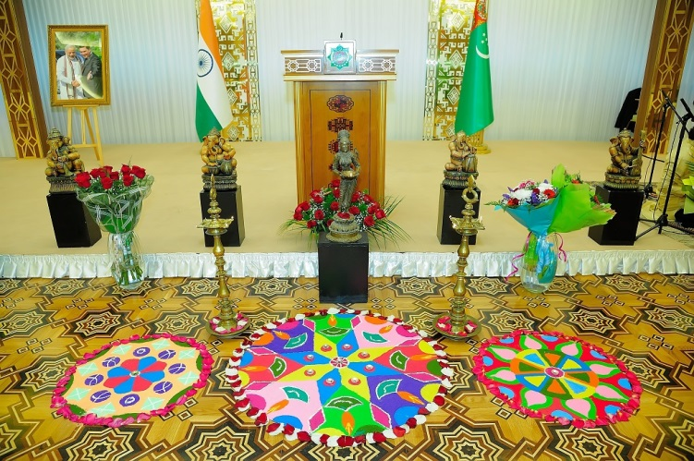
Republic Day Reception at Yyldyz Hotel on 28.01.2017

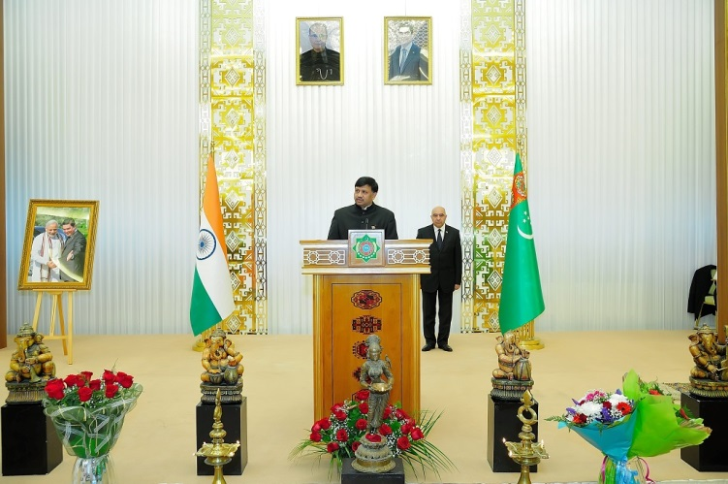
Ambassador Dr. T.V. Nagendra Prasad addressing the dignitaries

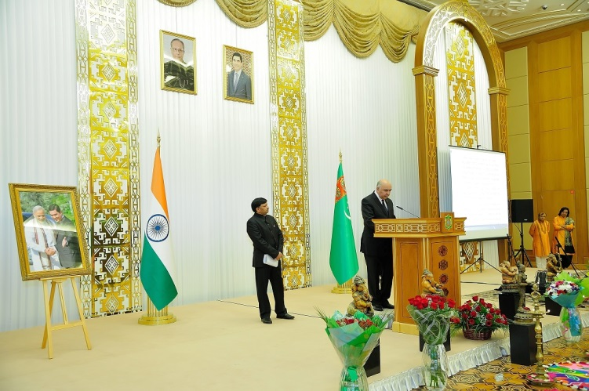
Deputy Prime Minister for Oil and Gas H E Y Kakayev addressing the dignitaries

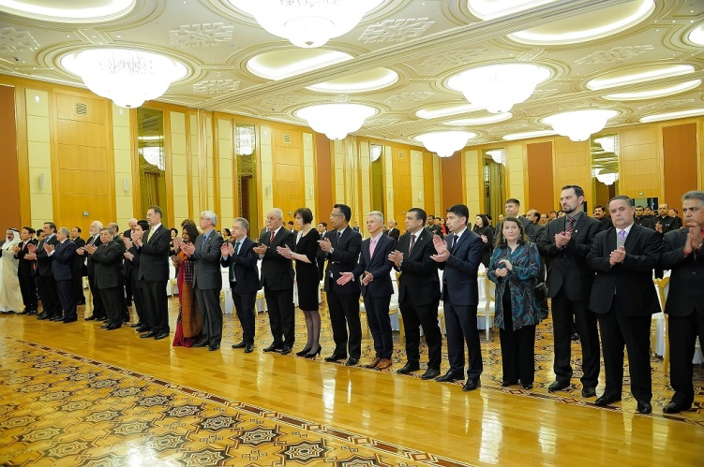
Ambassadors of different countries and other dignitaries on the occasion

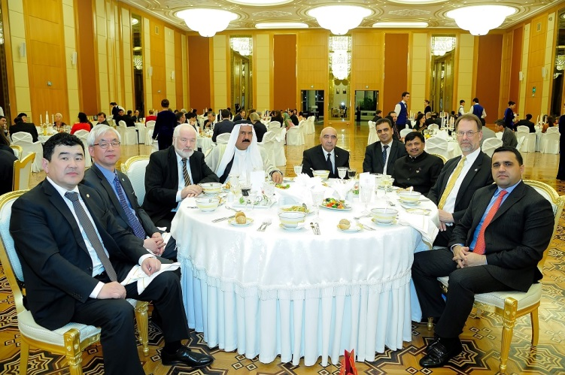
Ambassador Dr. T.V. Nagendra Prasad with Ambassadors of other countries

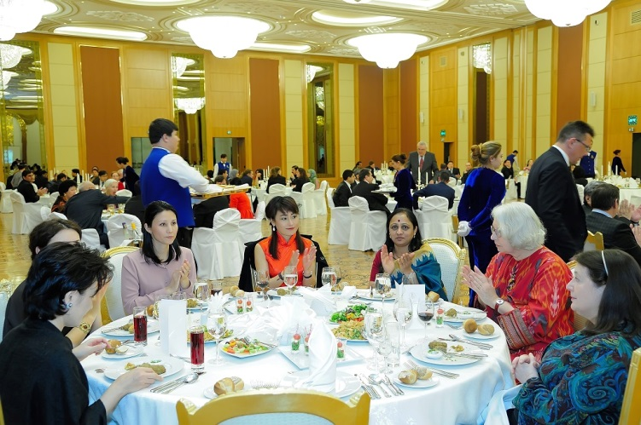
Mrs. Ambassador with spouses of Ambassadors of other countries

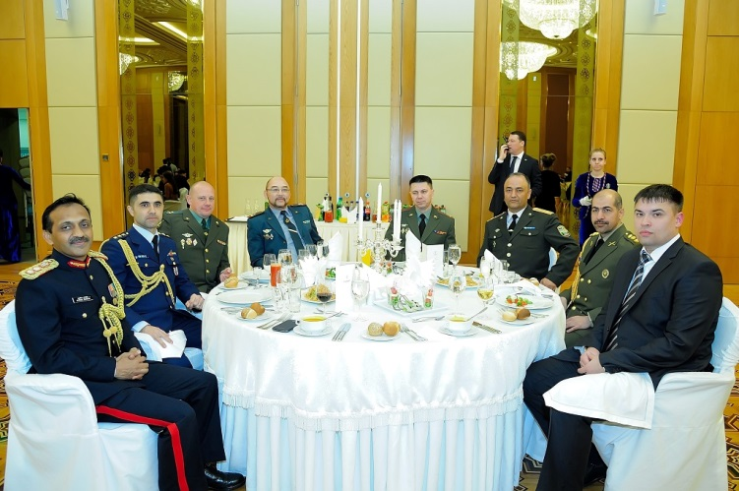
Col. Sudhir Thakur, Defence Attaché with Defence Attachés of other countries

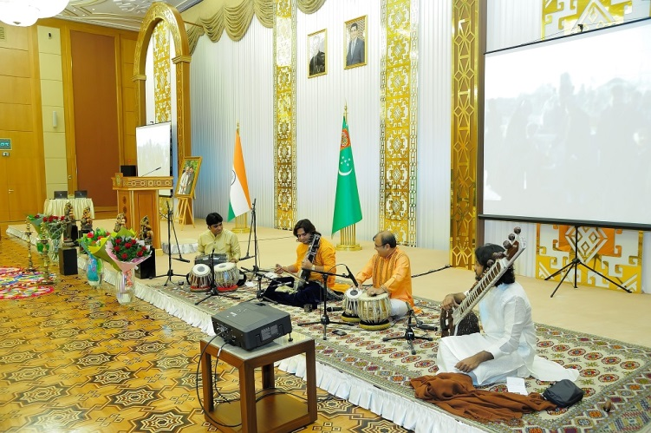
Musical Group 'Silicon' performing on the occasion

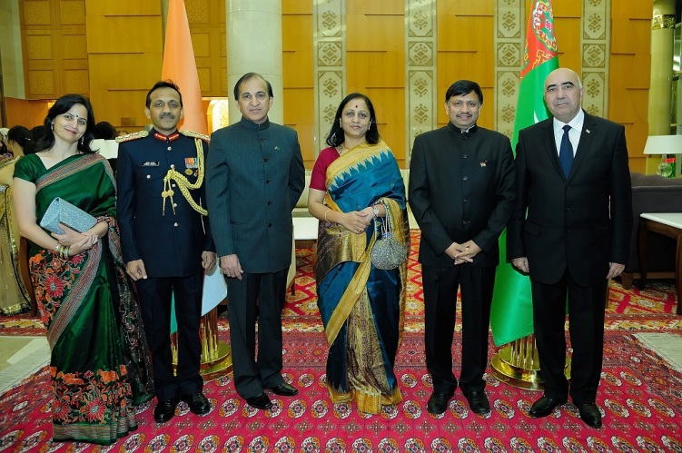
Ambassador with Deputy Prime Minister and Embassy Officials

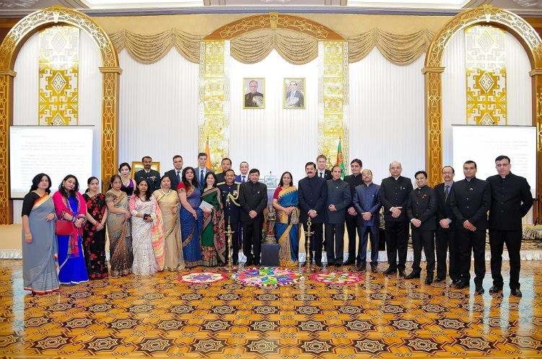
Republic Day Reception- Embassy Family

