A concert was held on 26th January by the visiting Silicon group (sponsored by the ICCR) in association with the Berkerar Shopping Mall to celebrate the 68th Republic Day in Ashgabat. It was attended by a large audience visiting the Shopping Mall and in association with Turkmen cultural artists playing 'Dutar' and other local musical instruments. Turkmen artists also performed to to some popular Bollywood tunes. The anchor conducted a quiz on Indian cinema and gave away prizes contributed by the Indian Embassy and Altyn Taj restaurant.

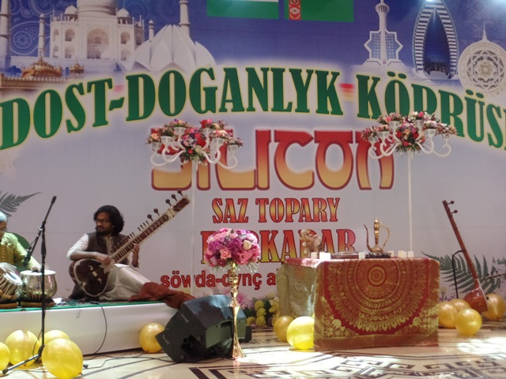

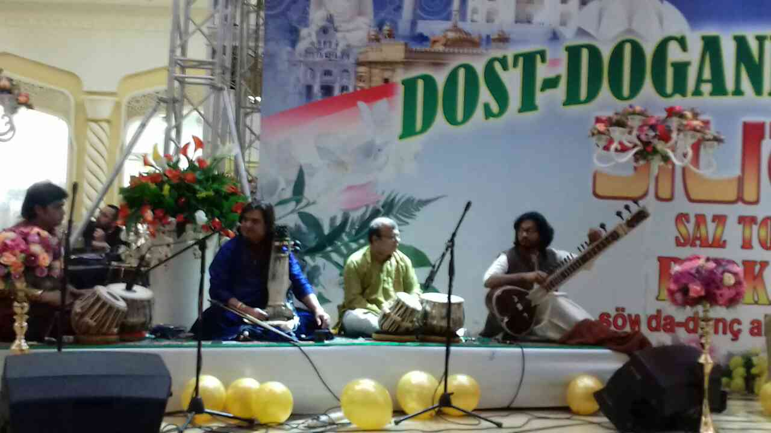
Performance by the Indian Musical group ‘Silicon’

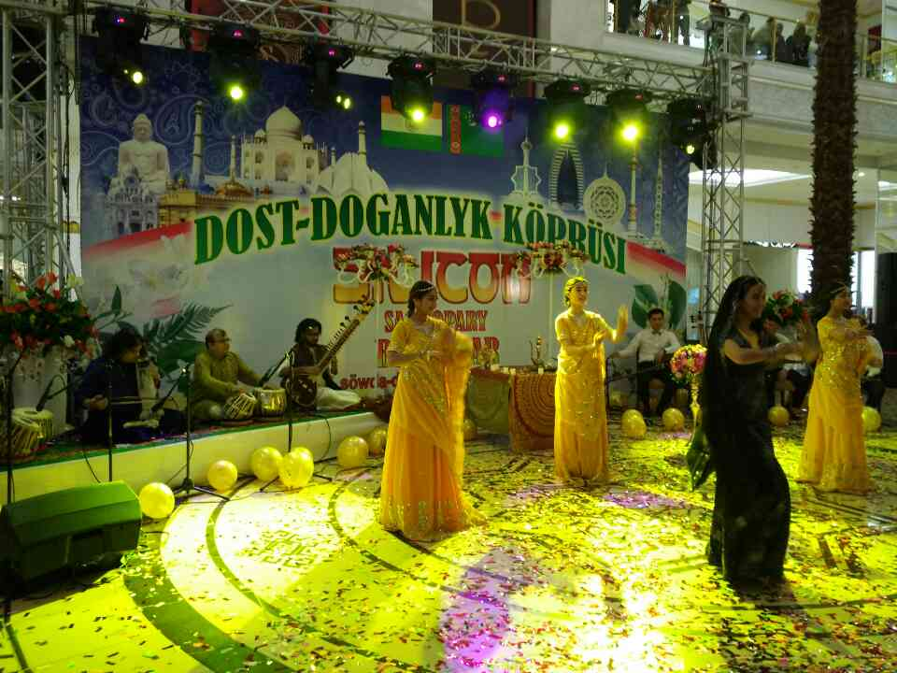
Turkmen dancers performing on the Indian music

