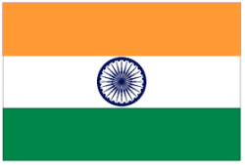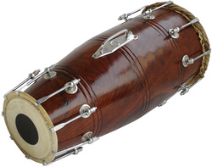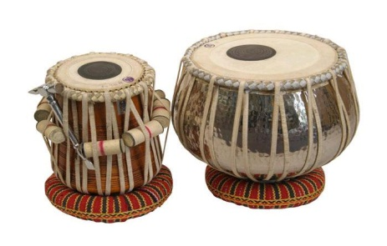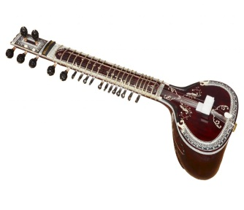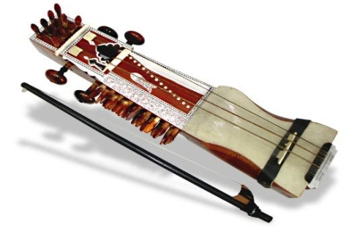

**Indian Embassy , Ashgabat,** **ICCR , NEW DELHI**

**To Celebrate the 68th Republic Day of India, Embassy of India, in collaboration with Ministry of Culture of Turkmenistan, is organizing Indian Cultural performance by Mr. Sandip Banerjee and group**

**Rhythmic & Soulful; Traditional and Contemporary Indian music**

Venues & Dates:

**1. Thursday 26th January 2017** from 1700 hrs at **Berkarar Shopping** Complex (-1 floor).

**2. Saturday 28th January, 2017** from 1900 hrs at **Watan theatre**, Ashgabat

**ALL ARE WELCOME!!!!!**

**Nal**

**Sitar**

**Tabla**

**Sarangi**