EMBASSY OF INDIA
YOGA CENTRE, ASHGABAT
Yoga is a combination of practice and philosophy. In addition to the regular practical classes at Bakhtyarlyk Sports Complex, a series of lectures have been started by the Yoga Teacher Shri R.R. Panigrahi to enlighten the students in different yoga related subjects, i.e., Concept of Yoga, Yoga & Diet, Astanga Yoga, Yoga & Health, Yoga for Stress Management etc. One such lecture was arranged on 12.01.2017 for the students of Yoga Centre. Around 300 students participated in the lecture cum Question-Answer session. The subject was ‘Concept of Yoga’ and certain ‘Dos and Don’ts’ in yoga. Keeping the higher dimension of yoga in view, the lecture was concentrated so that the students can keep the highest aim of yoga in mind and continue their practice. Many a times, people practice yoga thinking it to be an exercise because of lack of knowledge.
“Yujyate Anena Iti Yoga” – that which joins, is yoga; Individual soul to be merged with divine soul is the aim of Yoga, i.e., growing from lower level of personality to higher level of personality and becoming divine. Definitions of Yoga given by Sage Patanjali, Sage Vasistha and by Bhagavad Gita were given with all the necessary explanations. A detailed explanation was given on Karma Yoga which was liked by them. The one hour of yoga training is to improve the knowledge of Karma Yoga, which keeps oneself active and energetic. It trains also to enjoy each and every activity throughout the day. It also trains how to remain happy all the times.
The duration was around 1 and ½ hour. After one hour of lecture, the time was given for question-answer session. There were many questions from the audience related to the particular subject and related subject. They expressed that it was very informative. They were very enthusiastic about this new concept. They could realize that Yoga is not just an exercise, it has lot more benefit. They may gain lot out of it, not just satisfying with little. In addition to physical fitness, it will help in mental growth, intellectual growth and above all spiritual growth.
The students expect more such lectures related to the subjects in future. Accordingly, the next lecture will be on Yoga and Diet.
A similar lecture was there on 13.11.2016.
***
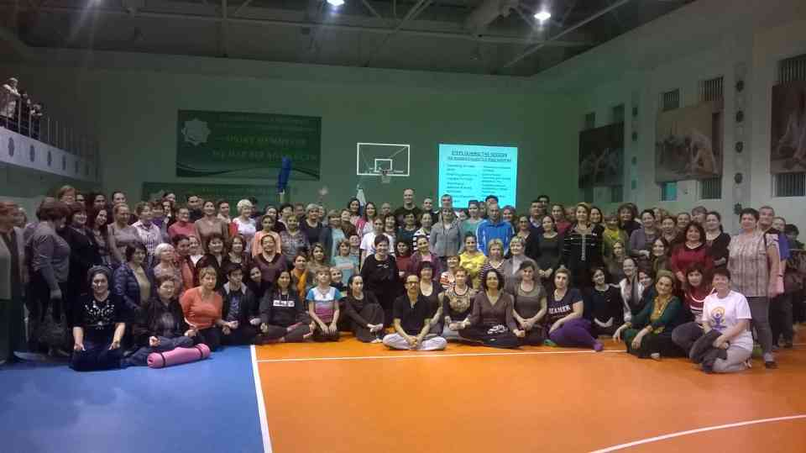
Participants of the Yoga Lecture on 12.01.17

