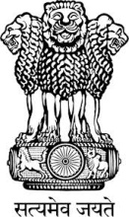

Embassy of India
Belgrade
Press Release
Ambassador’s presentation “India in the World” at NGO European Movement in Serbia
Indian Ambassador Smt. Narinder Chauhan delivered an interactive lecture on “India in the World” at the NGO European Movement in Serbia on November 23. “Nirvana & Beyond”, a film by Public Diplomacy Division of India was also screened on the occasion.
The event brought together retired Serbian Ambassadors, journalists and professionals from Serbia and the Balkans and was organized by the Forum for International Relations of the European Movement in Serbia.
The opportunity was also utilized for examining the present state and scope of India-Serbia bilateral relations.

November 25, 2016
Belgrade
*****

