Sardar Vallabhbhai Patel Birth Anniversary, 2016 at Ashgabat

On 31st October, 2016 Ambassador administered the National Unity Pledge to all India Based officials.

On 30th October, 2016 a ceremony was held at the Chancery to celebrate. “Rashtriya Ekta Divas” commemorating the birth anniversary of Sardar Vallabhbhai Pate. Ambassador H.E Dr. T.V. Nagendra Prasad presided over the function participated by Embassy officials and families.

On the occasion, Ambassador enlightened the gathering on the rich contributions made by great leader. Children of the Embassy officials paid tributes to Sardar Patel through their speeches on life and accomplishments of Sardar Patel

***

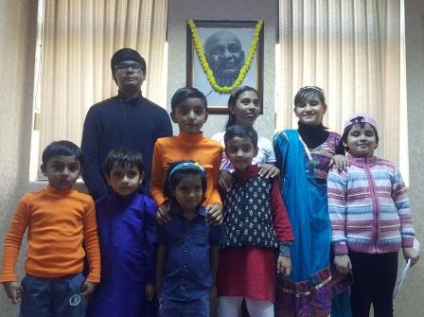
Sardar Vallabhbhai Patel Birth Anniversary Celebration, 2016-Children Paying Tributes

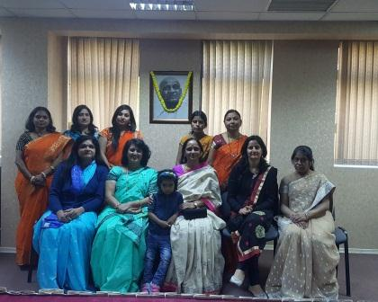

Sardar Vallabhbhai Patel Birth Anniversary Celebration, 2016-Embassy Ladies Paying Tributes

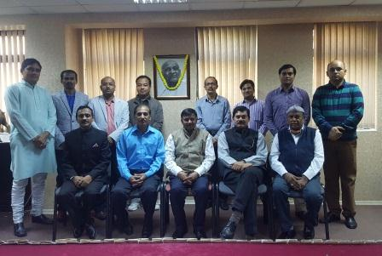
Sardar Vallabhbhai Patel Birth Anniversary Celebration, 2016-Ambassadro Dr T V Nagendra Prasad and Embassy Officials paying tributes

