|  |  |
| --- | --- |
| http://www.indianconsulate-sf.org/images/ashokachkra.gif | EMBASSY OF INDIA KUWAIT |

**Press Release**

**“Indian Handicrafts and Handloom Exhibition”**

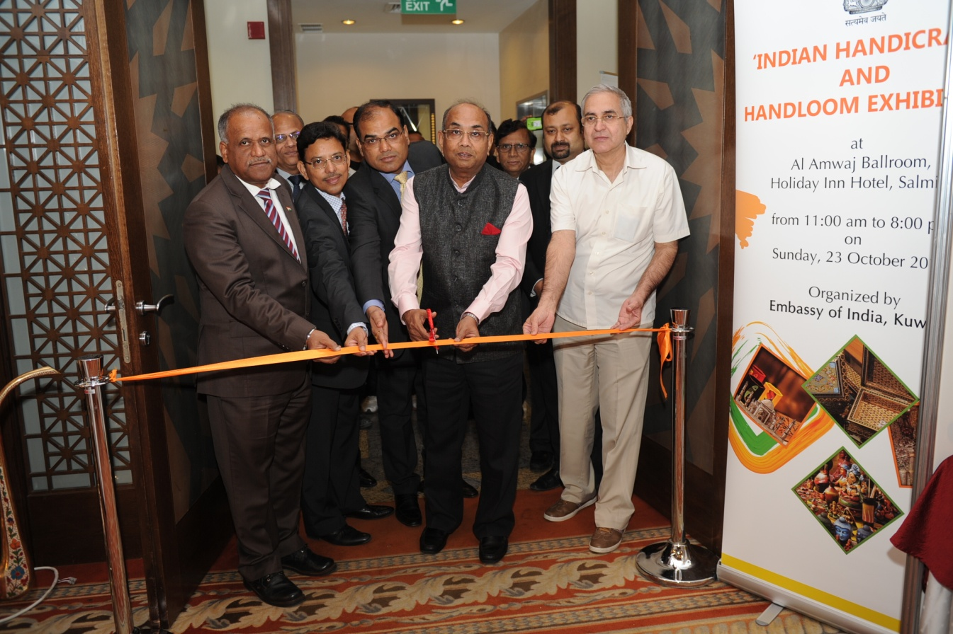

The Embassy organized an “Indian Handicrafts and Handloom Exhibition” at Holiday Inn Hotel, Salmiya on Sunday, 23 October 2016 from 11:00 am - 8:00 pm. Ambassador Sunil Jain inaugurated the Exhibition. The main aim of the Exhibition was to promote Indian Handicrafts and Handloom products in Kuwait.

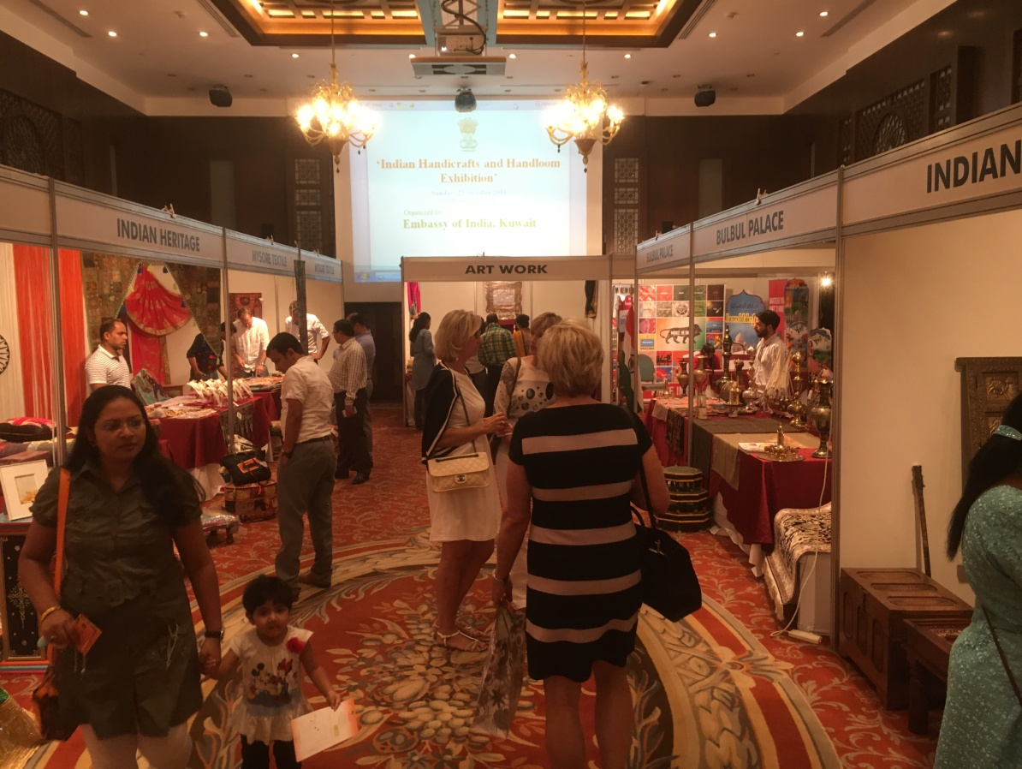

2. The Exhibition was organized with the participation of some local companies importing handicrafts and handloom products from India. These included Lulu Hypermarket, Bulbul Palace, Indian Heritage, Mysore Textile, Indian Home, Sanskruti and Art Work.

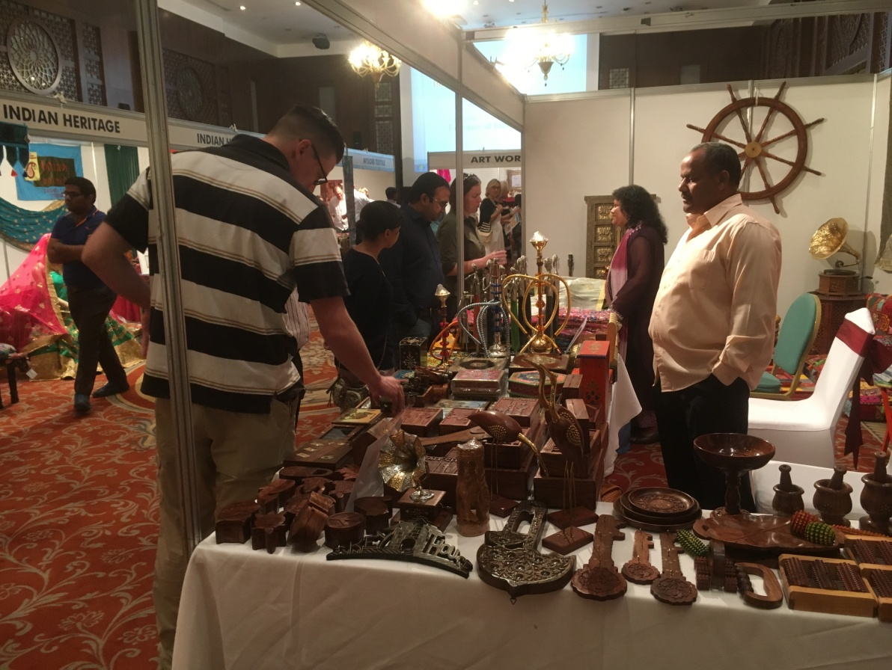

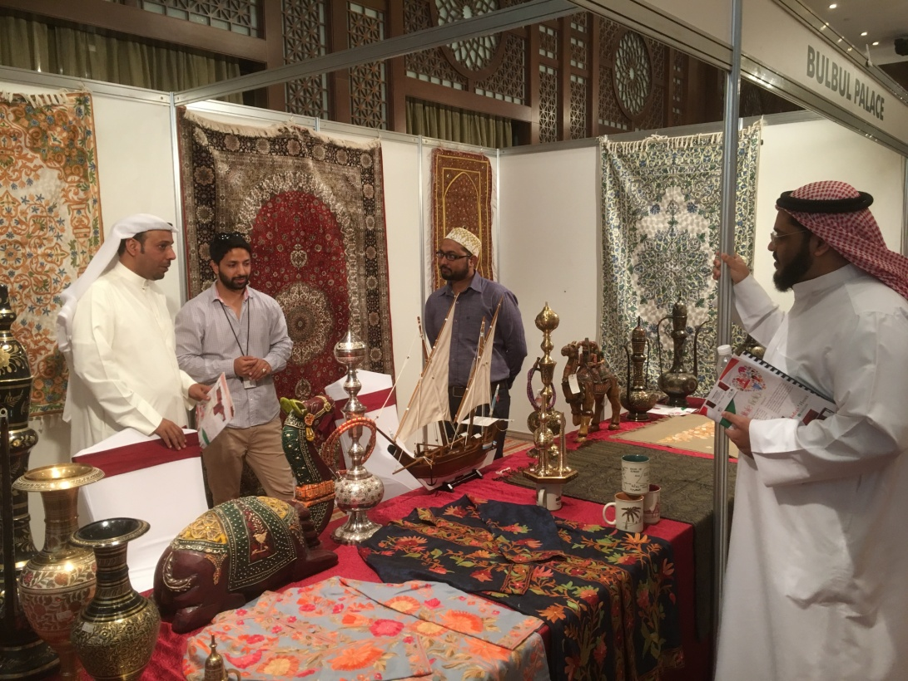

3. The “Indian Handicrafts and Handloom Exhibition” gaveboth Kuwaitis and expatriates a chance to see an array of Indian handicrafts and handloom products on display. Several varieties of hand made carpets, brass show pieces, marble pieces carved and designed with organic colours, handloom sarees, kurthas, ladies hand-bags, purses, antique pieces in wood and brass, jewelleries with semi precious stones, hand made furniture, table covers, cushion stools, cushion covers, framed paintings, etc., were displayed during the Exhibition.

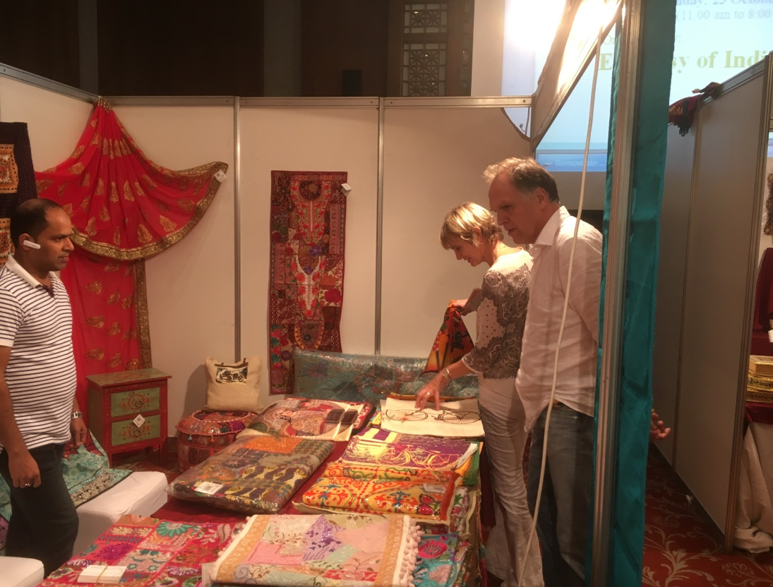

4. The Exhibition attracted a large number of visitors, including Indians, Kuwaitis and expatriates of other countries residing in Kuwait.

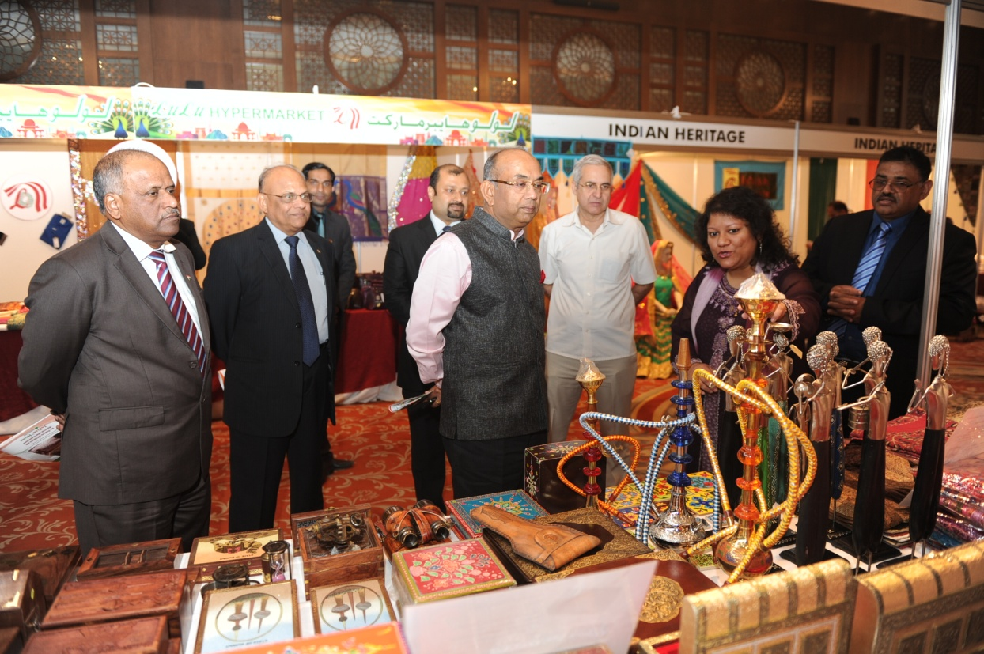

24 October 2016