High Commission of India
Nairobi
Celebrations of 2nd International Day of Yoga in Kenya

The Second International Day of Yoga was celebrated in Nairobi with great enthusiasm on 19th June, 2016. Over seven thousand people including university students, school children and yoga enthusiasts participated in the grand event which was held at the University of Nairobi organized by the High Commission of India and International Yoga Day Committee (#YogaKenya). Dr. Hassan Wario Arero, Cabinet Secretary (Minister) for Sports, Culture and the Arts represented the Government of Kenya as the Chief Guest.

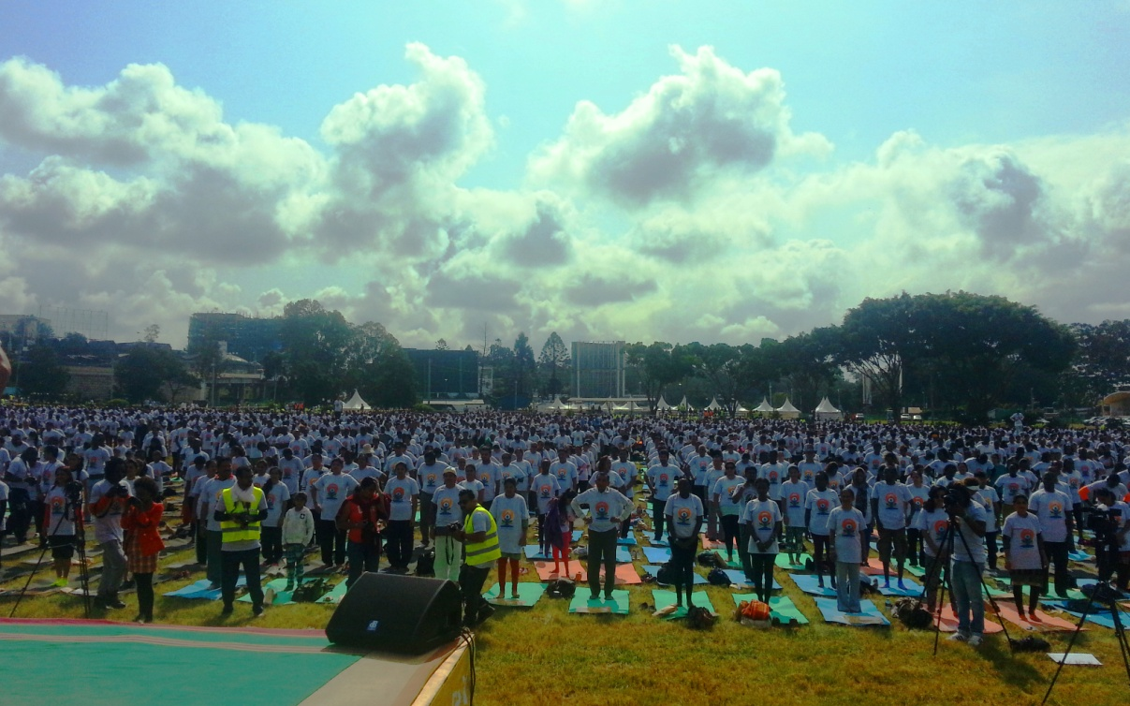

2. Prime Minister Shri Narendra Modi’s message on the occasion was played. High Commissioner Ms. Suchitra Durai, in her opening remarks, emphasized the importance of Yoga in daily life. Common Yoga Protocol was performed by the participants. Yoga teacher from the Ministry of Ayush, Government of India demonstrated advanced Yogic postures. Local institutions held camps related to health, wellness and traditional medicines at the occasion. The event was also celebrated simultaneously at 12 venues in major counties of Kenya such as Kisumu, Eldoret, Mombasa, Meru, Embu etc.
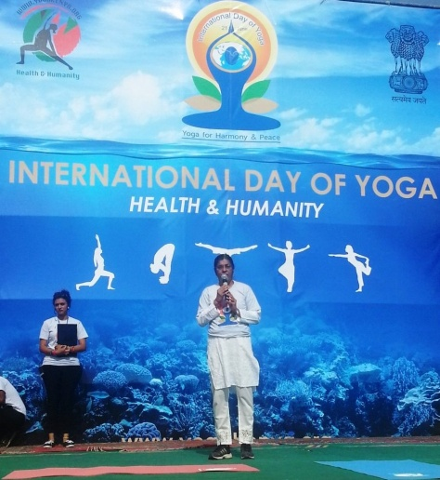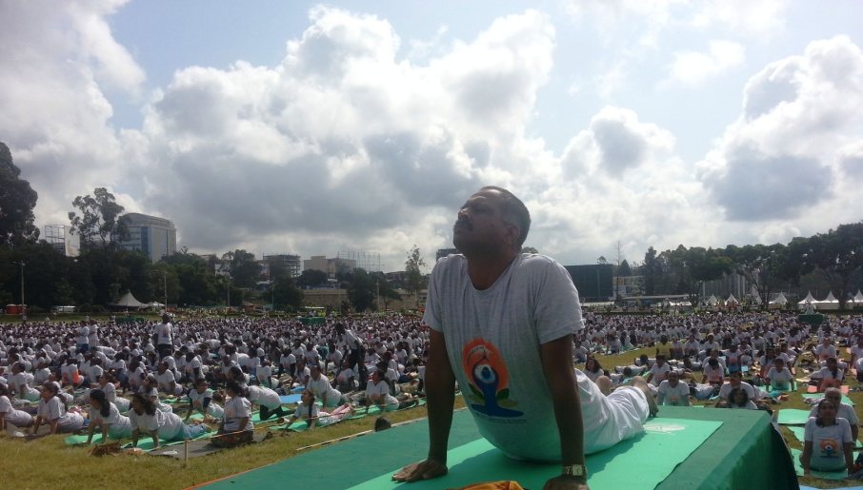

3. In her remarks, Director General of United Nations Office in Nairobi (UNON) Ms. Sahle Work-Zewde mentioned that no other UN International Day is celebrated with such a huge participation of common people. Vice Chancellor of the University of Nairobi, Dr. Peter Mbithi, Inspector General of Police of Kenya, Mr. Joseph Boinnet, Chairman of Bidco Africa Mr. Vimal Shah and Chairman of Comcraft Group and Pravasi Bharatiya Awardee Dr. Manu Chandaria attended the event. Various prominent local organizations such as Africa Yoga Project, Brahmakumaris Raja Yoga, Art of Living, Chinmaya Mission, Hindu Council of Kenya were the main partners in the event.

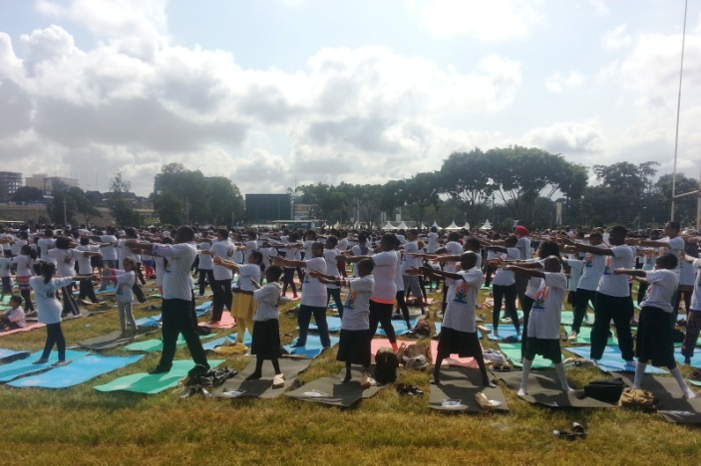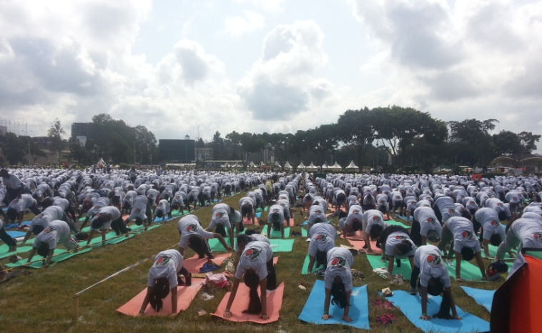
*****
19th June, 2016
Nairobi

