**Embassy of India**

**Tunis**

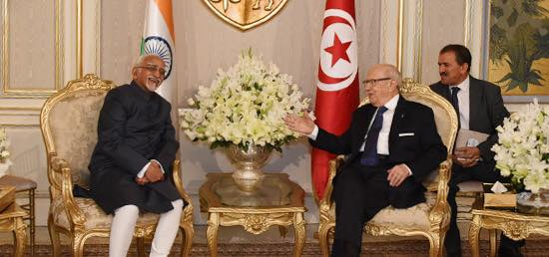

**Vice President calls on Tunisian President Beji Caid Essebsi on 03 June, 2016 in Tunis**