‘Yoga Therapy Course’

The second batch of students at the State Medical University, Ashgabat have successfully completed a 2-credit Yoga Therapy Course under the guidance of the Yoga Teachers Mr. M. Sanjeevi Kumar and Ms. J. Meenakshi on My 23, 2016. The course has been highly appreciated by the students.
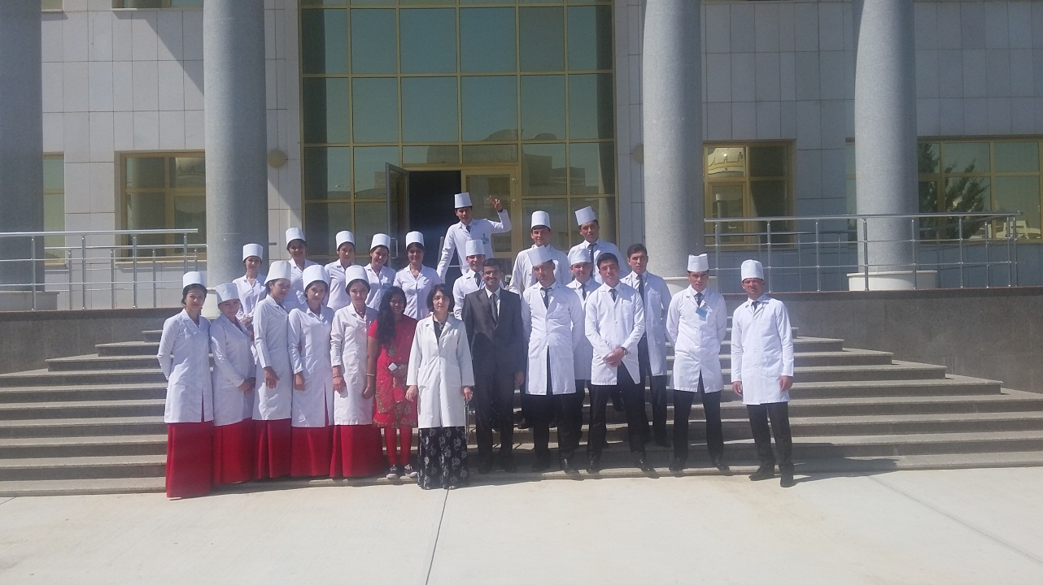

Yoga teachers with students at the State Medical University

