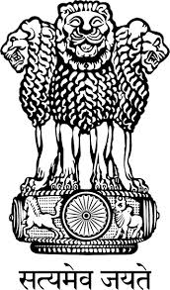
Embassy of India
Belgrade

Press Release

‘Padma Shri’ Award for Serbian Yoga Exponent
Mr. Predrag K. Nikic, President of the Yoga Federation of Serbia has been conferred upon with the ‘Padma Shri’ Award by the Government of India for his contribution to Yoga. The Award was presented to Mr. Nikic by the President of India, Shri Pranab Mukherjee on March 28, 2016 at a Civil Investiture Ceremony held at Rashtrapati Bhavan, New Delhi.
Among the dignitaries present on the occasion were the Vice President of India, Prime Minister of India, Union Ministers of Home Affairs, Urban Development, Housing & Urban Poverty Alleviation and Human Resource Development.
Padma Awards - one of the highest civilian Awards of the country, are conferred in three categories, namely, Padma Vibhushan, Padma Bhushan and Padma Shri. The Awards are given in various disciplines/ fields of activities, viz.- art, social work, public affairs, science and engineering, trade and industry, medicine, literature and education, sports, civil service, etc. ‘Padma Vibhushan’ is awarded for exceptional and distinguished service; ‘Padma Bhushan’ for distinguished service of high order and ‘Padma Shri’ for distinguished service in any field. The awards are announced on the occasion of Republic Day every year.

Place: Belgrade
Date: April 1, 2016

*****

