Republic Day reception
…..

The 67th Republic Day reception was held at Hotel Yyldyz in Ashgabat. H.E. Mr. Yagshigeldy Kakayev Deputy Prime Minister and Director of the State Agency for Management and Use of Hydrocarbon Resources was the Chief Guest. The reception was held with Indian food and music with the participation of 130 invitees including Turkmen government officials, diplomats resident in Ashgabat and members of Indian community. Speaking on the occasion, Ambassador Dr. T.V. Nagendra Prasad mentioned about the high-level exchanges of the year 2015 and scope for further deepening of relations. Turkmen DPM also reciprocated the sentiments.

………….

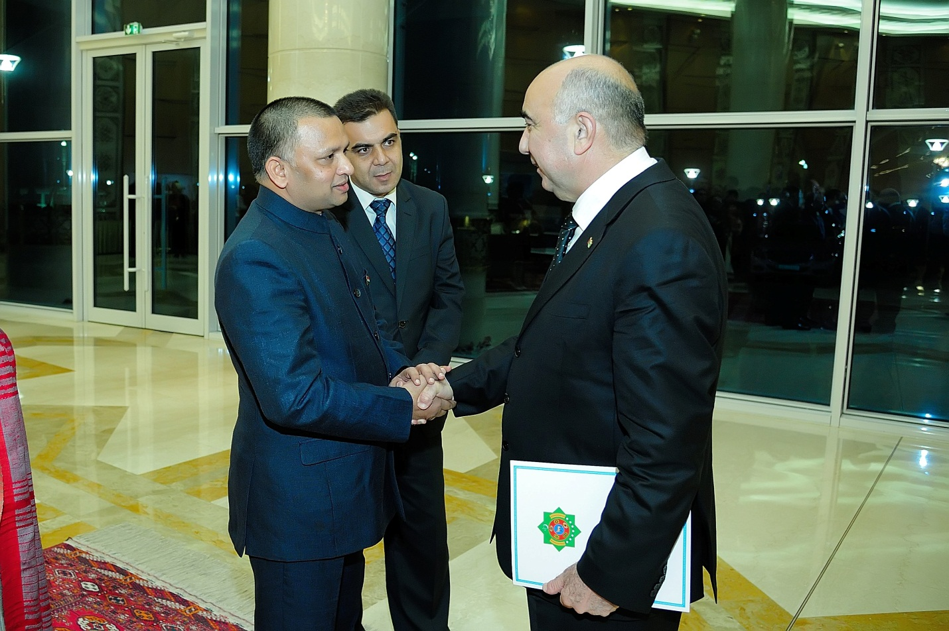

Ambassador Dr. T.V. Nagendra Prasad welcoming the Chief Guest H.E. Mr. Yagshigeldy Kakayev, Deputy Prime Minister
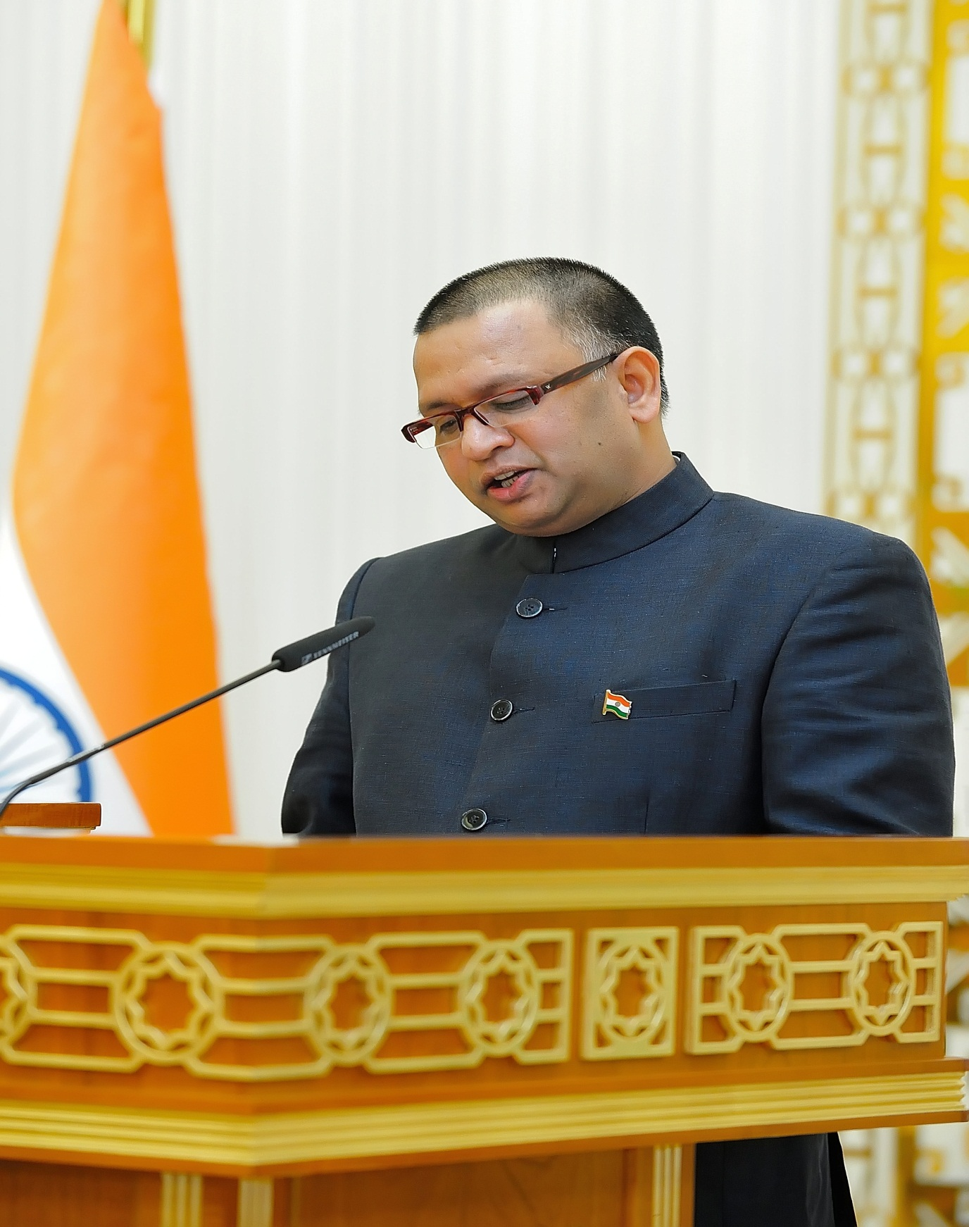

Ambassador Dr. T.V. Nagendra Prasad delivering the welcoming address on the occasion
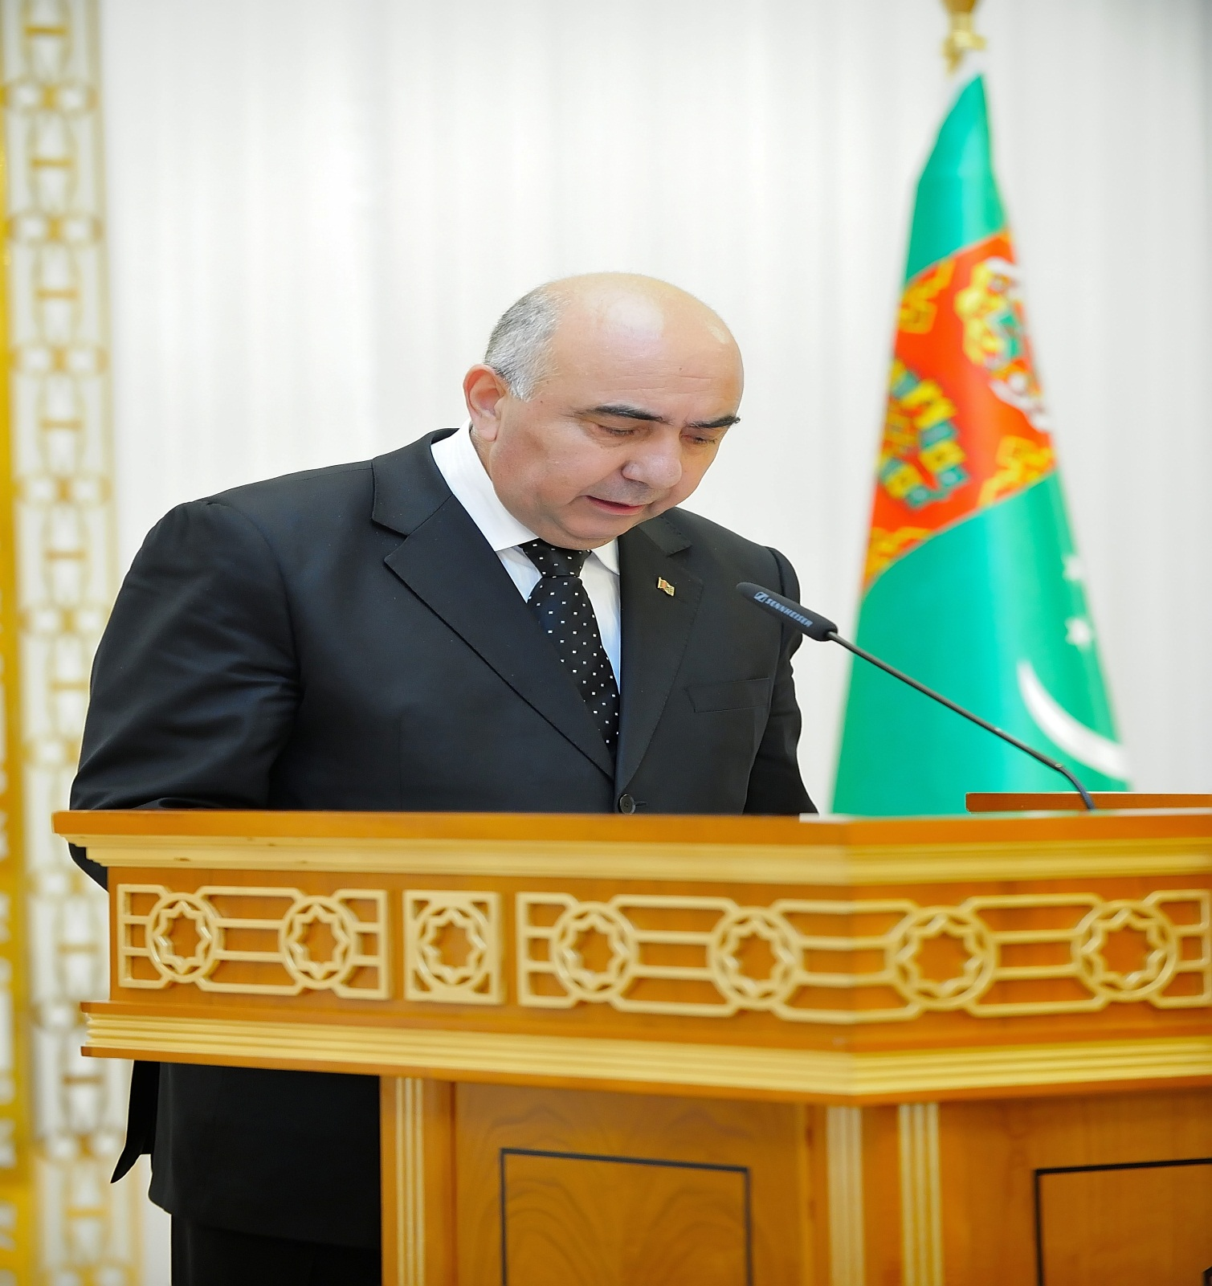

H.E. Mr. Yagshigeldy Kakayev Deputy Prime Minister and Director of the State Agency for Management and Use of Hydrocarbon Resources delivering a speech on the occasion
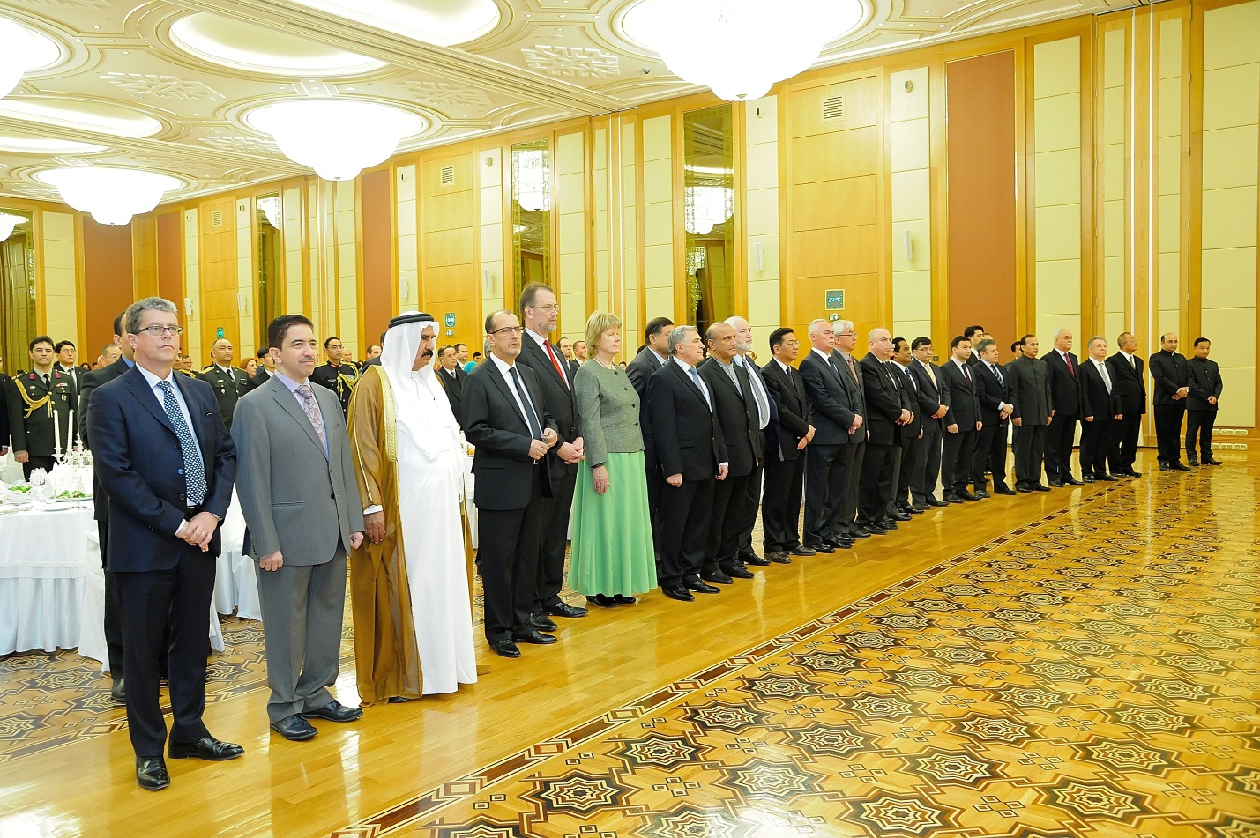

A view of diplomatic community on the occasion

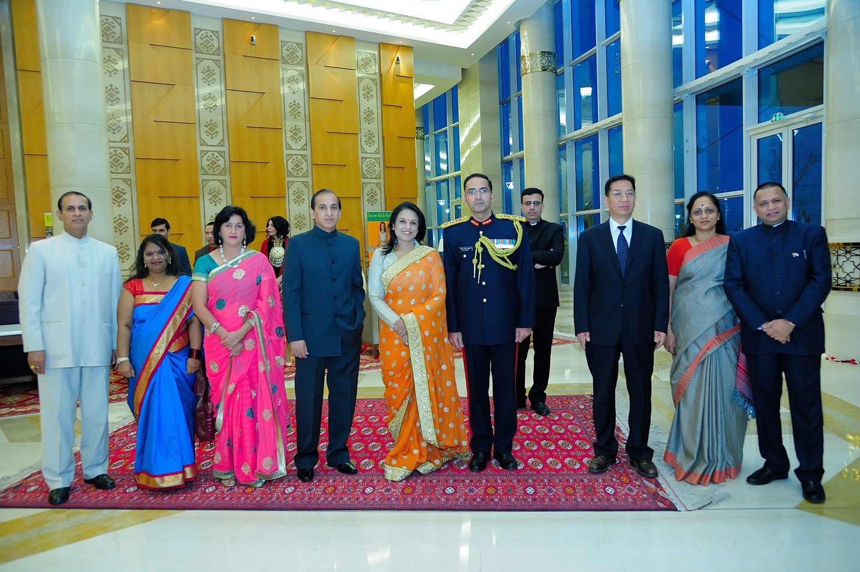

Ambassador Dr. T.V. Nagendra Prasad and Mrs Ambassador with Chinese Ambassador flanked by other officers of the Embassy

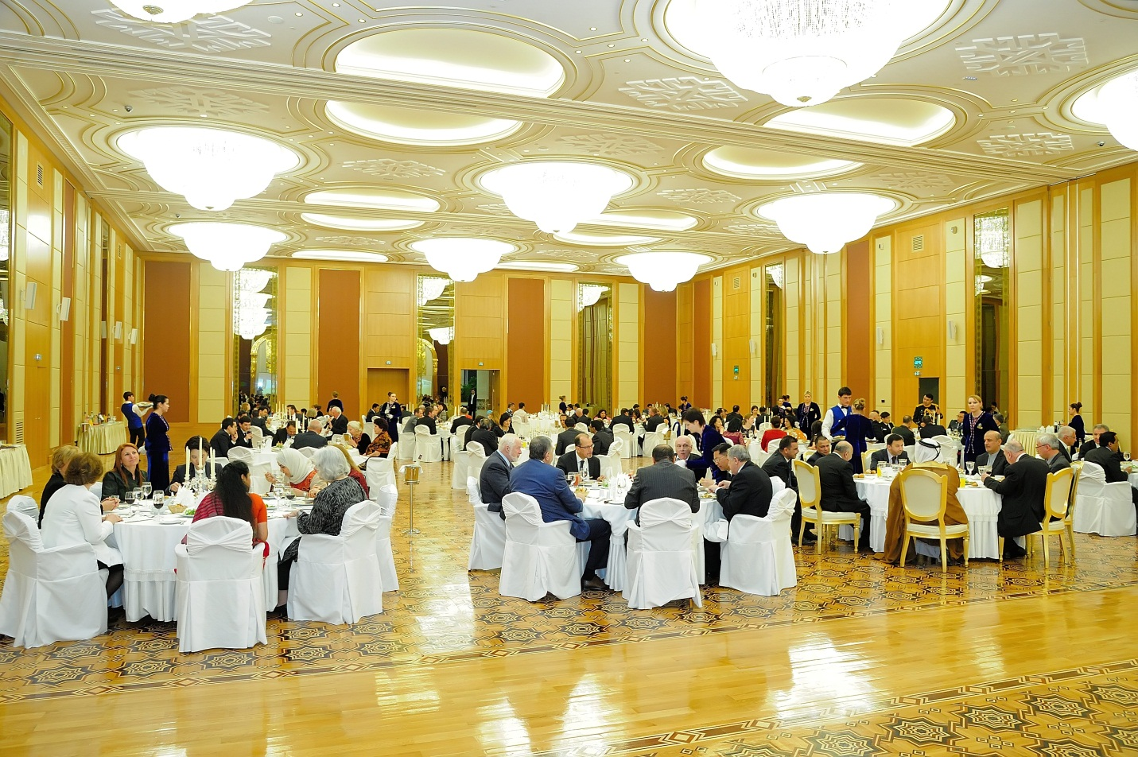

A view of guests at the dinner

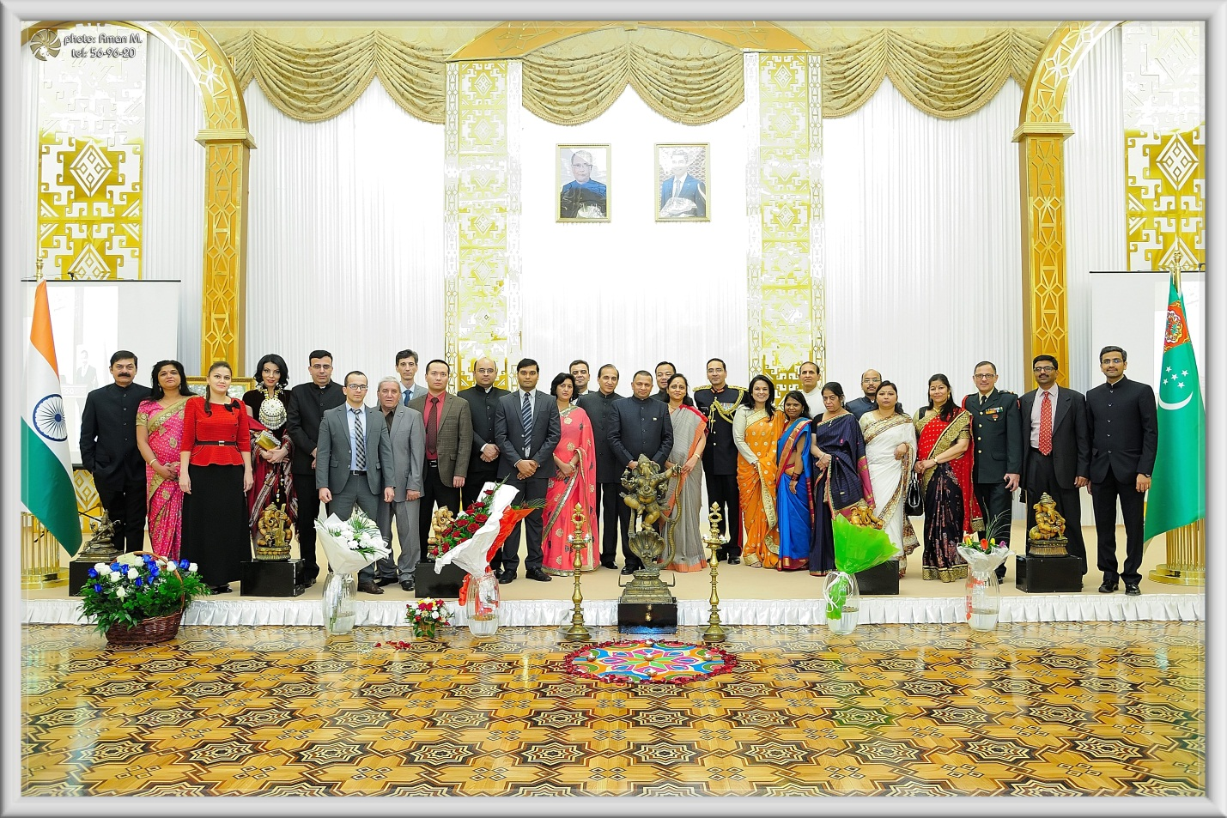

Indian Embassy officers & staff

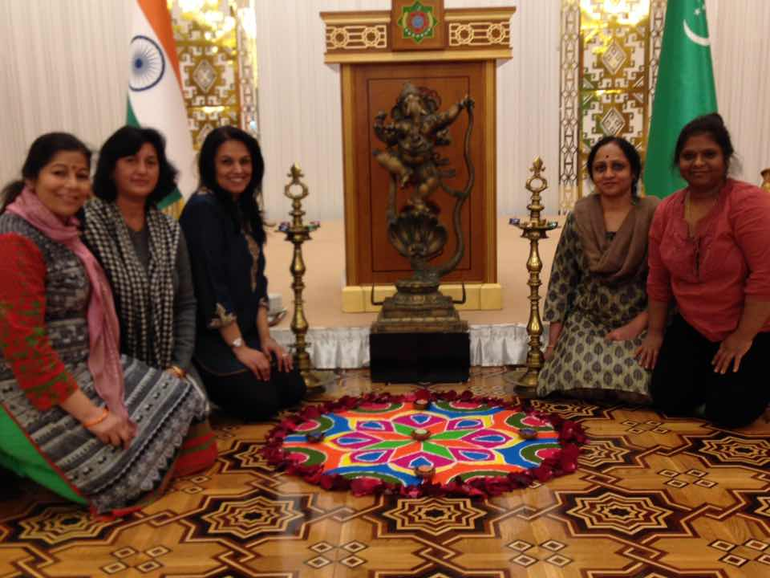

Indian Embassy Ladies preparing the Rangoli for the occasion

