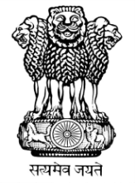 | भारत का राजदूतावास  मिंस्क  EMBASSY OF INDIA  MINSK

PRESS RELEASE

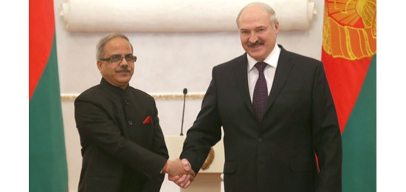

On 25th January, 2016, in a gracious ceremony at the Palace of Republic, Ambassador H.E. Mr. Pankaj Saxena presented his Letter of Credence to the Belarusian President H.E. Mr. Alexander Lukashenko, accrediting him as Ambassador Extraordinary and Plenipotentiary of India to the Republic of Belarus. Accepting the credentials and welcoming the Ambassador, the Belarusian President recalled the visit of Rashtrapatiji to Minsk in June 2015 and the various agreements signed during that visit. The President said that these agreements and the roadmap will help in intensifying bilateral trade and economic partnership.

25th January 2016

