Republic Day celebrations in Ashgabat, Turkmenistan
…..

The 67th Republic Day celebrations were held at the Embassy Residence on Tuesday, 26 January 2016. Indian community in Turkmenistan, PIOs and Embassy Officials’ families participated. Ambassador Dr. T.V. Nagendra Prasad hoisted the National Flag followed by the National Anthem. Ambassador read out the address of Hon’ble President Shri Pranab Mukherjee to the nation on the occasion. About 45 people assembled at the Residence for the celebrations.
………….

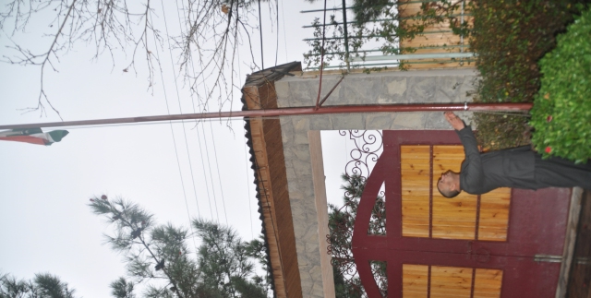

Ambassador Dr. T.V. Nagendra Prasad hoisting the National Flag

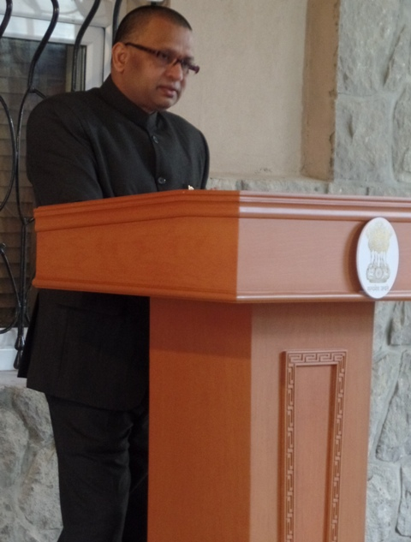

Ambassador Dr. T.V. Nagendra Prasad reading out the President’s Address

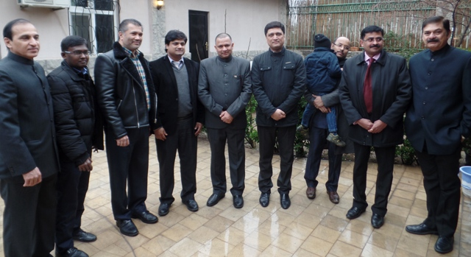

Ambassador Dr. T.V. Nagendra Prasad with Indian Community in Ashgabat

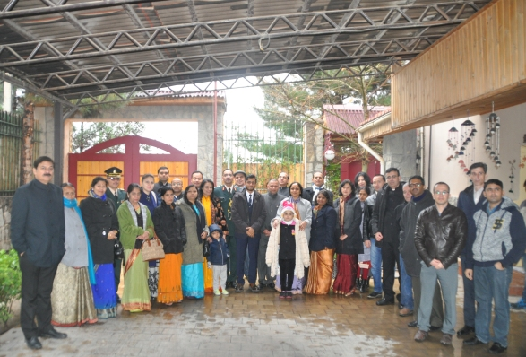

Embassy family

