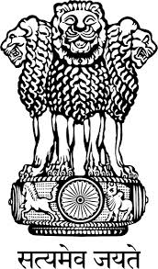
Embassy of India
Belgrade
Press Release
Indian Women Boxers shine at the 5th Nations Cup in Serbia
A 28-member Indian Women Boxing team participated in the 5th Nations Cup which was held in Ruma, Serbia from 8-12 January, 2016 organised by the Vojvodina Boxing Association, marking the first women’s boxing tournament of 2016. A total of 27 countries participated in the Tournament, including Russia, China, New Zealand, Kazakhastan, Greece, Poland, Germany, France, Finland, Lithuania, Sweden, etc. The Competitions were held in three categories viz. Junior, Youth and Elite.
The Indian team was placed second in the medal tally with total 23 medals. The Team was adjudged as the best Team in the Elite category with highest number of medals, and was placed second in Junior and Youth category. Indian Boxer Ms. Manisha was adjudged as the Best Boxer in the Junior Category.
H.E. Mrs. Narinder Chauhan, Ambassador of India presented gold medals to the winners at the finals of the Competition. She applauded and congratulated the Indian team on their outstanding performance.

January 14, 2016
Belgrade

***

