Visit of Hon’ble Vice President of India to Turkmenistan
11-13 December, 2015
………

Hon’ble Vice President of India Shri M. Hamid Ansari accompanied by Hon’ble Minister of State (I/c) for Petroleum and Natural Gas Shri Dharmendra Pradhan visited Turkmenistan from 11-13 December, 2015 to attend the 20th Anniversary of Neutrality celebrations of Turkmenistan in Ashgabat on 12 December and TAPI Ground-breaking ceremony in Mary on 13 December. During the visit, he held bilateral discussions with President Gurbanguly Berdimuhamedov on 12 December, 2015 and addressed the gathering of delegations from over 80 countries on the occasion. Hon’ble Vice President paid floral tributes at the Mahatma Gandhi’s Bust in Ashgabat on 12 December. The Turkmen students learning Hindi sang bhajan on the occasion.

2. At the TAPI Ground-breaking ceremony near Mary on 13 December, 2015, Hon’ble Vice President termed the occasion as historic for the TAPI gas pipeline project and said that the time has come to write another chapter in the voyage through history and the idea of an economically integrated South and Central Asia, whose time has come. Hon’ble Vice President along with President Gurbanguly Berdimuhamedov, President Ashraf Ghani and Prime Minister Nawaz Sharif participated at the traditional ceremonies of TAPI ground-breaking ceremonies by pressing the push button to start welding of pipelines and signing the Memorial Document. The highly successful event was witnessed by the people of Mary, Cabinet and senior officials of Turkmenistan, visiting delegations of India, Pakistan and Afghanistan and Ambassadors resident in Ashgabat.

………….

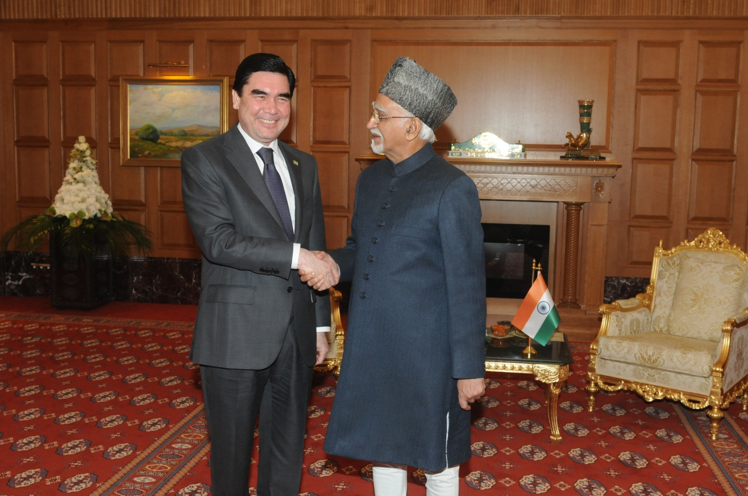

Hon’ble Vice President of India Shri M. Hamid Ansari with President Gurbanguly Berdimuhamedov

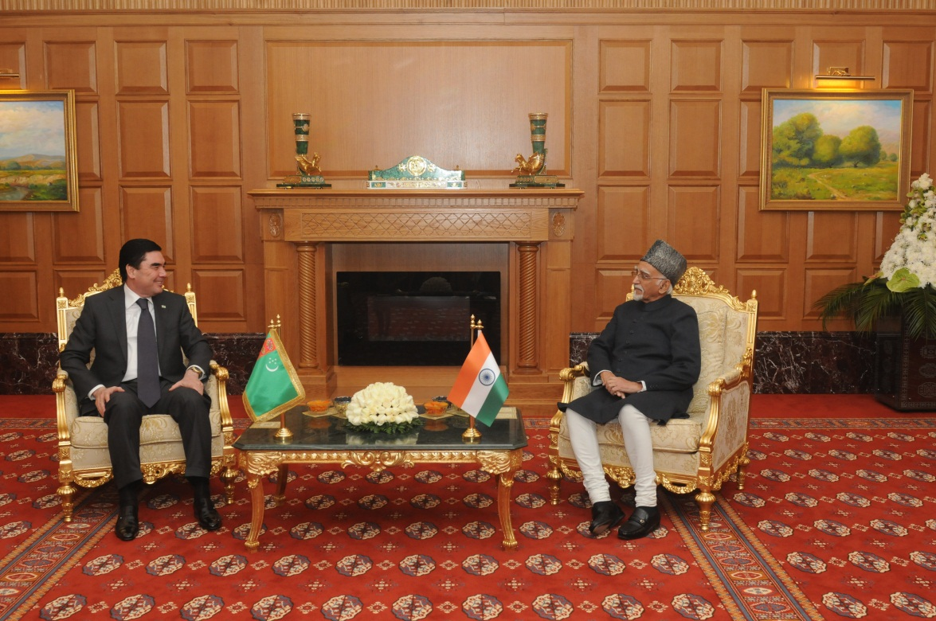

Hon’ble Vice President of India Shri M. Hamid Ansari with President Gurbanguly Berdimuhamedov at the Bilateral Meeting

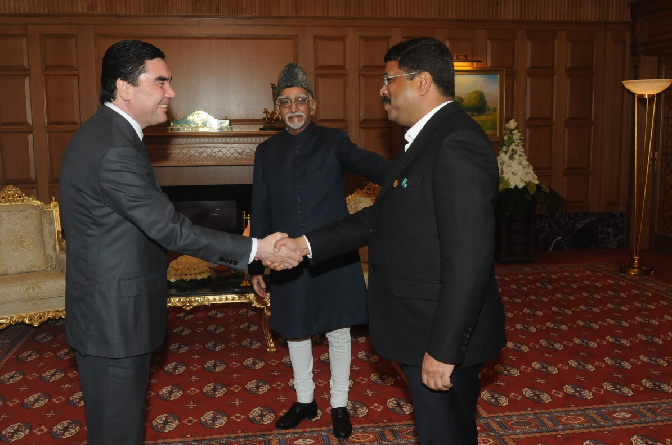

Hon’ble Vice President of India Shri M. Hamid Ansari and Shri Dharmendra Pradhan, Minister of Petroleum & Natural Gas (I/c) with President Gurbanguly Berdimuhamedov

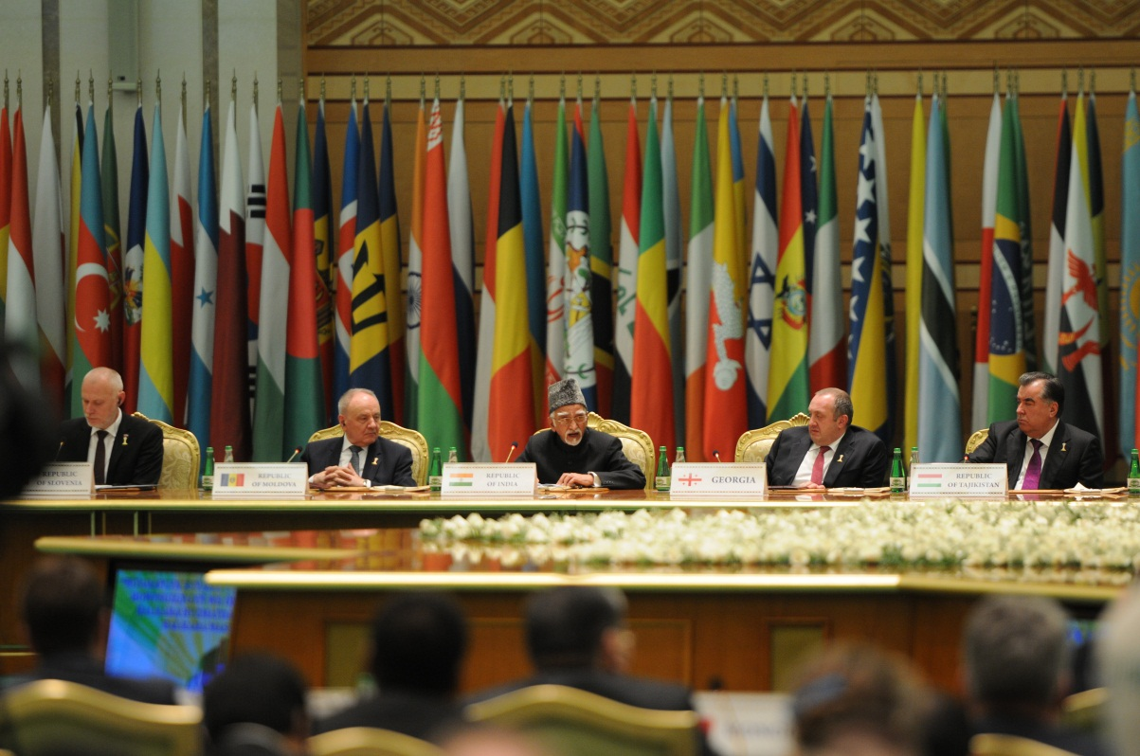

Hon’ble Vice President of India Shri M. Hamid Ansari at the Neutrality Event

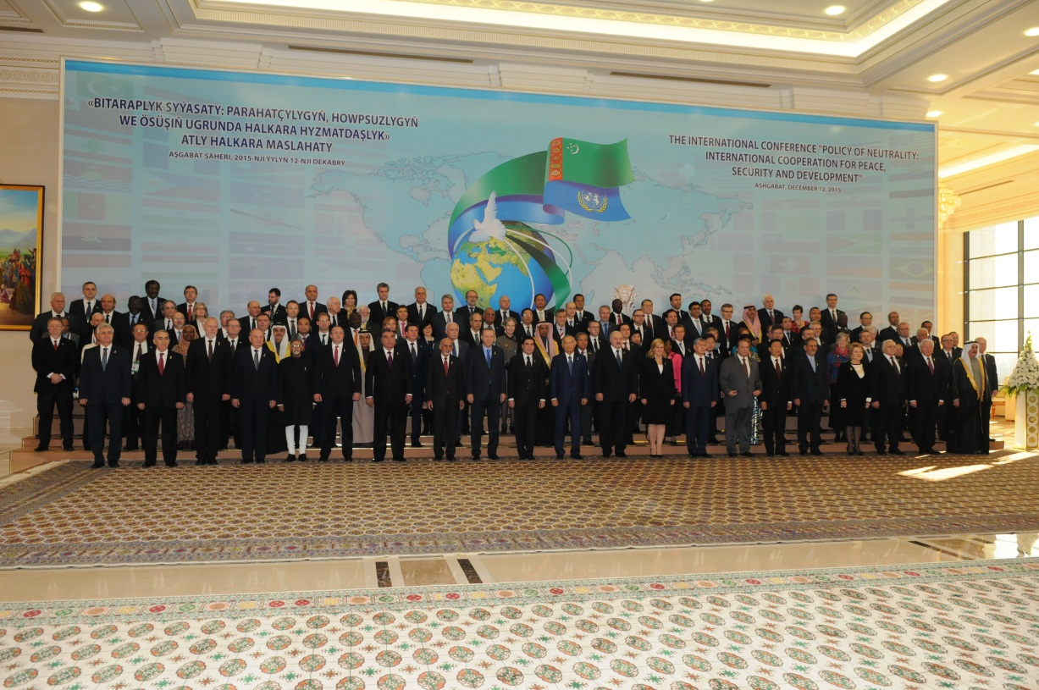
Hon’ble Vice President of India Shri M. Hamid Ansari with other Heads of State/Heads of Government at the Neutrality Conference
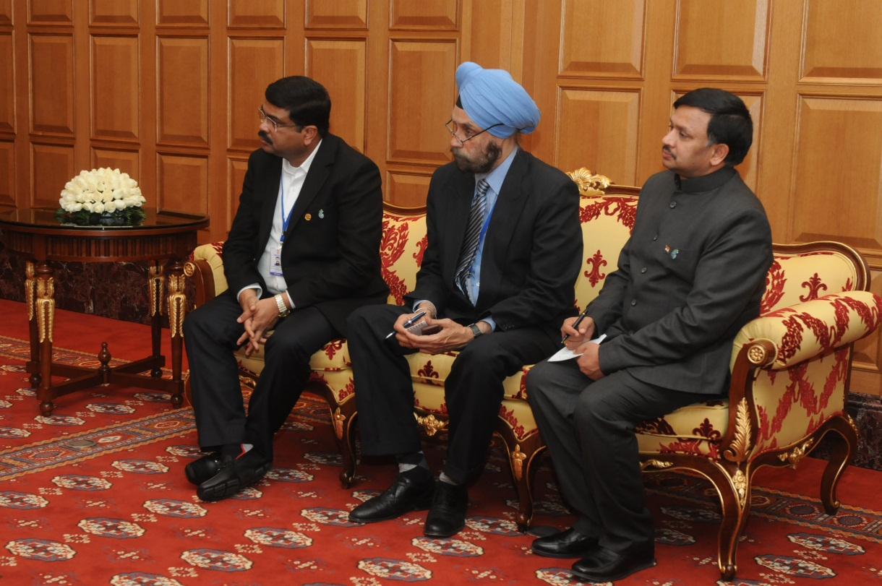

Shri Dharmendra Pradhan, Minister of Petroleum & Natural Gas (I/c), Shri Navtej Sarna, Secretary (West) and Ambassador Dr. T.V. Nagendra Prasad

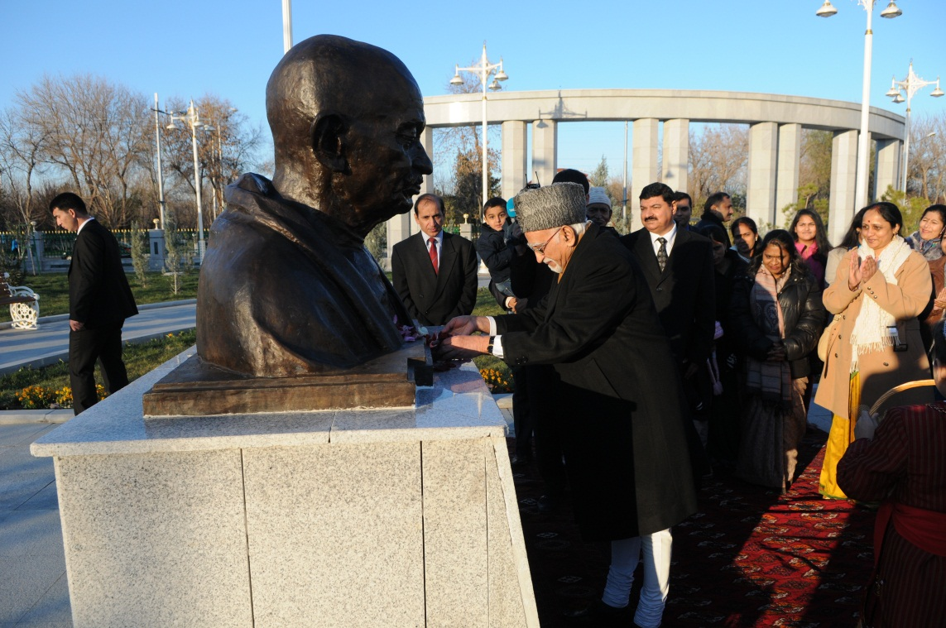

Hon’ble Vice President of India Shri M. Hamid Ansari offering floral tributes at
Mahatma Gandhi’s Bust

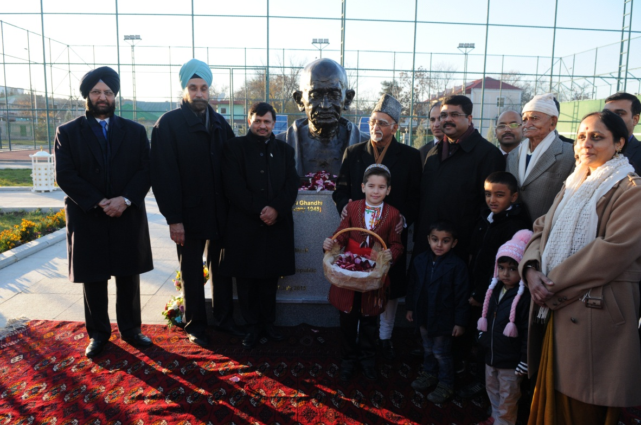

Hon’ble Vice President of India Shri M. Hamid Ansari offering floral tributes at
Mahatma Gandhi’s Bust

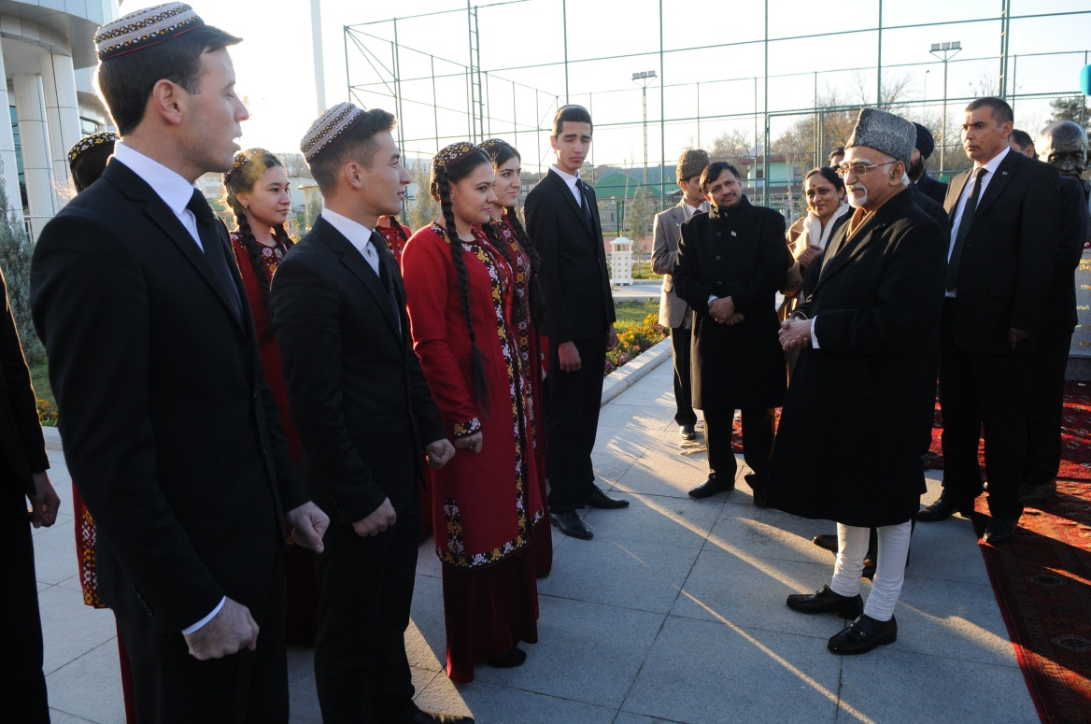

Hon’ble Vice President of India Shri M. Hamid Ansari interacting with Turkmen students

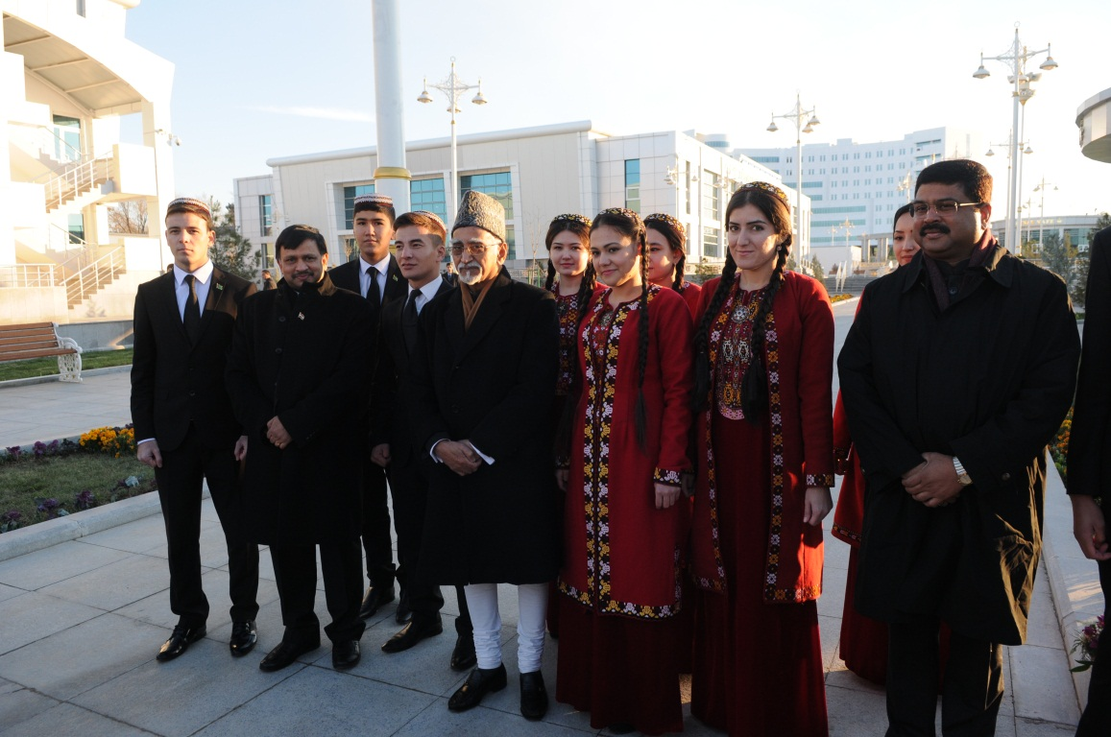

Hon’ble Vice President of India Shri M. Hamid Ansari and
Shri Dharmendra Pradhan, Minister of Petroleum & Natural Gas (I/c) interacting with Turkmen students

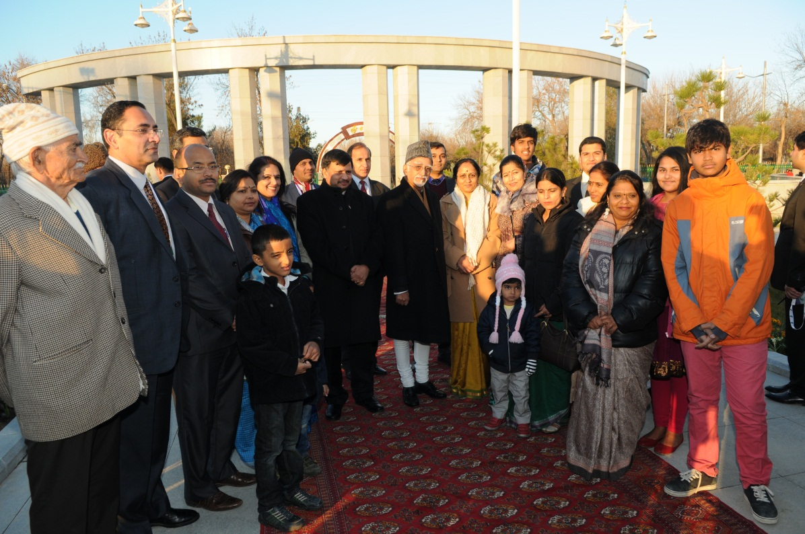

Hon’ble Vice President of India Shri M. Hamid Ansari with families of Embassy officials

