23rd TAPI Steering Committee Meeting
Ashgabat
24 October 2015
………….

The 23rd TAPI Steering Committee Meeting was held in Ashgabat on 24 October, 2015. The Indian delegation to the Steering Committee was led by Shri Kapil Dev Tripathi, Secretary, Ministry of Petroleum & Natural Gas. A day before, the Technical Working Group meeting was also held. A bilateral meeting was held with Hon’ble Deputy Prime Minister (Oil & Gas) Mr. Baymurat Hojamuhammedov during the visit. Indian delegation included the CMD of GAIL and MD of OVL. At the Steering Committee Meeting all the four parties initialled the Shareholding Agreement of M/s TAPI Ltd.

…………..

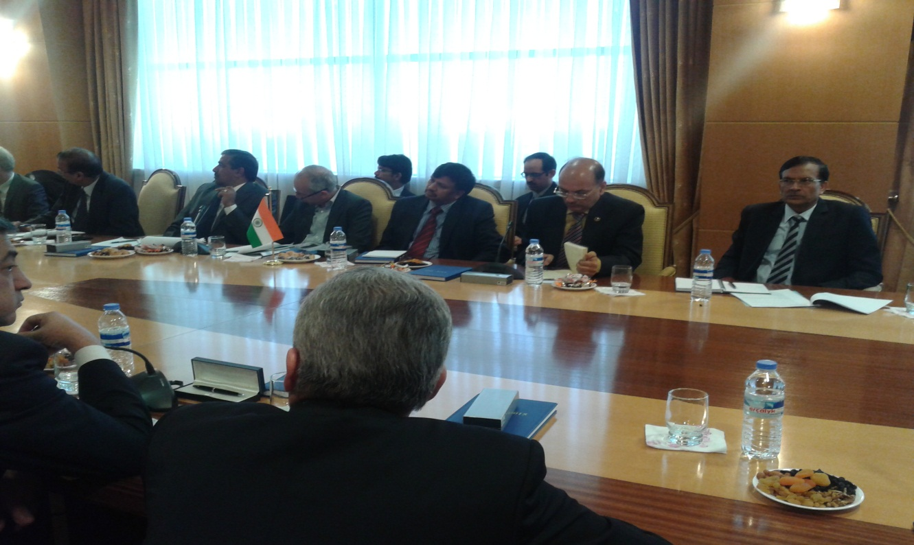

TAPI Steering Committee Meeting

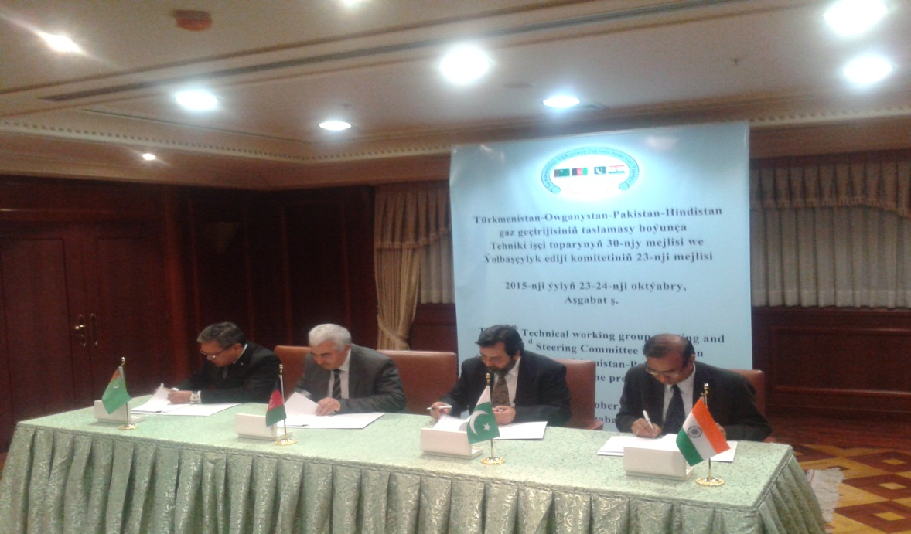

Initialling the Shareholding Agreement of M/s TAPI Ltd.

