‘Namaste Turkmenistan’ Cultural Shows
Ashgabat (17 October, 2015) & Mary (18 October, 2015)
…….

A cultural show titled ‘Namaste Turkmenistan’ was inaugurated by Ambassador Dr. T.V. Nagendra Prasad in Ashgabat (17 October) and Mary city (18 October, 2015) to packed houses. Heads of Missions resident in Ashgabat, art & culture lovers, students and people from all walks of life attended the cultural shows in both cities.
A 10-member cultural troupe led by Mrs. Madhu Natraj, Founder Director of Natya & STEM -Space.Time.Energy.Movement) Dance Kampni sponsored by ICCR visited Turkmenistan from 16-19 October, 2015 for cultural performances. The cultural performance showcased the evolution of dance from tradition to modernity.
The cultural performances were very well received by the spectators and earned a standing ovation at both the places.
…………..

Ashgabat
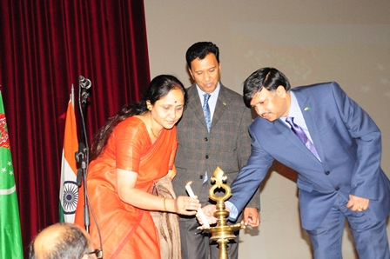
Mrs. Padmavathi & Ambassador Dr. T.V. Nagendra Prasad lighting the traditional lamp
inaugurating the cultural event
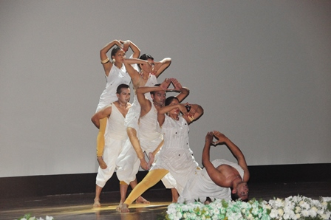
Culture troupe presenting the show

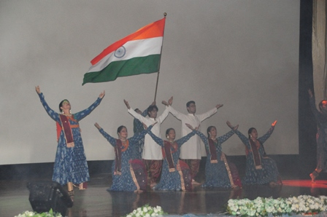
Culture troupe presenting the show
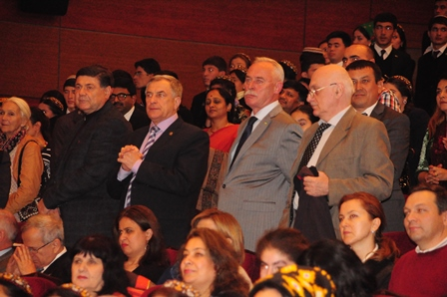
HOMs resident in Ashgabat enjoying the culture show

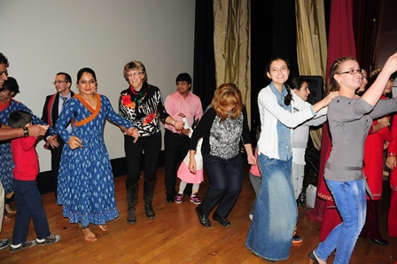
Culture troupe involving spectators in the show
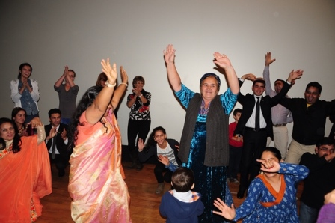
Culture troupe involving spectators in the show
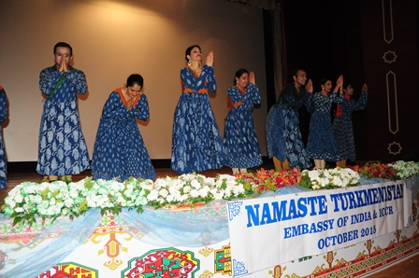
Culture troupe accepting standing ovation from the spectators

Mary city
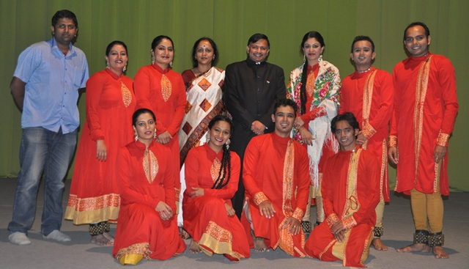
With the Cultural troupe in Mary city

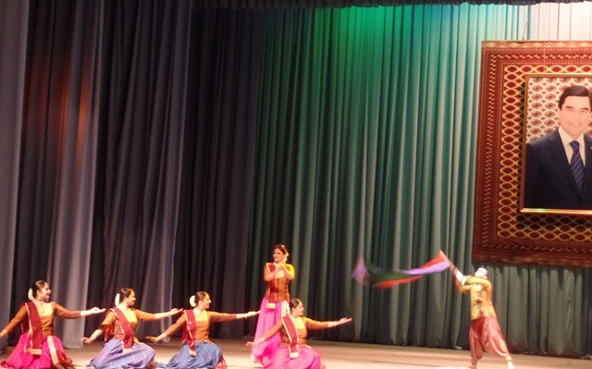
Cultural troupe presenting a performance

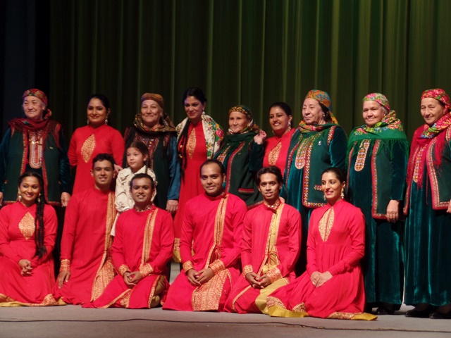
Cultural troupe with Turkmen elder folks in Mary

