Transit visit of Hon’ble EAM Smt. Sushma Swaraj

Ashgabat, 19 October, 2015,

Hon’ble EAM Smt. Sushma Swaraj made a brief stop-over at Ashgabat Airport on her way to Moscow on 19 October, 2015. DPM & Foreign Minister Rashid Meredov received Hon’ble EAM at the Airport. Discussions were held on bilateral issues and both appreciated the functioning of Yoga Centre in Ashgabat which was inaugurated during the visit of Hon’ble Prime Minister in July, 2015. ‘Ashgabat Agreement’, International North-South Transport Corridor (INSTC) and Turkmenistan-Afghanistan-Pakistan-India (TAPI) Gas Pipeline project implementation were discussed. It was also agreed that there is scope for increasing the bilateral trade from the current level. Hon’ble EAM invited Mr. Meredov for the next round of India-Turkmenistan Inter Governmental Joint Commission on Trade, Economic, Scientific and Technological Cooperation meeting to be held in New Delhi during the next year.

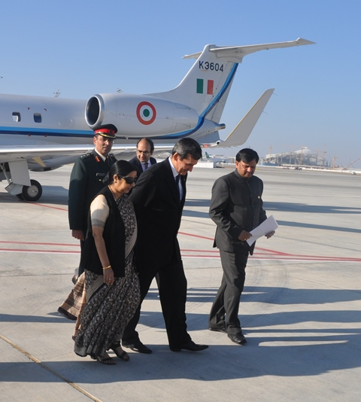
Hon’ble EAM Smt. Sushma Swaraj arriving at Ashgabat Airport

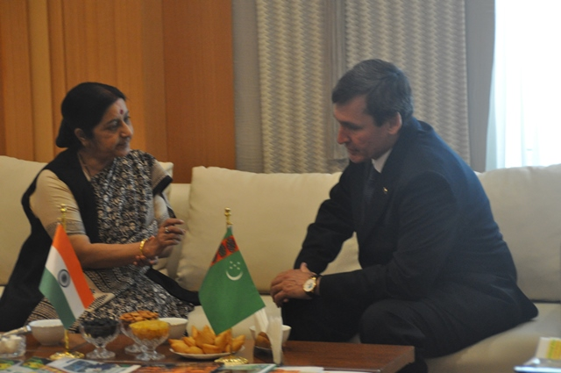

Hon’ble EAM Smt. Sushma Swaraj meeting with DPM & FM Rashid Meredov

