|  |  |
| --- | --- |
| http://www.indianconsulate-sf.org/images/ashokachkra.gif | EMBASSY OF INDIA KUWAIT |

**PRESS RELEASE**

**ONGC Pavilion at Kuwait Oil & Gas Show 2015, Kuwait**

**(12-14 October 2015)**

Oil and Natural Gas Corporation Ltd. (ONGC) is participating for the first time in the Kuwait Oil and Gas Show (KOGS)-2015 being held at the International Fair Ground, Mishref from October 12-14, 2015. H.E. Dr Ali Saleh Al-Omair, Minister of Oil inaugurated the ONGC pavilion on 12 October 2015. The Minister showed keen interest in India’s oil and gas sector.

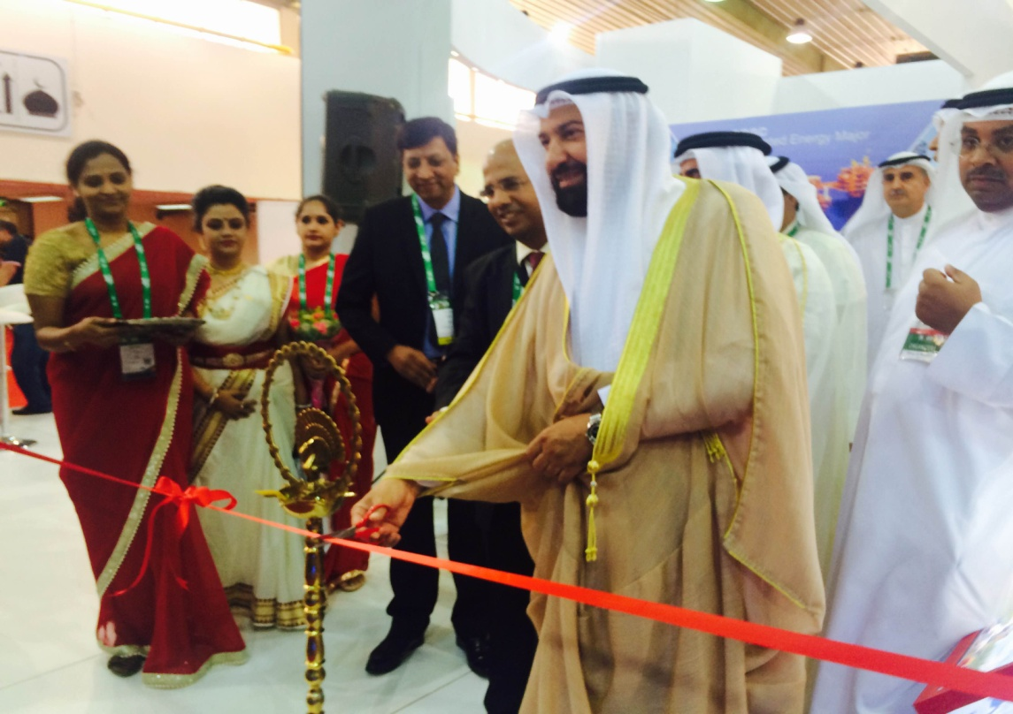

**H.E. Mr Ali Al-Omair, Minister of Oil inaugurating the ONGC pavilion**

ONGC, which was founded in 1956, has entered into its diamond Jubilee year with the resolution to increasingly fulfill India’s need for oil and gas. ONGC accounts for 69% of crude oil and 70% of natural gas production in India. ONGC Videsh Limited, a subsidiary of ONGC, has activities in 36 projects spread across 17 countries.

ONGC’s participation at the event is to showcase ONGC’s capabilities in the oil and gas sector. ONGC’s commitment is to realize the vision of Hon’ble Prime Minister to reduce India’s energy imports by 10% by 2022.

**14 October 2015**