Project Monitoring Committee (PMC) meeting for the Upgradation & Modernization of ‘Turkmen-India Industrial Training Centre’ (TIITC), Ashgabat, Turkmenistan
05.10.2015

A project Monitoring Committee (PMC) meeting for the Upgradation & Modernization of ‘Turkmen-India Industrial Training Centre’ (TIITC) was held in Ashgabat on 5.10.2015. The meeting presided over by Ambassador and Mr. Atamanov Bayrammurat Yaylymolivch & Mr.Ashyrmuhammet Myratlyyev, the Rector of Turkmen State Architecture & Constructions Institute was also attended by PMC members from Ministry of External Affairs, representative from the HMTI and the Embassy of India, Ashgabat. The PMC reviewed the upgradation along with the experts. Turkmen side expressed the gratitude to the Government of India for the upgradation and supply of State of Art equipment to train their engineering graduates. They also expressed satisfaction at Trainers Training Programme conducted for their teachers in India.

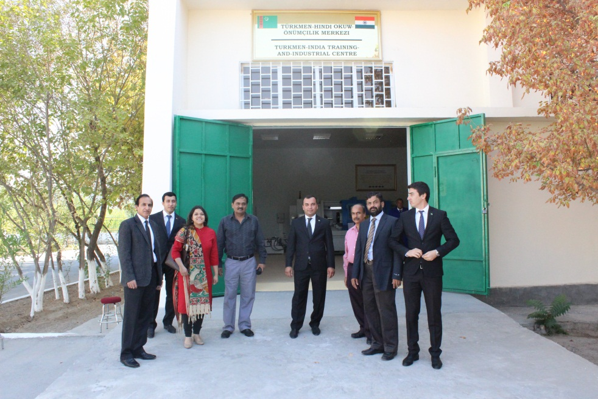
Delegation members with Turkmen officials

